
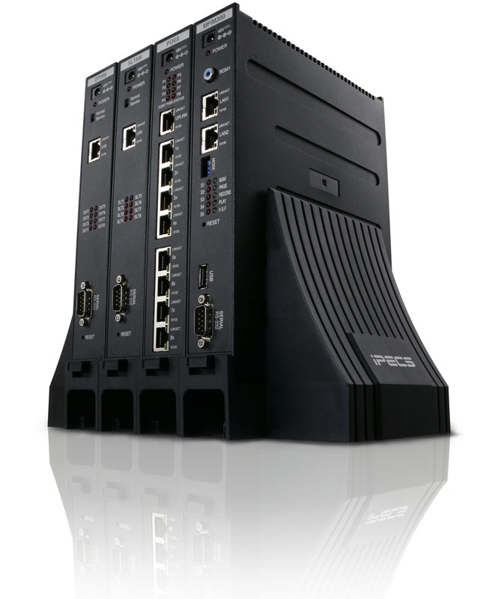
iPECS Attendant (SMB)
User Manual

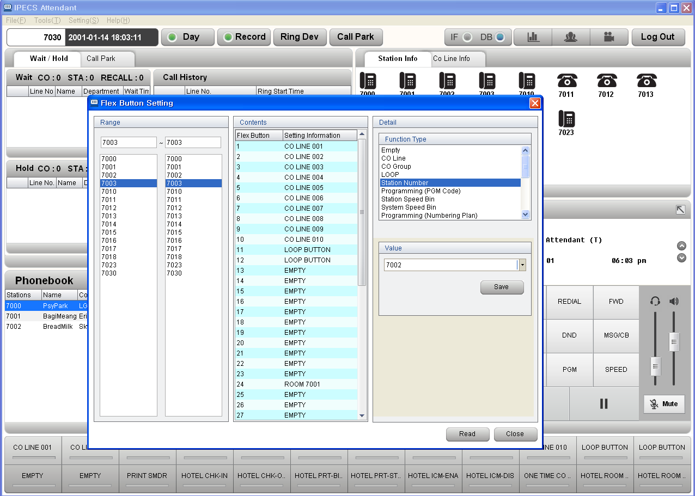

Revision History

Version | Date | Description
A.0Aa | 2011-09-01 | Draft
A.0Ab | 2011-09-26 | Function Addition & Description Improvement
A.0Ac | 2011-10-15 | Improvement of Addition of Network Station Function/Description
A.0Ad | 2011-10-27 | Improvement of Login/Account Description
A.0Ae | 2011-11-02 | Improvement of Import Description
A.0Ah | 2011-11-24 | Improvement of Main Window Description
A.0Ai | 2011-12-16 | Improvement of Call Park & the Whole Description
1.0Ak |  | 1st LIK version
 | 2012-02-17 | Atlas Gentech draft revision for iPECS connection & i-ATD setup
 | 2012-08-10 | Revised installation & login section.
 | 2012-08-28 | Revised instructions for ‘Call Functions’ section
 | 2012-08-31 | Corrected and re-organised Manual.
 | 2012-09-05 | Added Outlook to IP ATTENDANT Import Phone Book example.
 | 2012-09-24 | Added UCTI fail for license reason.
2.0Ax | 2012-12-31 | Phase 2 Upgrade
B.0Ai | 2014-01-19 | B.0Ai feature upgrade
B.1Ag | 2014-11-19 | Phase 3(PMS Reservation) Upgrade

--- Contents ---

1 iPECS Attendant Introduction 5
1.1 iPECS Attendant, Software IP Attendant Console 5
2 User log in 6
2.1 Important information 6
3 Basic Call Handling Functions 7
3.1 Answering a call 7
3.2 Making a call 7
3.3 Video 8
3.4 Call Record 8
3.5 Call Transfer 9
3.6 Conference 11
3.7 Mute 14
3.8 Hold/Connect 14
3.9 Call Pick Up 14
3.10 Call Park 15
4 IP Attendant Program Menu 16
4.1 File Menu 16
4.1.1 Import DB(Phone Book Data) 16
4.1.2 Export DB(Phone Book Data) 17
4.2 Tools 19
4.2.1 Phone Book 19
4.2.2 Phone book Search Window 21
4.2.3 LDAP 21
4.2.4 Account 23
4.2.5 Call Log 25
4.2.6 Call History 26
4.2.7 Call Statistics 27
4.2.8 Call Record Report 29
4.2.9 Change Station Name 30
4.2.10 CO Name 31
4.2.11 Preselected Message (Absend Message) 32
4.2.12 Paging 34
4.2.13 Music Selection 34
4.2.14 Date/Time 36
4.2.15 SMS 37
4.2.16 Conference 38
4.2.17 Monitoring Window 39
4.3 Setting Menu 40
4.3.1 Custom Setting [Environment Setting] 40
4.3.2 Flex Button Setting 48
4.3.3 Wakeup Setting 50
4.3.4 Group Setting 51
4.3.5 Code Setting 52
4.3.6 Speed Dial 55
4.3.7 PhoneBook Setting 56
4.3.8 Function Key Setting 57
5 IP Attendant Main Window 58
5.1 Logout 58
5.2 Wait/Hold Window 58
5.3 Monitoring Window 59
5.4 Dial Pad Window 62
5.5 Alarm Display LED 63
5.6 Windows Location 64
6 Installer’s Section 67
6.1 IP ATTENDANT. Program Installation 67
6.2 IP Attendant Login 69
6.2.1 iPECS-SMB Setting 69
6.2.2 Program Basic Setting 69
6.2.3 Program Start 74
7 PMS for Hotel Version 75
7.1 About PMS 75
7.2 PMS Monitoring Window 77
7.2.1 Database Syncronization with System and PMS 78
7.2.2 Database Backup 78
7.2.3 Reservation 78
7.2.4 Room Serivce 79
7.2.5 PMS Setting 80
7.2.6 Group 82
7.2.7 Document 83
7.2.8 Hotel Information 84
7.2.9 Currency 84
7.2.10 Customer Search 85
7.2.11 Room Status 86
7.2.12 Room Change 87
7.2.13 COS 87
7.2.14 Memo 88
7.2.15 DND 88
7.2.16 Wake Up 88
7.3 PMS Reservation Window 90
7.3.1 Holiday 91
7.3.2 Peak Information 92
7.3.3 Sale Information 93
7.3.4 Room Information 94
7.3.5 Call Information 95
7.3.6 Tax Table 96
7.3.7 Call Rate Table 97
7.3.8 Service Type 99
7.3.9 Service Table (Item Information) 99
7.3.10 Room List 100
7.3.11 Customer Information 101
7.3.12 Reservation / Check-In 103
7.3.13 Check-Out / Invoice 105

iPECS Attendant Introduction

iPECS Attendant, Software IP Attendant Console

iPECS Attendant is the new software based IP Attendant console that extends the features of ez-Attendant with embedded soft phone function, hotel features and an improved user interface.

The powerful Attendant capabilities and superb GUI are designed to improve Attendant functions for the user.
iPECS Attendant simplifies call handling for Attendants with a simple click of a mouse on a PC and may operate without the need for desktop hard phone. iPECS Attendant links to local and corporate databases (MS Outlook, Excel, ACT and Goldmine) so the answering position is able to greet callers knowing who is calling. From a glance at the iPECS Attendant Monitoring Window, the receptionist views the status of users idle, busy, etc.

iPECS-LIK supports up to 5 Attendant Stations, each of which can be IP Attendant (with or without the associates desk ‘hard phone’), for larger or high call-volume environments and can be used as a Centralized Attendant in networked environment.

iPECS Attendant is supported for LIK Hospitality Software, as a separate product ‘PMS Attendant’ (Proprietary Management System). This application requires iPECS-LIK Hotel SW for connection.

User log in

Important information

The IP Attendant Program uses login information, in the form of User ID and Password, created during the application’s initial setup. This data should be recorded in a safe place, to protect against lost or forgotten passwords.

If this data is lost the IP Attendant program cannot be started.
In such a situation, the iPECS ATD will need to be uninstalled and reinstalled to the desired PC, in order to create a new ID and password.

Even if the application is set to auto login, it can be deselected during start-up of the application.

If your IP Attendant does not have a user log in, refer to the Installers Section for instructions regarding the initial log in and creating IP ATTENDANT ID and Password details (Seciton 4.2.4 Account).

Basic Call Handling Functions

Answering a call
Description
An IP Attendant operator may answer internal (other stations on the system) or external (outside line) calls.

Procedure
Station Answer
- When an incoming call presents, it will pop a call alert and will displayed in the Wait window, as well as ring the PC speakers (or headset – as configured within the IP ATTENDANT).
- When Call Popup Window option is set to [Only Inactive], If the IP ATTENDANT is not focussed in the foreground of windows, you will see the pop-up alert.
But the ringing information in the ‘Wait’ window of the main application may not be visible until the IP ATTENDANT application is presented to the foreground of windows.)
- When Call Popup Window option is set to [Always], you will see the opo-up alert always.
- When Call Popup Window option is set to [Disable], you will not see it.
- Call Popup Window option can be set in menu → Setting → Custom Setting → Display Option → Calling Popup Window.
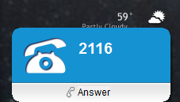
- Either Click the Speaker key 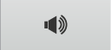 in the Dial Pad window,
Or double click the station number in the Wait window,
Or click anywhere on the pop up alert
Or double click the station icon in the station info window.
Or (when IP ATTENDANT is the active window) press the ‘Enter’ or ‘Space Bar’

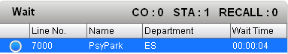

Hanging up a call

To hang up a current call click the Speaker key in the Dial Pad window. The current call is terminated and the IP ATTENDANT returns to an idle state.

Or when IP ATTENDANT is the active window – press ‘Esc’ key on the PC keyboard or press ‘Space Bar’ to hang up the current call.

When IP ATTENDANT program is active window, The ‘Space Bar’is worked as toggle – On-Hook / Off-Hook.

Making a call
Description
An IP Attendant may generate ICM (‘intercom – a.k.a Station to Station call) as well as outside line calls.

Procedure
Station Calling
- Dial the Station number at the IP ATTENDANT key pad using the PC mouse.
- Double Click the station icon in the Group Information window.
- In IP Attendant is active state(foreground of windows), use the PC Key Pad to dial the Station number.
- Drag from Station Info window and Drop to Dial Pad window.
- Drag from Phonebook window and Drop to Dial Pad window.

Line (external) Calling
- Dial the Line access code, followed by the PSTN number (at the Application key pad, or PC key pad)
- Drag from Phonebook window and Drop to Dial Pad window.

Note

- Other methods for outbound calling are given in this user guide. For details see the feature in use (eg dialling from the phone book).
- When dialing digits, DTMF tone is generated IP Attendant itself.

Video
Description
In an IP Attendant, Video Call is allowed.

Procedure
Station Calling
On talking with other Video Device, press button.
Video Call is established as below.
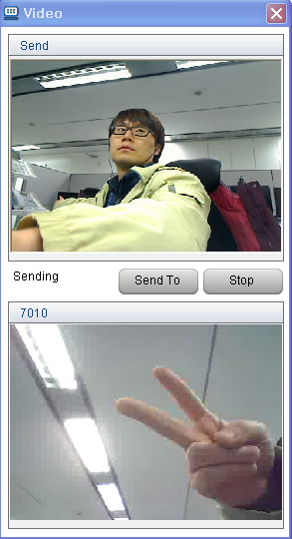

Note

- Video call is only allowed in talking state.
- If associated device is not video station, video call is not allowed.

Call Record
Description
In an IP Attendant, Call Record is allowed.

Procedure
Station Calling
On talking with other Device, press  button.
Record List can be checked at Call Record Report.

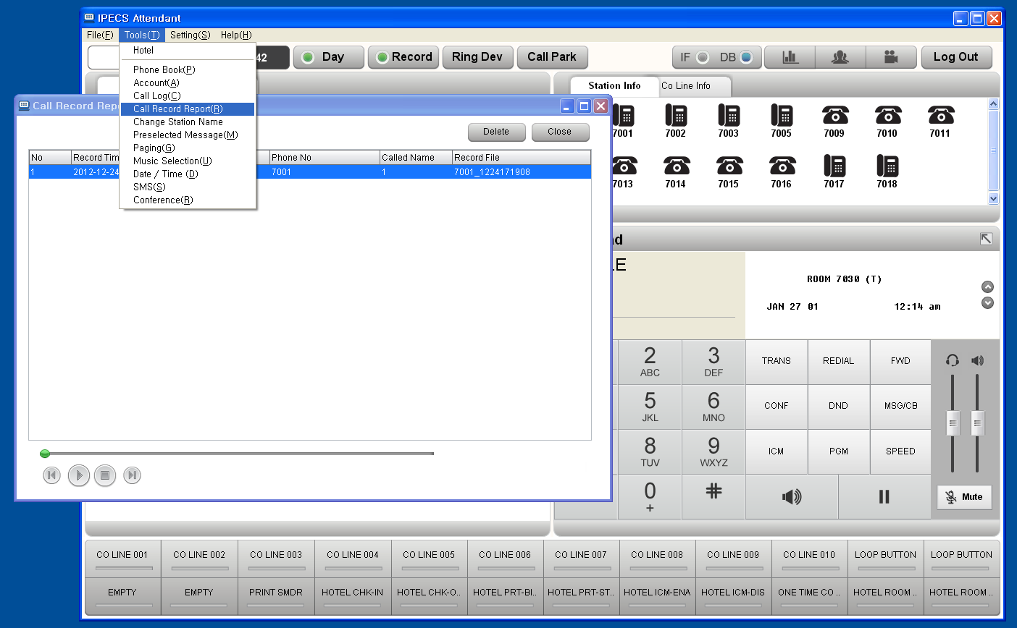

Note

- Call Record is only allowed in talking state.
- Call Record Max time is limited up to 3 hours.
- Default Call Record Time is 30 minutes.

Call Transfer
Description
The IP Attendant operator can transfer various types of incoming/outgoing calls.

Procedure
- General Way.
  - On calling, user presses [TRANS] key.
  - Dial destination number or Double Click a station icon in Station Info window.
  - [Speaker] button or press [Space bar] in the keyboard.
- Drag & Drop.
  - On calling, user drag connected number(or CLI) from Dial Pad.
  - Drop to a station icon.
  - [Speaker] button or press [Space bar] in the keyboard.
- Double Click.
  - On calling, user double click a station icon in Station Info window.
  - [Speaker] button or press [Space bar] in the keyboard.
  - Below option is checked, Double Click action can be worked as Transfer.
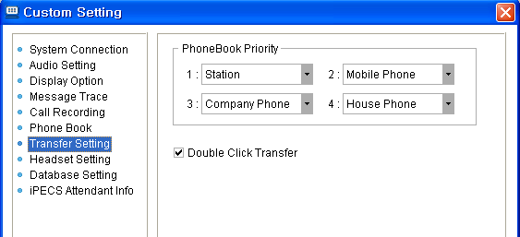

  - When this option is not checked, just new call is made, previous call is just disconnected.
- Transfer to Phonebook.
  - On calling, user Double Click a phonebook record.
  - The call is transferred to valid phonebook destination. The destination priority is set in below setting.

  - On calling, user click mouse right button.
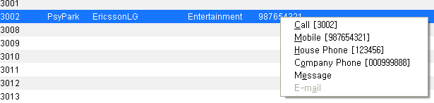
  - User may choose the destination.
  - [Speaker] button or press [Space bar] in the keyboard.
- Using Keyboard Function Key.
  - On calling, user press Fxx key that is assigned as [TRANS] key on the keyboard.
  - Dial destination number on the keyboard.
  - Press [Space bar] on the keyboard.
  - Fxx key can be programmed as below(Setting → Function Key Setting).
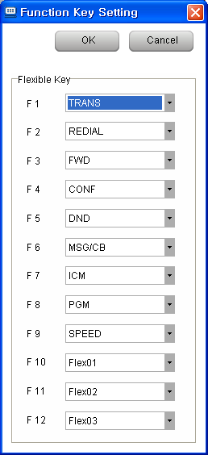

- Dial destination number first.
  - On calling, dial destination number first.
  - Press [TRNAS] key or Fxx key that is assigned as [TRANS].
  - [Speaker] button or press [Space bar] in the keyboard.
  - In this case, Dial DTMF tone is heard to the users.

Conference
Description
The iPECS-ATD operator can create a conference call.

Procedure
- The iPECS-ATD operator can make a Add On Conference / Conference Room / Conference Group by using Dial Pad as normal hard phone.
- The iPECS-ATD operator can make a Add On Conference / Conference Room / Conference Group by using Conference Menu or Conference Button.
- In Conference window, there are 4 tab – Add On, Room, Station Conference Group, System Conference Group.
- There are Member List, and notepad that is used for brief memo for the conferece.
- In Member List, member number, phonebook name, each member’s state are shown.

- In Add On Tab, Conference member is added, Conference member is deleted, current Conference is ended.
- Add Member way is two kinds – Entering Number directly in add column, and Searching Phonebook.
  - Entering Station Number – Just enter station number(ex : 3333) and press [add member] button or press [Enter] key.
  - Entering Outside Number – Enter Co seize number(ex : 9, 801, 88001) and enter outside number(1234567) and press [add member] button or press [Enter] key.
  - Searching Phonebook – press magnifier icon, and double click a number that you want to add.
If you want to add station 3000, then double click 3000.
If you want to add mobile phone 1234, then double click 1234.
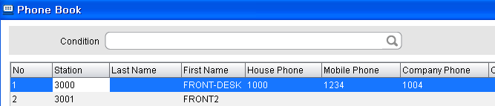

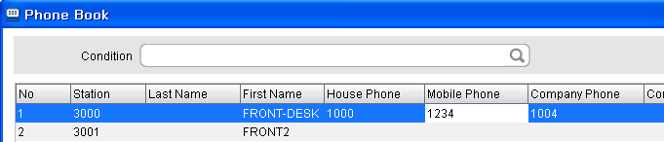

- If a conference member state is [Talk(C/A)] – means Conference Available, then this member can be joined at this conference by pressing mouse right button.
- On conference, each member can be deleted by pressing mouse right button.
- On conference, if pressed [End Conference] button, conference is finished.
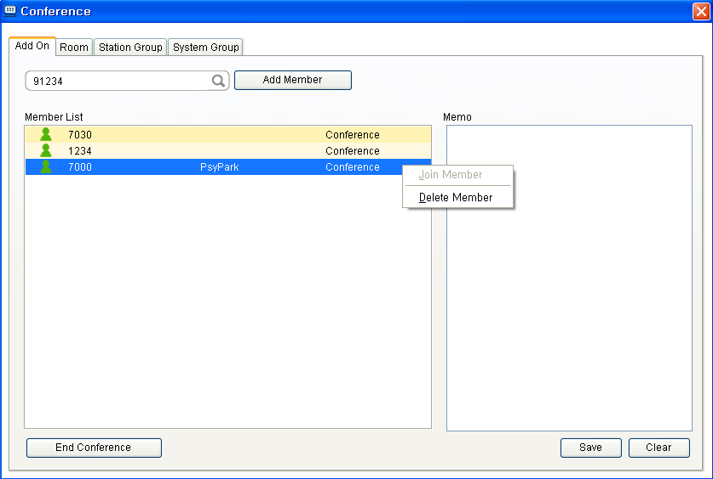

- In Room Tab, Conference Room list is displayed.
- Total current member count, room status is displayed.
- When a room is chosen, member list can be displayed – member number, member name, member status.
- Each Room can be activated or deactivated by pressing [Activate],[Deactivate] button.
- IP ATTENDANT itself can enter or exit by pressing [Room In], [Room Out] button.
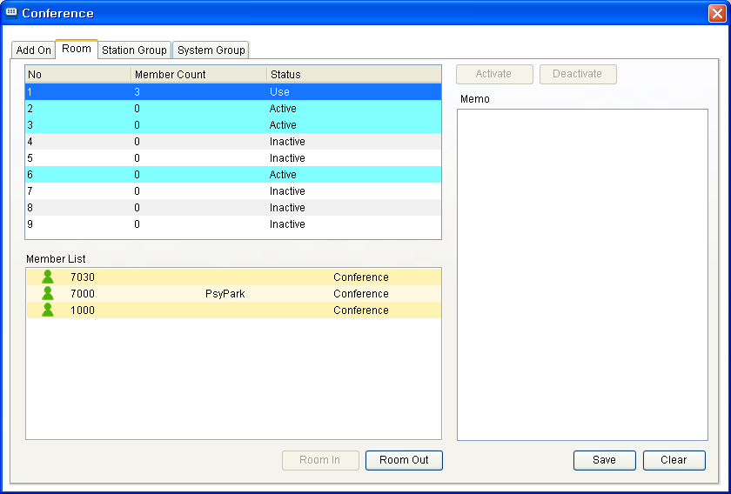

- In Group(Station or System) Tab, Conference Group list is displayed.
- Total current member count, group status is displayed.
- When a group is chosen, member list can be displayed – member number, member name, member status.
- Choose a group, and press [Start] button, then conference group call is started.
- If [Stop] button is pressed, current conference group call is finished.
- If IP ATTENDANT is conference state, new member can be added. The adding new member way, is same as Add On Conference.
- If a member is conference state, the member can be deleted from the conference by clicking mouse right button.
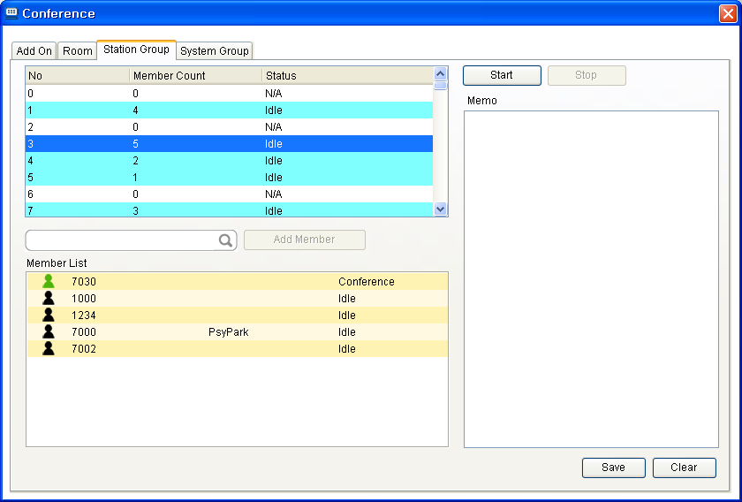

Note
- MCIM is needed in the iPECS system if more than 3 party conferencing is required.
- In case of Conferece Room, Conference Group, MCIM should be installed.

Mute
Description
During the phone call, the iPECS-ATD operator activates the "Mute" function so that the other party cannot hear the iPECS-LIK operator's voice path.

Procedure
- During the phone call, click the "Mute" button in the Dial Pad window.
- The connected party will not hear the voice path from the iPECS-LIK Attendant
- Click the "Mute" button for deactivation.

Note

Hold/Connect
Description
The iPECS-Attendant operator may place and retrieve a station or trunk (outside line) caller from hold.

Procedure
Hold
- Click the  button during the phone call between the iPECS-Attendant operator and a caller.
- The caller will hear "holding tone" and the relevant caller's information will be displayed in the "Wait/Hold" window. And the number of call count is increased.

Holding Answer (Retrieve from Hold)
- Click the button
- Double click the caller’s information displayed in the Hold window.
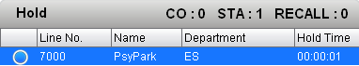
- In case of ICM Holding call, press 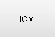 button.
- The phone call with the caller will be restored.

Hold Transfer
- Drag from Hold window, Drop to Station Info window station.

Call Pick Up
Description
By using the "Call Pick Up", the iPECS-Attendant operator is able to pick up calls that ring to other stations. This function is applicable for station, trunk and recall.

Procedure
- Double click the station icon that is ringing state for call pick up.
- In order to disconnect the phone, click the "ESC" key or the button.

Note
Call pick up function cannot be used when the iPECS-LIK operator is busy or in the middle of PGM setting.

Call Park
Description
The iPECS-LIK operator performs "Call Park" operations so that users of other station may retrieve the caller from the park location (a.k.a Park Orbits).
Also, Call Parking list is displayed, so whole system call park status can be checked.

Procedure
Call Park
- Choose the "Call Park" menu in setting or press  button in the main window.
- The caller will be heard MOH, while waiting at the Call Park location.
- Call Park list is displayed when clicking the tap on the right side of "Wait/Hold".

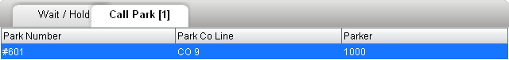
- A call can also be parked by pressing the "Transfer" button followed by the available Park Location number (ex. 601), or use the PC Key pad.

Call Park Answer
- To retrieve a Parked call, press Call Park number using the Dial Pad, or use the PC Key pad,
Or double click the call in the Call Park list.

Note
Call Park answer is recommended to be done when the IP ATTENDANT is "IDLE".
Call Park is only available for external (outside line) callers.

IP Attendant Program Menu

File Menu

Import DB(Phone Book Data)
Description
Using the Phonebook import function for importing data into the Phone book from other programs or files.

Procedure
- "Menu" → "File" → "Import Phone Book". | or ALT+F I
- Select one of types (“Act!”, “Gold Mine”, “ez-Attendant”, “Excel” ) that contains the data to be imported
- Select the file in the file import window and then click the "Open" button.
- The Import process will complete automatically.

Notice
- The program selected at the import type must be already installed in the PC.
- During the Phone Book Import process, iPECS-ATD may slow its response speeds. IP ATTENDANT cannot receive calls while a phone book import is in progress. Therefore, import phone book is recommended to be done when call traffic is low.
- When network station numbers are imported by import phone book, those numbers will be shown in the monitoring group immediately after restarting the IP-ATD program.
- If a station numbers already exists in the phone book, those same station numbers will not be imported (ie they will not be over-written).

Conditions
- Importing Phonebook data will not overwrite an existing Station entry.
- If the current phone book contains a STA entry not contained in the imported data, it will be kept.
- An entry is identified by its Stations’ Information field
- To dial out from the phone book the Code Setting (ALT+S T) fields need to be configured.
- This job is only allowed in Night ring mode.

Note
Importing the phone book through “Act!” or “Gold Mine” will not import E-mail address.

Example: Outlook export & IP ATTENDANT Import
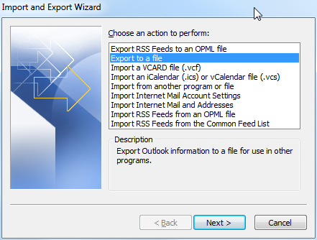
Outlook 2010 - export contacts as excel 97-2003/:
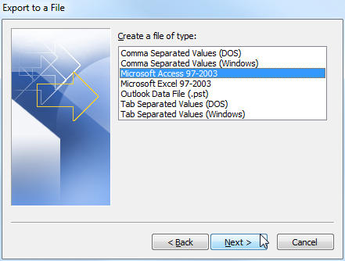
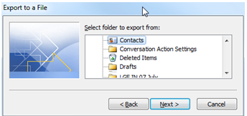
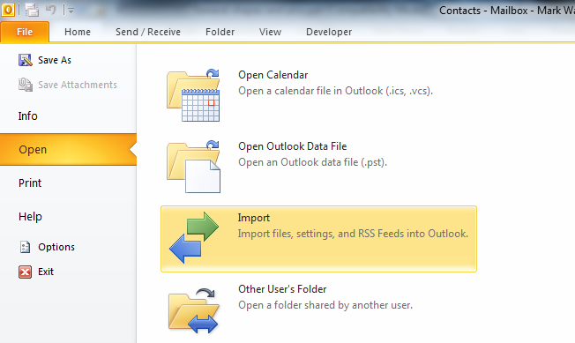

Open the spread sheet - change the Sheet name from 'Contacts' to 'PhoneBook'
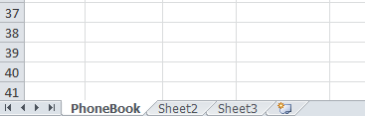
Column Headings:
Title
FirstName → 2
MiddleName
LastName → 3
Suffix
Company → 4
Department → 21
JobTitle →7
BusinessStreet →10
BusinessStreet2 → 11
BusinessStreet3 → 12
BusinessCity → 13
BusinessState → 14
BusinessPostalCode → 15
BusinessCountryRegion → 19
HomeStreet
HomeStreet2
HomeStreet3
HomeCity
HomeState
HomePostalCode
HomeCountryRegion
OtherStreet
OtherStreet2
OtherStreet3
OtherCity
OtherState
OtherPostalCode
OtherCountryRegion
AssistantsPhone
BusinessFax → 8
BusinessPhone → 9
BusinessPhone2
Callback
CarPhone
CompanyMainPhone → 1
HomeFax
HomePhone → 5
HomePhone2
ISDN
MobilePhone → 6
OtherFax
OtherPhone
Pager
PrimaryPhone
RadioPhone

Column Headings:
TTYTDDPhone
Telex
Account → 22
Anniversary
AssistantsName
BillingInformation
Birthday
BusinessAddressPOBox
Categories
Children
DirectoryServer
EmailAddress → 16
EmailType
EmailDisplayName
Email2Address
Email2Type
Email2DisplayName
Email3Address
Email3Type
Email3DisplayName
Gender
GovernmentIDNumber
Hobby
HomeAddressPOBox
Initials
InternetFreeBusy
Keywords
Language1
Location
ManagersName
Mileage
Notes → 20
OfficeLocation
OrganizationalIDNumber
OtherAddressPOBox
Priority
Private
Profession
ReferredBy
Sensitivity
Spouse
User1
User2
User3
User4
WebPage
An Outlook 2010 export example:

Then rearrange the columns to suit IP ATTENDANT
database:
IP ATTENDANT Database:
Column Headings:
- STATION
- FIRSTNAME
- LASTNAME
- COMPANY
- HOUSEPHONE
- MOBILEPHONE
- JOB
- FAX
- COMPANYPHONE
- ADDRESS1
- ADDRESS2
- ADDRESS3
- CITY
- STATE
- ZIP
- EMAIL
- NICKNAME
- SPEEDNO
- COUNTRY
- MEMO
- DEPARTMENT
- ACCOUNTNO
- PHYSICALSTATION
- PHONE_LEVEL
Usage example of Outlook exported data:
Used
Not used

The columns of the Outlook exported file need to be rearranged to match the IP ATTENDANT order, many are deleted.
The column headings do not require editing.
Save the spread sheet Use the IP ATTENDANT Import function to browser to the saved spread sheet and import it to IP ATTENDANT.

Export DB(Phone Book Data)
Description
IP-ATD can export its Phone Book data in MS Excel format.

Procedure
- "Menu" → "File" → "Export Phone Book" → "Excel". | or ALT+F E E
- Input the file name in the file export window and then save it.
- After the window that shows progress disappears, export phone book will be completed.

Notice
- "Export Phone Book" menu is functional only when Server type is "Local". (Custom Settings/ System Connection)
- During export phone book, iPECS-LIK might get slower and receiving calls is impossible as long as import phone book is in progress. Therefore, export phone book is recommended to be done when call traffic is low.
- This job is only allowed in Night ring mode.

Tools

Phone Book
Description
Phone book operation includes number registration, creation, editing and deletion.
In Setting, phonebook type is set as Outlook, it’s information is applied to IP Attendant Phone Book.
If Synchronize Phonebook is checked, when user modify some information from IP Attendant, this modification is applied to Outlook.

Window

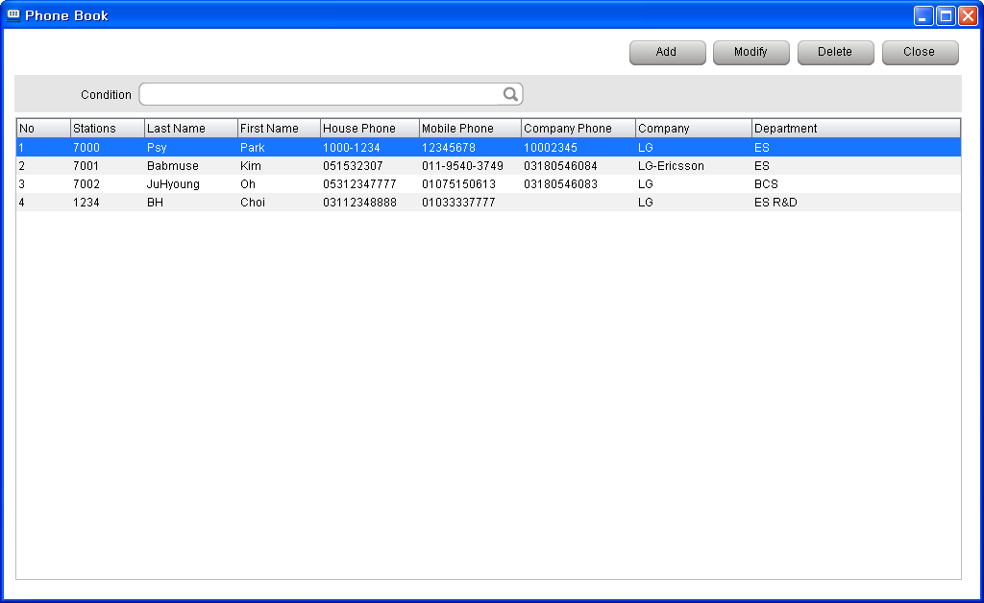

Editing Procedure
- "Menu" → "Tools" → "Phone Book". | or ALT+T P
2) To create a new record, click the "Add" button.
3) In the new Phone Book window edit values as required and then click the "Save" button.
4) If it is necessary to change the information in a record, use the "Modify" button.
5) To delete a group of records, select the relevant records (use Shift or CTRL keys) and then click the
"Delete" button.

Notice
- Numbers that have been newly registered in the phone book will be applied Station Info, but details such as the Station name will be applied after IP ATTENDANT restarts.
- Program restart is required if network station is registered by importing phone book data.
- Calls can be made from this window of the Phonebook by using the right click menu. The call-able record fields containing data are made available for calling (empty fields are not offered).
Note
- The information that has been newly registered in the Phone Book will be displayed in the all subscriber information display part of the program.
- A network station number can be registered similar as normal station number.
- A maximum of 30,000 phone numbers is recommended. A phonebook of over 30,000 phone numbers might result in slow search speed.
- When phonebook type is set as outlook, the outlook s/w should be installed ahead at the PC.
If the S/W is not installed, IP Attendant is not working correctly.
- On executing outlook program, if IP Attendant is log on with synchronizing outlook, it should be closed.

Phone book Search Window
Description
The Phonebook can be searched for Station users who are registered at the Phone Book.

Window & Procedure
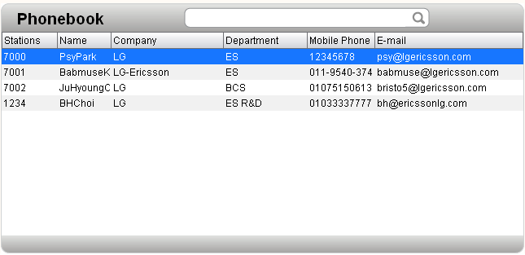
- The Phone book search function searches "Station", "Name", "Company", "Department" and "Mobile Phone number" fields simultaneously to the search term.
- Click the right button of the mouse on the selected subscriber. "Mobile" is for calling selected subscriber's mobile & "Call" is for calling the station & "Email" is for sending an email & "SMS" is for sending a text message".
- This Phone book Search Window can be configured as user want.
In Menu → Setting → PhoneBook Setting, each item can be added or can be deleted as below.
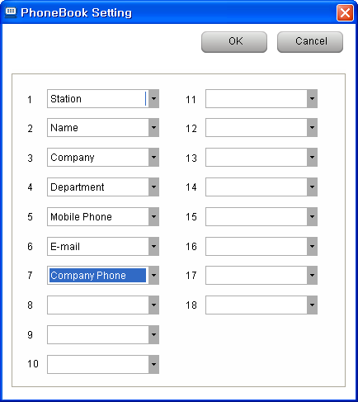

Note
- "Menu" → "Tools" → "Phone Book" for "registration" & "Modification" & "Deletion" of subscriber information | or ALT+T P
- Currently the Search facility is NOT case sensitive. Eg search LAB and Lab is same result.

LDAP
Description
LDAP Server Information can be connected with IP ATTENDANT.

Window & Procedure
- LDAP Setting is as below.
Menu → Setting → Custom Setting → Phone Book → Enable LDAP → Enter Information
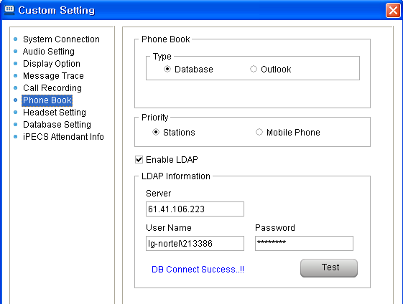

- After enable LDAP, LDAP button is activated in main window as below.
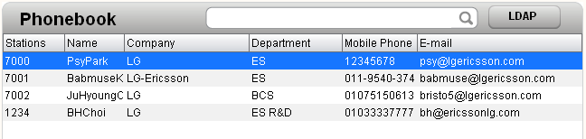
- This is LDAP information window.
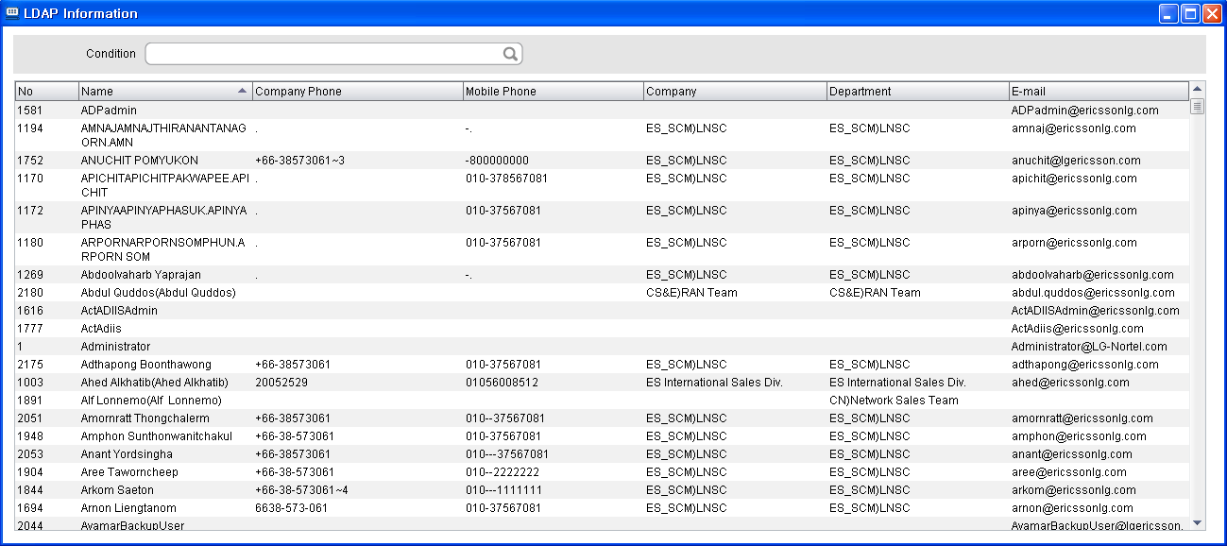

Note
- After LDAP enable, IP ATTENDANT should be restarted again to apply it correctly.
- When user try to call to company phone or mobile phone by using mouse right button, if Code setting table is configured, this dialing rule is applied.

Account
Description
Account information is the IP ATTENDANT account data (including the IP ATTENDANT log in credentials).
When IP Attendant log in, this account’s ID/Password is used.

Window

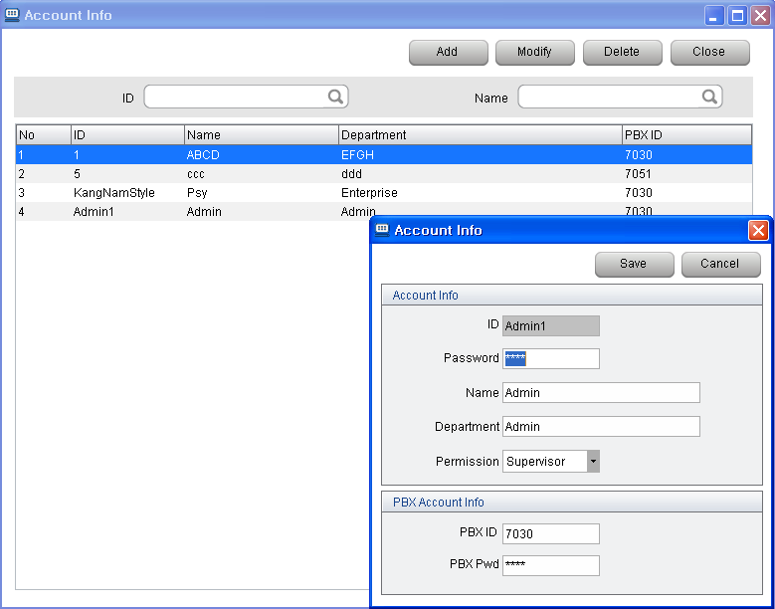
Procedure
- "Menu" → "Tools" → "Account". | or ALT+T A
- To create new operator registration information click the "Add" button.
- In the Account Info. window, input the relevant information such as ID, Password, Name, Department, Perm (Permission), PBX ID and PBX Password, and then click the "Save" button.
- If it is necessary to change the information of the registered operator, select the relevant operator and then click the "Modify" button. Then in the Account Info. window [Modification], change the information and then click the "Save" button.
- If it is necessary to delete the information of the registered operator, select the relevant operator and then click the "Delete" button.
Notice
- ID / Password is log in User ID / Password to IP Attendant Application.
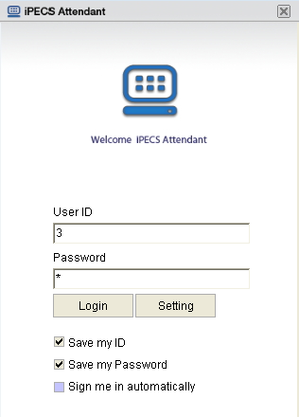
- PBX ID / PBX Pwd is PGM 443 ID / Password.
- There are two type permission – Supervisor / User.
If user log in with Supervisor permission ID, this user can see and modify Account Information.
But, with User level ID, this user cannot see or modify it.
- If PBX ID and PBX Password in PBX Account Info. are wrong, communication with the iPECS will fail and the IP ATTENDANT will fail to log in. (This will report as a Database Fail error during login)
- Bear in mind that operator information is provisioning with all information registered by the operator, so when the operator is deleted, any setting or any information such as program environment setting registered by the operator will be deleted.

Note
- Initial Log In ID/PW (“admin” and “1111” that is used for the initial set-up) still can be used after a new operator with Supervisor permission is created, but it has some feature limitation.
- To remove feature limitation, new account should be created in account table.
- Initial Log In ID/PW (admin /1111)’s PBX ID/PW is always Default PBX ID / Default PBX PW as below.
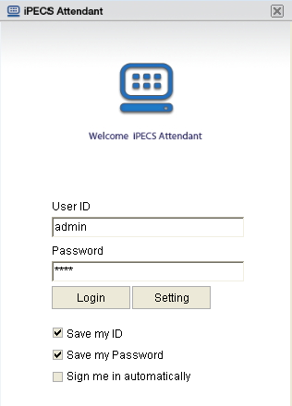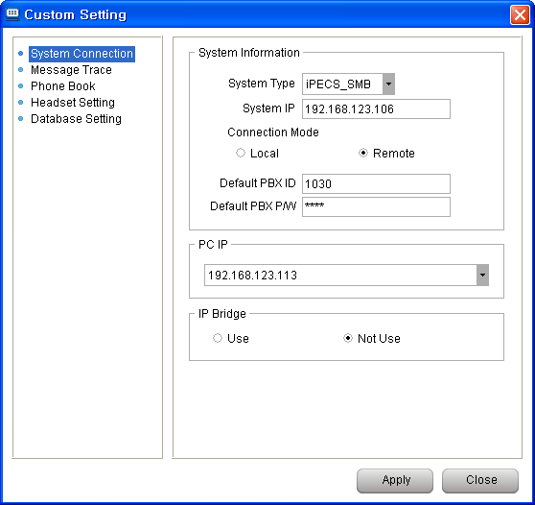

- In account table, a account record can be saved without entering PBX ID/PW. In this case, Default PBX ID / Default PBX PW is used as below.
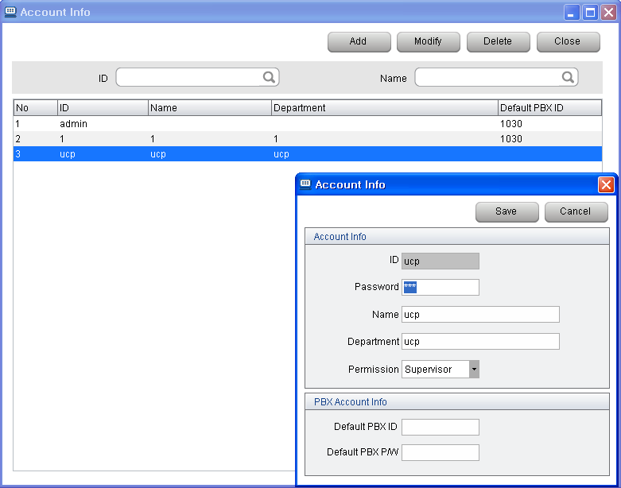
- The recommended maximum number of operator registrations is 50.

Call Log
Description
The call Log provides a list and search facility for the history of incoming calls and outgoing calls through the iPECS-LIK.

Window

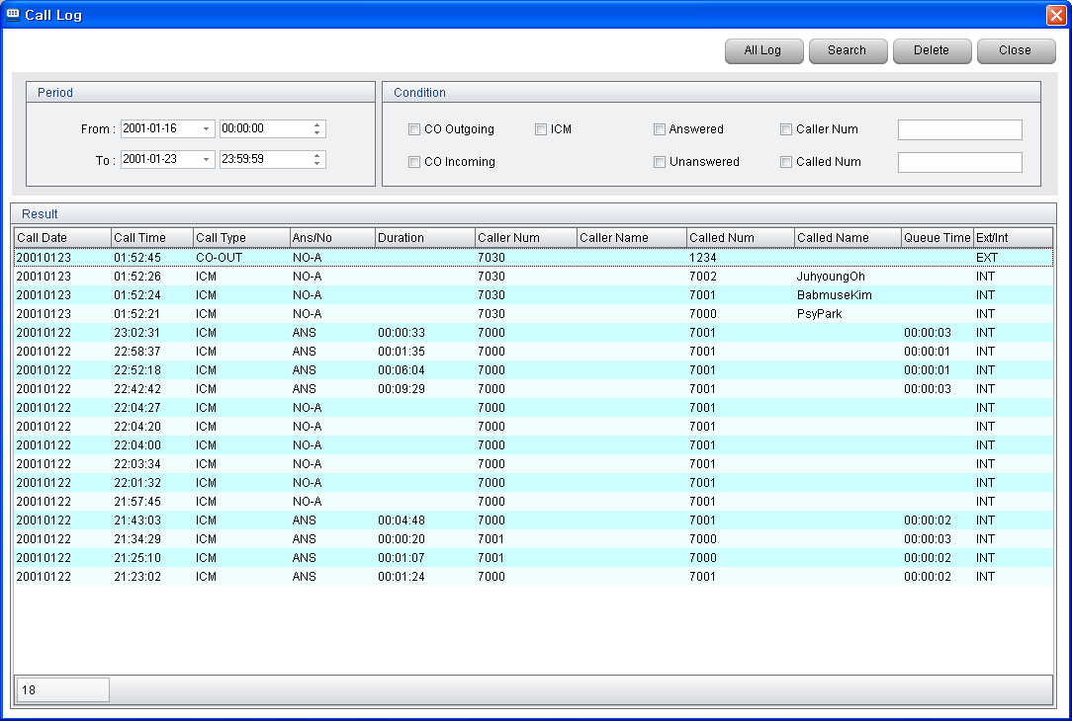

Procedure
- "Menu" → "Tools" → "Call Log". | or ALT+T C
- Period Search or Condition Search is allowed.
- In the Call Log Window, all system call log is remained.
- In the Call History of IP ATTENDANT Main window, call log that is related with Attendant is displayed.

Note
- The information of called name, caller name, department and mobile phone will be displayed on the basis of incoming number to the operaor/outgoing number by the operator.

Call History
Description
The call history window is located in main window of IP Attendant.
In this window, call logs that is related with IP Attendant are displayed.
By double click each history, or drag & Drop, call can be established.

Window

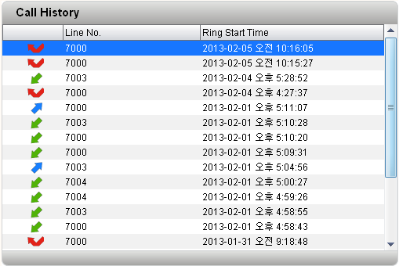

Procedure

Note

Call Statistics
Description
By using  button, call statistic window can be activated.
This statistics are made from call log data(4.2.5).

Window
- Column Diagram
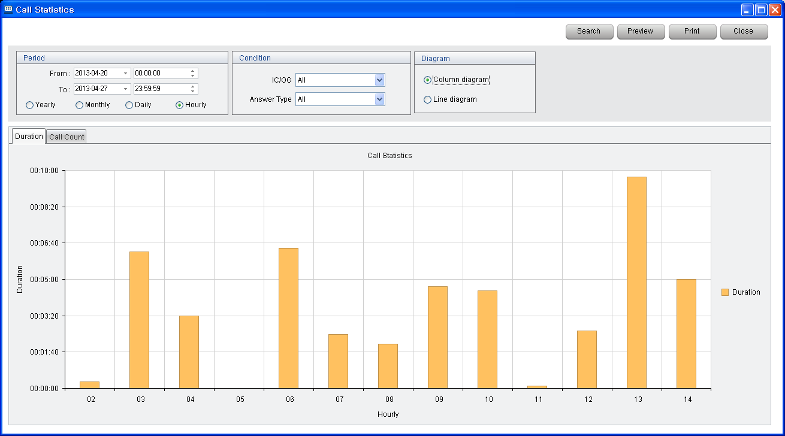

- Line Diagram
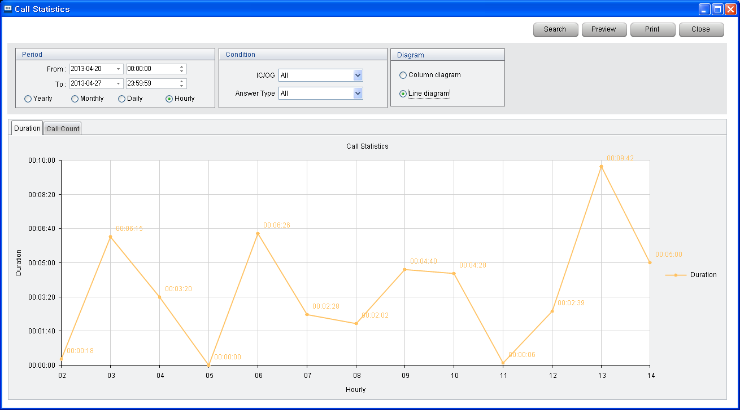

Procedure

- In Period field, From Date/Time and End Date/Time can be assigned, and statistics is shown as Yearly, Monthly, Daily, Hourly.
- In Condition field, Call type can be devided as All call / Incoming call / Outgoing call / ICM call.
Answer type also can be devided as All / Answered / Unanswered.
Call type and Answer type is AND relation, that means if user choose incoming and answered, then incoming call and also answered call statistics is displayed.
- In Diagram, graph type can be choosen – Column type or Line type.
- Call Duration(call time) and Call Count graph is supported.
- Statistic result can be previewed and can be printed.

Note

Call Record Report
Description
During conversation, call record is allowed by using  button.
After record is end, Call Recording List can be checked this Call Record Report.
.

Window

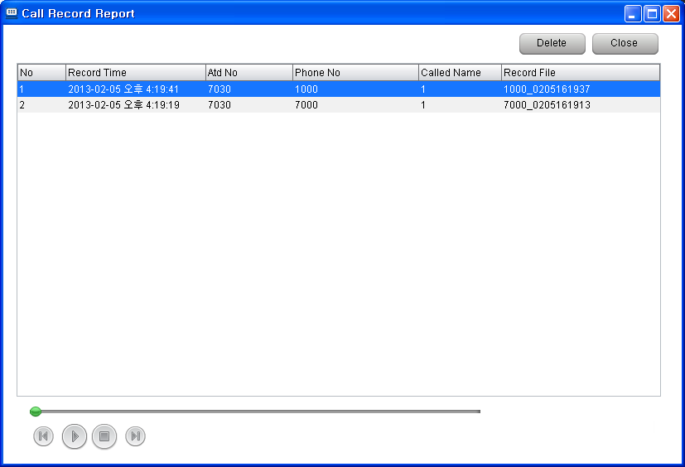

Procedure
- Each recorded record can be played, can be deleted.
- In Phone No field, Callre ID is displayed.

Note
- The recorded file location is C:\Program Files\iPECS Attendant.

Change Station Name
Description
IP Attendant can change the Station name of stations connected to the LIK.

Window

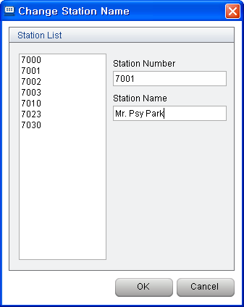

Procedure
- "Menu" → "Tools" → "Change Station Name". | or ALT+T N
- Select the station number in the list or input the station number directly.
- Input the new station name to be displayed.
- Click the "OK" button.

Note
- If the station being edited has a Name already registered, that name will be displayed in the Station Name.

CO Name
Description
IP Attendant can label the CO name of co-lines connected to the LIK.
This CO name is not synchronized with system CO Name values, only IP Attendant have this CO Name.

Window

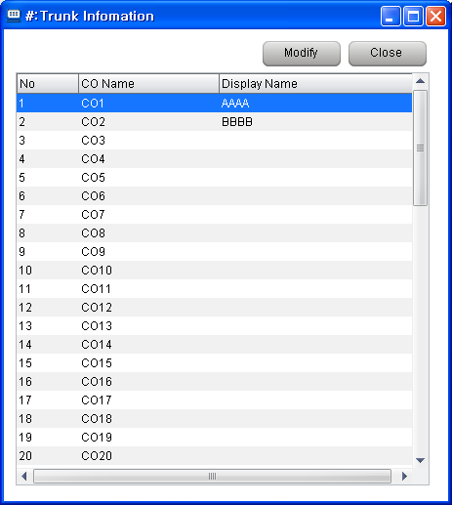

Procedure
- "Menu" → "Tools" → "CO Name". | or ALT+T C
- Select the CO number in the list or input the CO name.
- Click the "OK" button.

Note

Preselected Message (Absend Message)
Description
iPECS-LIK is able to send Preselected message or Customized message to the other stations (as well as to callers as an audio message – when this feature is supported). Station subscribers can send a message to LCD of the other station telephone Depending on type or feature of Preselected message, additional time and date can be set.
The audio reply based on Preselected message is called “Preselected Message with VSF Group”, and is supported in iPECS (subject to conditions – see the 5.6 Release document) from 5.6 Software release.

Window

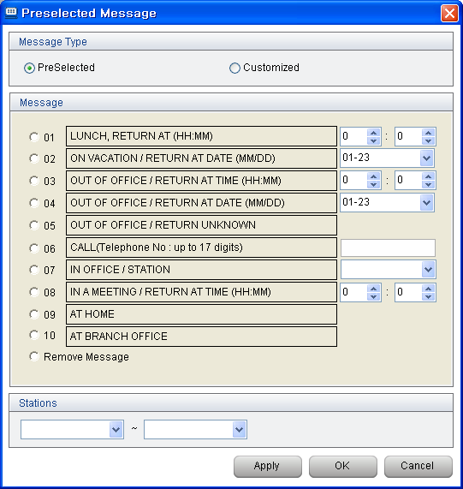

Procedure
- "Menu" → "Tools" → "Select Message Type". | or ALT+T M
- Select Preselected or Customised. (‘Preselected message with VSF Group’ is not supported for customised type)
- Select a message or Remove Message.
- Set the station range in the station input fields.
- Click the "Apply" button or "OK" button.
- If Remove Message is set, and applied, the current message will be disabled.

Note
- In order to change the message in the Customised, choose the Customized, and press the Setting button as below.
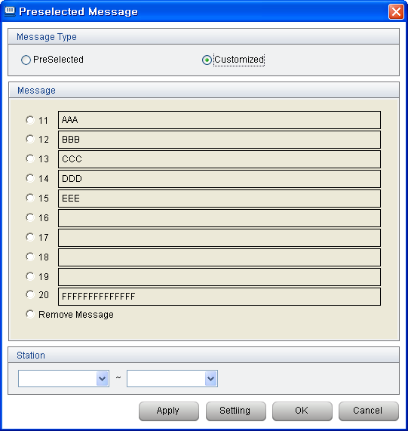

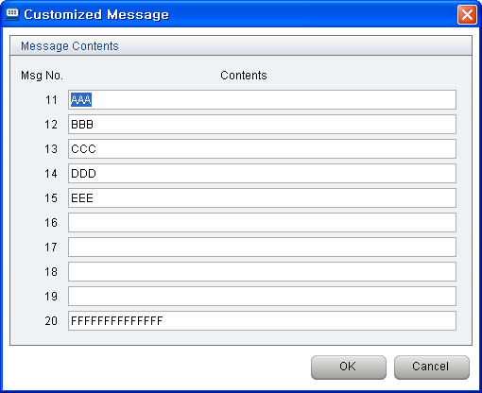

Paging
Description
The LG-Ericsson iPECS-LIK system can perform various "Paging" functions to stations as well as to external paging solutions. The paging options within the selection window are defined within the iPECS system.

Window

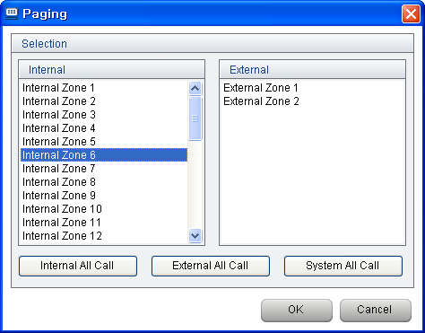

Procedure
- "Menu" → "Tools" → "Paging". | or ALT+T G
- Select the appropriate paging option in the paging selection window.
- The IP ATTENDANT operator presses the speaker button  to make the page call.

Notice
- In order to do paging, the operator's telephone must be permitted to do paging.
- iPECS-LIK only supports one type of speaker mode for paging.

Music Selection
Description
Background music can be selected for use by the iPECS-LIK.

Window

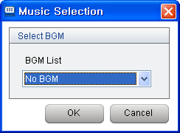
Procedure
- "Menu" → "Tools" → "Background Music". | or ALT+T U
- Select the one of background music options and then click the "OK" button.
- To disable the background music, select the No BGM and then click the "OK" button.

Note
- Individual iPECS Stations may select their own BGM source

Date/Time
Description
IP-ATD can control the iPECS system Date and time.

Window

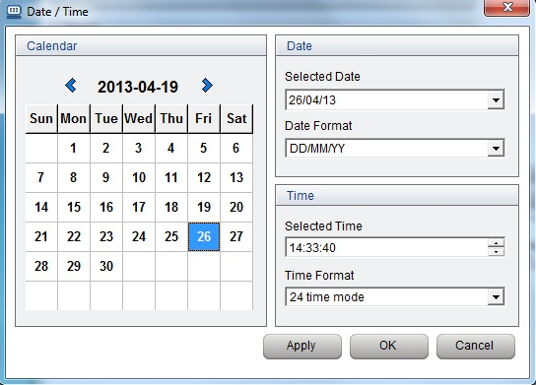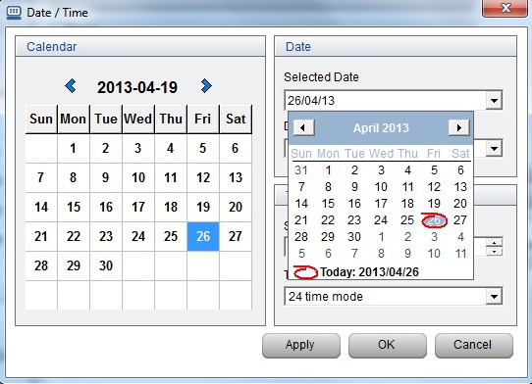

Procedure
- "Menu" → "Tools" → "Date/Time". | or ALT+T D
- Select the display type of date and time.
- Change date and time and then click the "OK" button.

Note
- The display type of time shown in all telephone LCDs will be changed.
- The date may be changed without changing the time, and vice versa.

SMS
Description
The SMS function sends SMS messages to other iPECS Stations.

Window

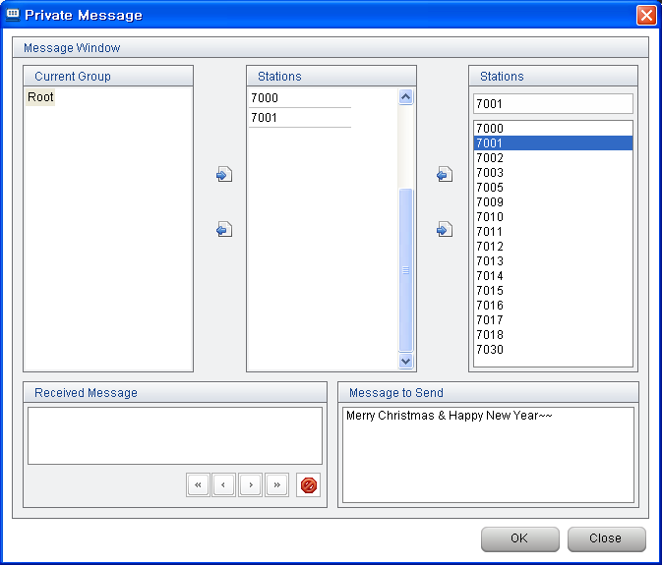

Procedure
- "Menu" → "Tools" → "SMS". | or ALT+T S
- Select the destination station that will receive SMS and input the message, and then click the "Send" button.
- Once messages are received from the other stations, they will be displayed in "Message Receive" on the bottom left of the window.
- Messages can be moved using the direction button <, > and deleted by clicking the "Del" button.

Note

- Receiving stations require a LCD to display the message. Analogue Stations must support FSK CLID to show messages.

Conference
Description
When iPECS has the use of a MCIM module, it supports Multiparty conferencing solutions.
IP Attendant is designed to efficiently manage the status of iPECS conference feature – Add On Conference, Conference Room, Conference Group.

Window
- Add On Conference
- Confernece Room
- Conference Group

Procedure
- About Conference Procedure, refer to the chapter 3.6 Conference.

Note

Monitoring Window
Description
When User want to see Station Info or CO Line Info with more large size window, this menu is available.
This menu is chosen, separate Monitoring Window is newly opened, this monitoring window information is synchronized with Main window’s Station Info or CO Line Info.
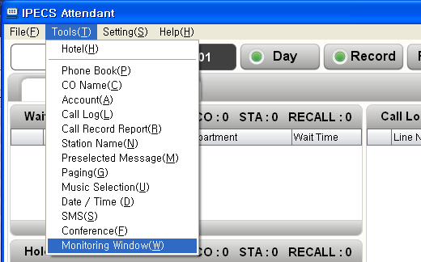

Window
- Monitoring Window
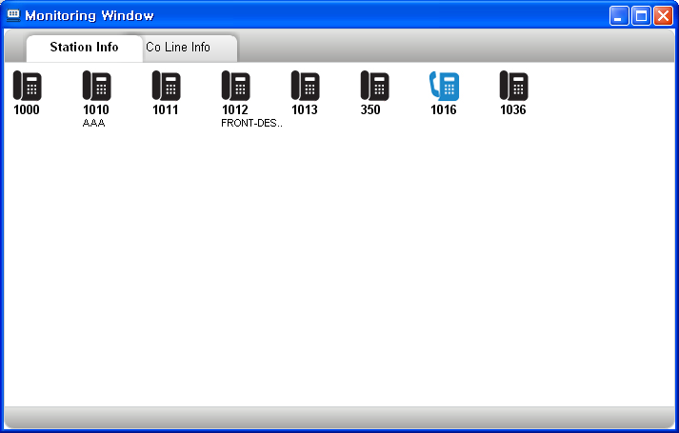

Procedure

Note

Setting Menu

Custom Setting [Environment Setting]
Description
This is for custom setting for program operation.

Window & Procedure
- "Menu" → "Setting" → "Custom Setting". | or ALT+S C
- In the "System Connection", system information such as "PBX Type", "System IP", "Connection Mode", "PBX ID" and "PBX PW" is configured.
If IP Bridge is checked at Use, Linked Pair is used as IP Bridge feature with Hard Phone.
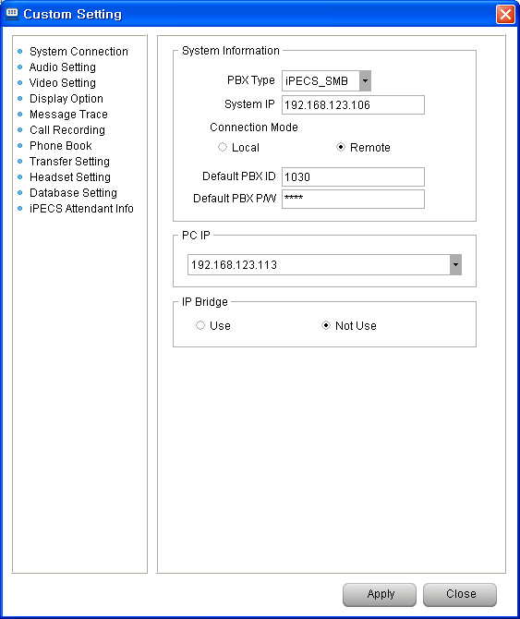

- In the "Audio Setting", settings for microphone & speaker can be done and bells for station incoming & PBX incoming can be set.
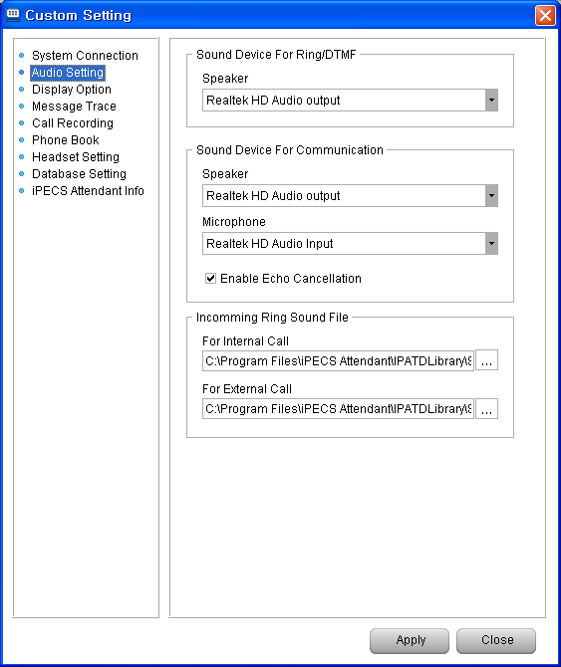
- In the "Video Setting", Video Frame Rate can be set.
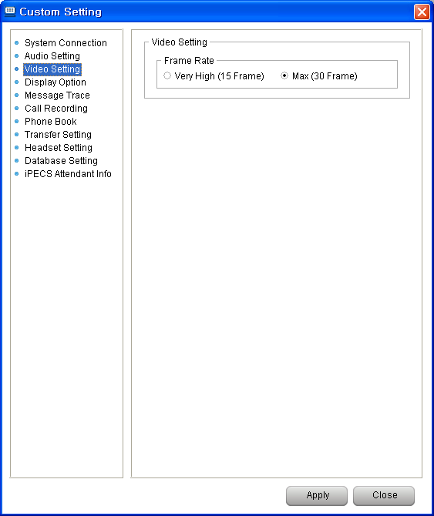
- In the "Display Option", the size of monitoring group display icon can be set by Station Type & the position of window at the time when the program is operated can be set by Window Position & Program language (Language Select) can be set by Language Select. Font Size can be set.
Call Popup window display option can be set.
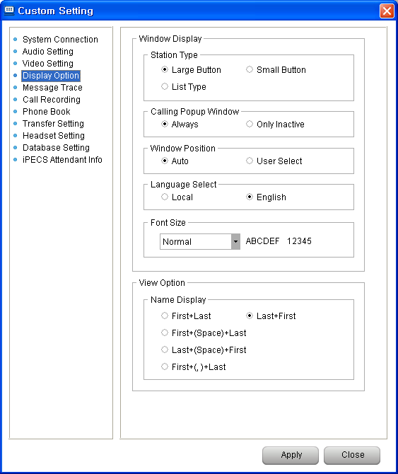

- In the “Message Trace”, the history of communication with the PBX can be saved as either "Detail" or "Summary".
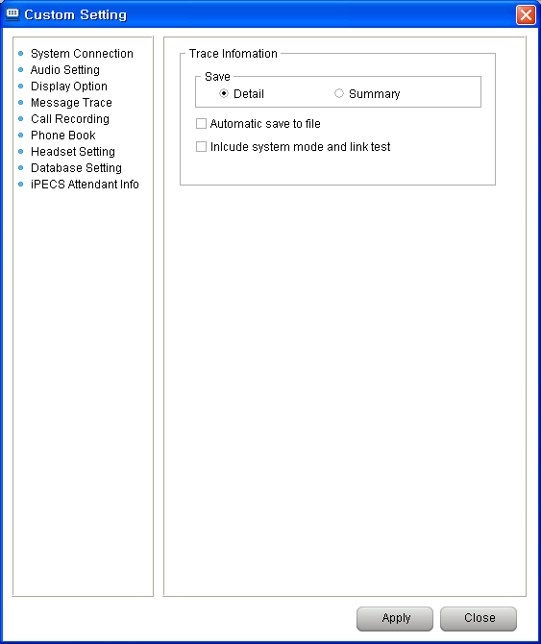

- In the “Call Recording”, recording file location can be set.
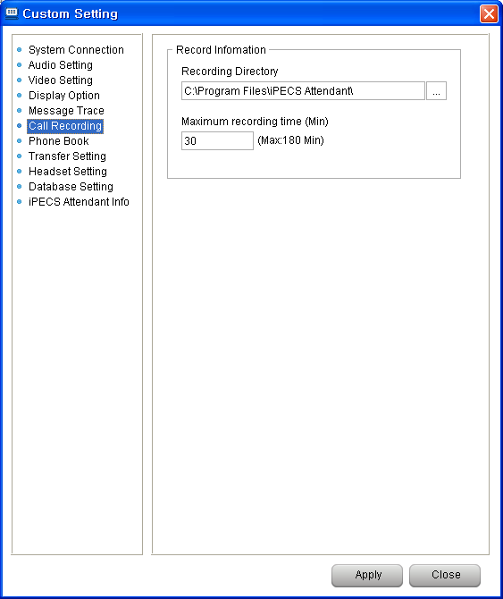

- In the “Phone Book”, phone book type can be set between Database and Outlook.
If the Outlook is chosen, Outlook information is applied to IP Attendant Phone Book.
If Synchronize Phonebook is checked, when user modify some information from IP Attendant, this modification is applied to Outlook.
If LDAP option is set, LDAP information can be used in IP Attendant as below.
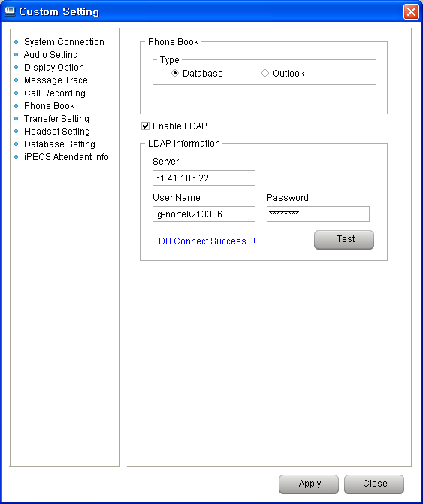

After enable LDAP, LDAP button is activated in main window as below.
This is LDAP information window.

- In the "Transfer Setting", Transfer option can be chosen.
In the Phonebook, there are 4 type number – Station, Mobile, Company, House.
This priority is applied to below cases.
    - To call to phonebook number, Drag & Drop from Phonebook to Dialpad.
    - To transfer to phonebook number, Double Click a each phonebook record.

On calling with another, IP Attendant user double click a station icon, this call is transferred to the station, if Double Click Transfer is checked.
If this option is not checked, previous call is end, new call is established.

- In the "Headset Setting", Headset type can be chosen.
If Headset type is not normal(Jabra or Plantronics), each driver file should be installed ahead.
The driver file location is C:\Program Files\iPECS Attendant\Drivers.

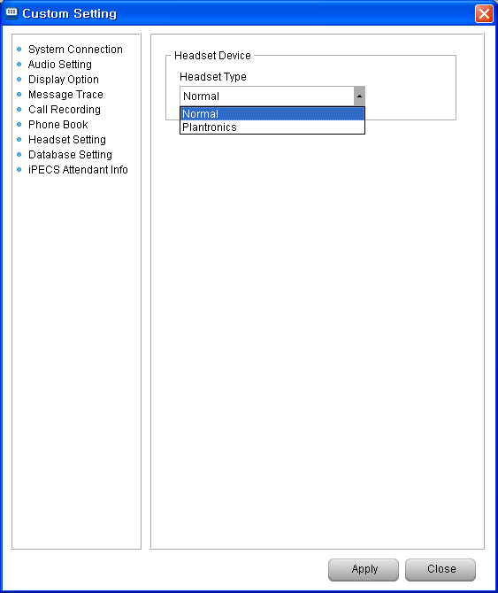

In some PC(newer than Windows 7 – it is different with PC user setting), Jabra or Plantronics headset is not recognized correctly. In this case, [Control Panel – User Accounts – Change User Account Control Settings] the value is set to [Never notify], and the iPECS Attendant S/W should be restarted again.

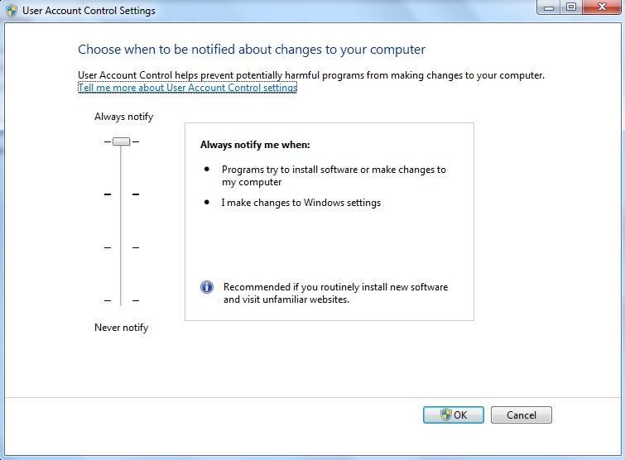

- In the "Database Setting", DB operation mode can be set.
IP Attendant default DB is Firebird.
DB connection mode is two type – Local / Remote.
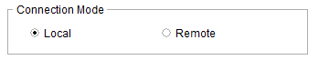
  - Local Mode.
    - If DB connection is set to Local, Firebird DB is chosen by default.
    - Firebird is installed automatically, when IP Attendant is installed.
  - Remote Mode.
    - DB type is Firebird.
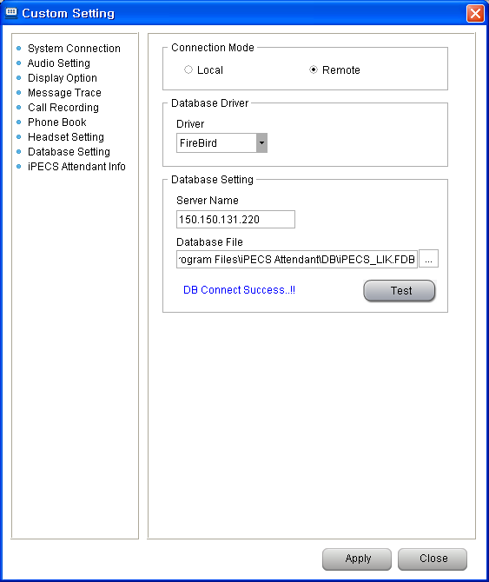
In case of "Remote" as the server,
Server name can be set IP address of the PC that is installed another IP Attendant.
Database file is the location of another PC’s IP Attendant Firebird Database - C:\Program Files\iPECS Attendant\DB\iPECS_LIK.FDB.

    - DB type is another(MySQL, Oracle, MS-SQL).
Database IP address, Database Name, User Name, User Password should be entered.
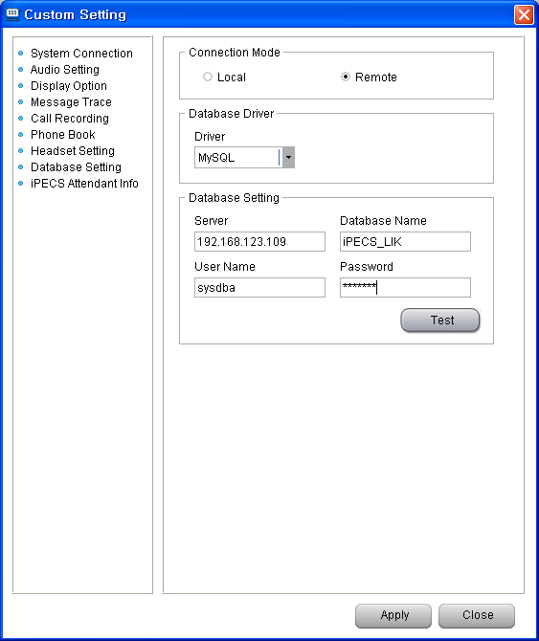
- In the "iPECS Attendant Info", Program information / System version is displayed.

Notice
- In case of using devices such as USB speaker & microphone (headset), these devices must be installed prior to program start.
- Bear in mind that if "Include system mode and link test" in Message Trace, program speed will be down and the size of log file will be bigger.
- After "Database Setting", connection test by using the "Test" button is strongly recommended.
- When modifying custom setting fields, It’s recommended the IP Attendant be restarted.
Note
Some settings such as language selection and PBX information are applied, once the program is restarted.

Flex Button Setting
Description
The IP Attendant may edit the functions of its own Flex buttons as well as those of other Stations.

Window
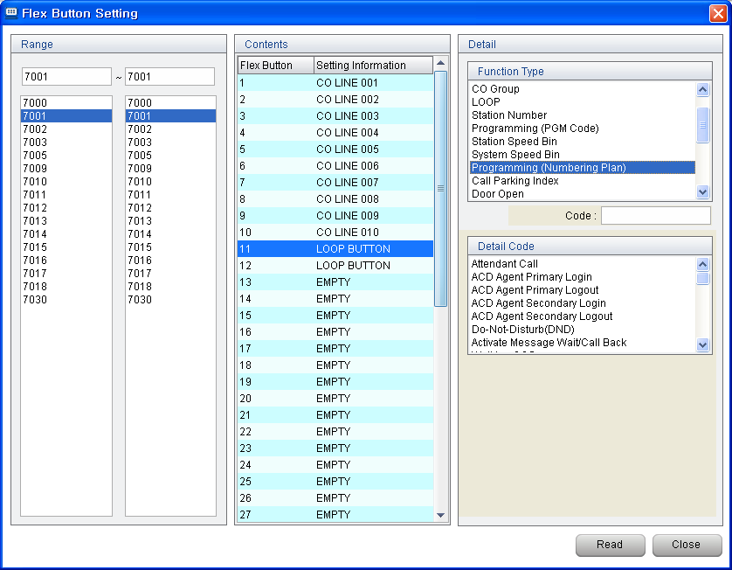

Procedure
IP-ATD Flex Key Registration by using the Dial Pad
- Click the "PGM" button. 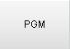
- Click the "Flex" button that needs to be registered. 
- Dial the station number that needs to be set at the "Flex" button.
- Click the  button, The new assignment for the IP ATTENDANT flex button is saved and automatically labelled
- The label may be edited by right clicking the flex key and editing the label name directly.
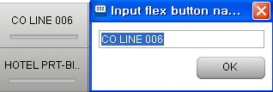

Registration by using Flex button setting menu
- "Tools" → "Setting" → "Flex button setting". | or ALT+S F
- Set the range of the stations to be edited.
- Display the existing flex button programming by executing the ‘Read’ button.
- Select the flex key to be changed and select the relevant function. After that, input the necessary value and then click the "Save" button.

Note
- If another button is selected without applying the "Save" button after the setting change, the changes will not be applied.

Wakeup Setting
Description
This feature creates a wakeup call at the specified time.

Window

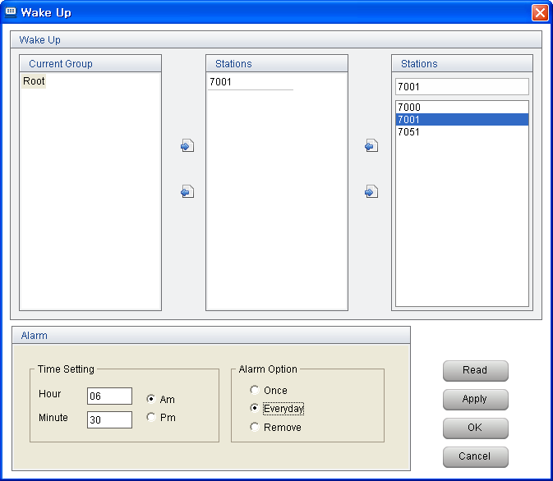

Procedure
Old Wake Up Setting
- "Tools" → "Setting" → "Wake Up Setting". | or ALT+S W
- Select the station that needs to be set with Morning Call.
- In Time Setting, input the time in Time Setting and select the relevant option in Alarm Option.
- Click the "Apply" button.

New Wake Up Setting (5 wake up calls per station)
- "Tools" → "Setting" → "Wake Up Setting". | or ALT+S W
- Select the station that needs to be set with Morning Call.
- Select the relevant Wake Up option next to the numbers between 1 and 5
- Input date and time that are suitable for the selected option and click the "Apply" button.
- The history of Morning Call that has been set at the station can be checked by clicking the "Read" button. In case of selecting many stations, the history will be displayed with reading the first station.
- The history of Morning Call that has been set can be deleted by clicking the "Clear" button. Bear in mind that all Morning Calls set at all stations can be deleted by "Clear" button.

Note

For the New wake up settings to be applied, System Attribute “New 5 Wake Up Usage’ must be enabled.

Group Setting
Description
Stations can be managed or viewed as a group of specified stations. The group that has been added here can be easily used for SMS or Morning Call.

Window

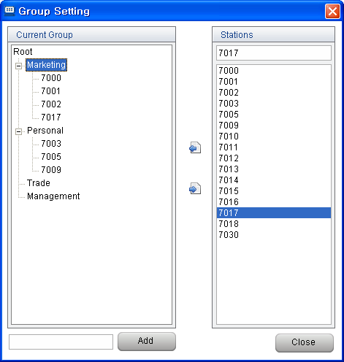

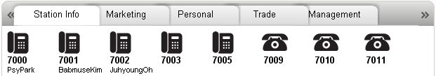

Procedure
- "Menu" → "Setting" → "Group Setting". | or ALT+S G
- To create a new group registration, click the "Add" button after inputting the group name.
- A new group will be created on the "Current Group" window.
- Select a group at the "Current Group" window, select a station or stations (use ‘Ctrl’ key to add more selected stations) at the "Stations" window, and then click the button. The new stations will be added to the group.
- If it is necessary to delete a station from a group, select the relevant group and click the button.
- To perform a group deletion, select the relevant group and click the right button of the mouse, and then click the "Delete". Another way of deletion is to click the button.

Code Setting
Description
The code setting is applied number handling for CO Access or for applying various CO Dialing rules from IP Attendant.
This is useful when users dial from Phonebook, LDAP.

Window

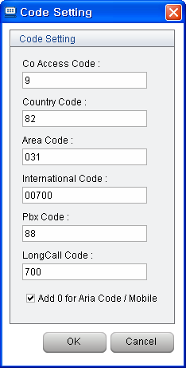

Procedure (example)

Middle Class | Small Class | Test Item | Operation – real dialing digits
 |  | No code setting | Remove +, (, ), - and only numbers dialled.
CO Access(9) |  | Less than 7 digits  - ex) 85468 | No attached CO access code.  - ex) 85468
CO Access(9) |  | More than 7 digits  - ex) 8054687 | CO Access Code is attached.  - ex) 98054687
CO Access(9) + Country (82) | Country code included | +82-031-2005-2510 | 903120052510 ( remove country code)
CO Access(9) + Country (82) | Not same country code | +1-949-336-6800 | 919493366800 ( if country code is different, it is not removed)
CO Access(9) + Country(82) + Area (031) | Country code included  &  Area code included | +82-031-2005-2510 | 920052510
CO Access(9) + Country(82) + Area (031) | Country code included  &  Area code included | 82 031)450-4800 | 94504800
CO Access(9) + Country(82) + Area (031) | Country code included  &  Area code included | +82-31-8054-6233 | 93180546233 ( In this case, 31 is area code, but Not same as 031, so it can not be deleted)
CO Access(9) + Country(82) + Area (031) | Country Code included  &  Not same area code | +82-02-2155-4393 | 90221554393
CO Access(9) + Country(82) + Area (031) | Not same country code  &  Not same area code | +1-949-336-6800 | 919493366800 ( If different country code, do not remove country code, area code)
CO Access(9) + Country(82) + Area (031) | Not same country code  &  Area code included | +1-031-336-6800 | 910313366800(If different country code, do not remove country code, area code, although same area code)
CO Access(9) + Country(82) + Area(031)  + International (00700) | Country Code included | +82-031-2005-2510 | 920052510 (international code is not added, because country code is same)
 | Not same country code | +1-949-336-6800 | 90070019493366800 (After CO access code, international code is inserted, because country code is different)
CO Access(9) + Country(82) + Area(031)  + PBX (8000) | Less than 7 digits | 805468 | 805468 (regarded as ICM call)
CO Access(9) + Country(82) + Area(031)  + PBX (8000) | More than 7 digits | 01071020830 | 9800001071020830 (After CO Access code, PBX code is inserted)
CO Access(9) + Country(82) + Area(031)  + PBX (8000) | More than 7 digits | 031)450-4444 | 980004504444 (Area code is removed. After CO Access code, PBX code is inserted)
CO Access(9) + Country(82) + Area(031)  + PBX (8000) | More than 7 digits | +82-031-8054-6078 | 9800080546078
CO Access(9) + Country(82) + Area(031)  + PBX (8000) | More than 7 digits | +1-949-336-6800 | 9800019493366800
CO Access(9) + Country(82) + Area(031)  + Long Call (7000) | Same Area code | +82-031-8054-6078 | 980546078 (Do NOT add Long Call code)
CO Access(9) + Country(82) + Area(031)  + Long Call (7000) | Different Area code | +82-02-2155-4393 | 970000221554393 (Remove country code. After CO Access code, Long Call code is inserted in front of Area code)
CO Access(9) + Country(82) + Area(031)  + Long Call (7000) | Different Country Code | +1-949-336-6800 | 9170009493366800 (Do NOT remove country code, Long Call code is inserted in front of Area code)
CO Access(9) + Country(82) + Area(031)  +International (00700)  + PBX(8000)  +Longcall(7000) | Same Area code | +82-031-8054-6078 | 9800080546078 (No international code, No Long Call code)
 | Different Area code | +82-02-2155-4393 | 9800070000221554393 (CO Access + PBX + Long Call + different Area code + ……)
 | Different Country Code | +1-949-336-6800 | 9800000700170009493366800 (CO Access + PBX + International + different country code + Long call code + …..)
CO Access(9) + Country(82) + Area(031) +  Add 0 for Area code / Mobile |  | +82-31-8054-6233 | 980546233 (31 regarded as 031, so 82 is removed, 31 also removed)
 |  | +82-2-2155-4393 | 90221554393 (Add 0 for Area code, because this is not international call)
 |  | +1-949-336-6800 | 919493366800 (NOT add 0 for Area code, because this is international call)

Note
- CO call should be more than 7 digits.
- International Code is attached to next CO Access Code.
- PBX Code is used when real outside line is connected another upper PBX.
- Long Call Code is used when Long distance call. This code is attached in front of Area Code.
- When the number is not international type, if area code or mobile number is not started with 0, then 0 is inserted automatically.

Speed Dial
Description
System Speed Dials are designed to manage numbers that are in frequent use.

Window

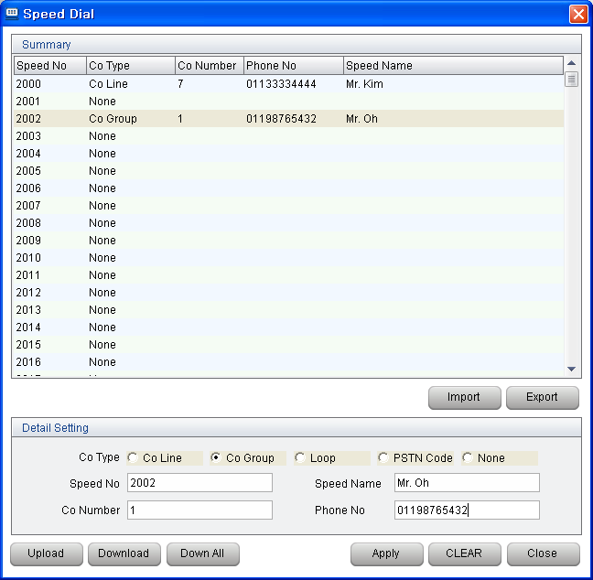

Procedure
- "Menu" → "Setting" → "Speed Dial Setting". | or ALT+S S
- Select the speed dial that needs to be set.
- To check the iPECS setting for a given speed dial, select the speed dial & click the "Download" button.
- On editing a speed dial, click the "Apply" button to save the data (it must still be uploaded).
- When editing a speed dial, set the trunk type as well as the other relevant information.
- Click the "Upload" button to apply the changed information into iPECS’s database.
- If it is necessary to download all speed dials that have been saved in PBX, click the "Down All" button. This function can use a lot of system resources, so downloading of all speed dials can take a long time. Therefore, this should be done at the time when the other operators do not use the program. Also during a database download, the downloading or uploading speed dials cannot be performed.

Note
In case of uploading or downloading a lot of speed dials, press the “Ctrl" key and click the speed dials that need to be uploaded or downloaded. Another way is to press the “Shift" key and click the "↑" button or "↓" button. After that, click the "Upload" button or "Download" button.

PhoneBook Setting
Description
In IP Attendant Main wondow, Phonebook item is configured with Phonebook Setting value.
If the column is set as empty, the item will be removed.

Window

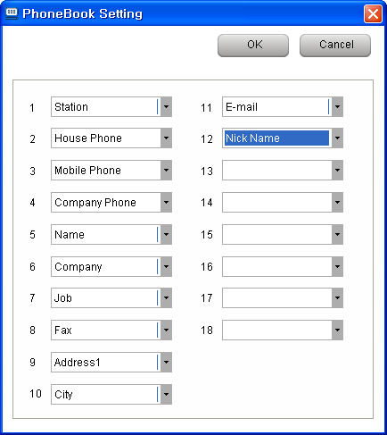

Procedure
- "Menu" → "Setting" → "Phonebook Setting".

Note

Function Key Setting
Description
Keyboard Function key (F1 – F12) can be used as below Flexible Key program table.
F1 to F12 key can be matched 9 Fixed key(From TRANS key to SPEED), and 24 Flexible key.

Window

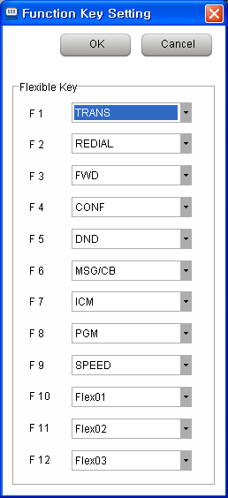

Procedure
- "Menu" → "Setting" → "Function Key Setting".

Note

IP Attendant Main Window

Logout
Description
For IP Attendant logout.

Window



Procedure
- Click the "Logout" button in the main window.
- Once IP ATTENDANT is logged Out, the Log In window will be offered.

Wait/Hold Window
Description
This window displays information for incoming, queued and held calls to the IP ATTENDANT.

Window

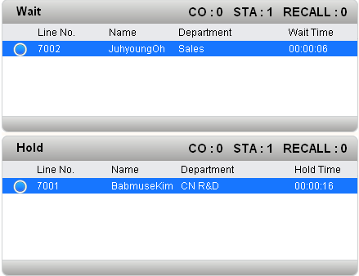

Procedure
- In the "Wait" window, the incoming call information such as TRUNK, Station and Recall is displayed.
- In case a call come in, clicks the button or hit the “Space Bar” on the keyboard for call response. In case of using the mouse, double click the displayed incoming information for call connection
- The information of holding calls during phone call will be displayed in the Hold window.
- If it is necessary to make a phone call with a station in the wait/hold list, double click the relevant station when the status is "on hook".
- By using Drag & Drop action, waiting call or holding call transfer is allowed to another station.

Notice
The display order in the Wait/Hold window is basically determined according to incoming order or order of pressing the "Hold" button, however, in case priority has been assigned in the phone book, top priority will be displayed on the top.

Note
The number of queuing calls are displayed (after being summarized) on the top right of the Wait window. The number of station calls is summarized to be displayed like "STA:” the number of trunk calls is summarized to be displayed like "CO:” the number of recalls is summarized to be displayed like "RECALL:” However, the recalls from stations is added in the number of STA calls (not in the number of RECALLs).

Monitoring Window
Description
The Monitoring window shows the real-time status of iPECS stations and trunks (lines). The default views are Station Info (all registered stations) and CO Line Info (all registered Lines). Other views are added as New Groups are created (ALT+S G).
To see more large window for Monitoring Window, Tools → Monitoring Window, separate monitoring window is opened. This separate window is synchronized with Main Window’s monitoring window.

Window

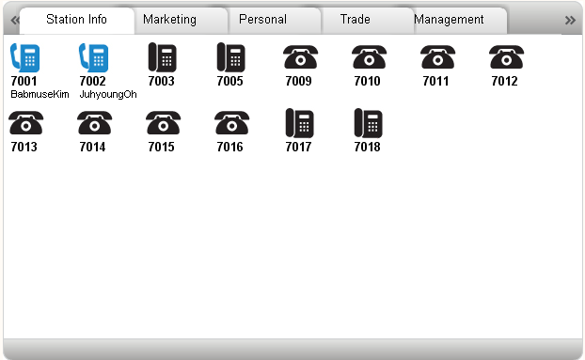

Procedure
- A call to a station can be made by Double click the icon or Drag & Drop to the Dial Pad during the "IDLE" status.
- If the relevant station number has been registered in the Phone Book, it will be displayed as the registered name.
- The Station Info screen can be displayed several views: large icon, small icon, or list. To set a different view, right click on any station and select.
- The Station info screen can also be sorted in two ways – either by system port (basic sort) or by logical station number (Number sort). Again just right click a station and select.
- The window view has a short cut to the two default groups.
When viewing any group, right clicking any of the window’s group titles will offer CO Line Info and Station Info view.

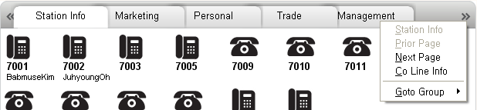

- If the windows view option is list view as below, alignment is allowed by clicking of each list name.
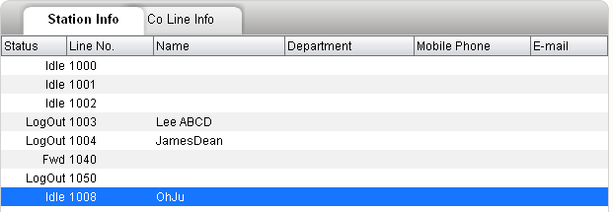

Note
- Any changed information of monitoring group is displayed as soon as the changes are saved.
- Status Icon (The below icons are for status display. There are no additional icons).
- The network station status is 2 kinds – Idle / Busy.
- When new network station is added to phonebook, all network station icon is refreshed to idle.
- If a station is registered to the system, after that, it goes to not available state, then indicated to the Out Of Service.
- In UCP system, UCS Station type is supported. UCS IM Presence is indicated In left side bar of the icons.



BUSY IDLE CFWD


DND PRESECECT Out Of SVC



Network



IDLE BUSY DND CFWD Out Of SVC Preselected
UCS Station with Presence

Online Offline Away Busy DND
(Be Right Back,
Out Of Office,
In a Meeting)

IM Presence

Station icons:
 ➔ IP (IPLKTS, SIP, WIT-400H, iPECS Cmmunicator) Stations
➔ SLT (Analogue) Phones
➔ Cordless Phone (eg DECT phone)
➔ Networked Station
➔ UCS Station

Co-line icons:
Idle Busy Disable

Dial Pad Window
Description
In this Dial Pad window, "connection", "answer", "holding", "conference", "redial" and "Mute" can be done and this window displays subscribers' numbers, date and time.

Window

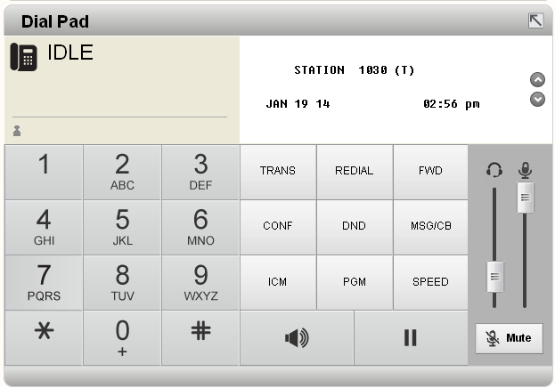

Procedure
- The way of using the dial pad is same as the way of using the station dial pad.
- Because the PC Keyboard can be used for dialling, the IP ATTENDANT dial function can operate in more than one way:
  - When IP ATTENDANT is focused in the foreground, you can dial the number at the PC keyboard (it appears in the Dial Pad screen – as above), and press “Enter” key to ‘go off hook’ and send the ‘pre-dialed’ digits.
  - A mouse can select the digits at the IP ATTENDANT keypad – the IP ATTENDANT ‘goes off hook’ and sends the digits as they are dialed.
- Receiving calls are possible (When the IP ATTENDANT window is focused in the foreground) by clicking the "Enter" key or hitting the space bar while the bell is ringing.
- In order to hang up (When the IP ATTENDANT window is focused in the foreground), click the "ESC" button or press “Space Bar”.
- In order to adjust the received volume during a call, use the slide button below the headset icon.
- By using button, Dial Pad and Fixed Button Pad can be hidden.
- When dial a digit, DTMF Tone is generated.

Note
- Adjusting the volume cannot be done at IDLE status.
- Microphone volume above the "Mute" button & next to headset icon can be only display the current volume status (cannot be adjusted – it is a function of the PC Operating system).
- IP Attendant LCD is 24 line. When the IP Attendant name is set more than 12 character, LCD overflow to next line might be happened.

Alarm Display LED
Description
This is for displaying the status of connection between iPECS-LIK & PBX and alarm.

Window



Note
- In case of emergency calling or system warning(ex : Interface between LIK system and IP Attendant is disconnected, PRIB board goes to Line Out), the red light on the left LED(IF LED) will go on.
- Right LED(DB LED) displays the status of database connection.
- In case there is a request to restart the program or exit the program, the red light on the left and the green light on the right will flash in turn.

Windows Location
Description
In IP Attendant Main Window, each daughter windows size and position can be managed as below example by drag & drop of each windows.
This chaged windows location and size can be saved by each log in users, if Setting → Custom Setting → Display option → Window position → User Select.

Window

- Normal Window.
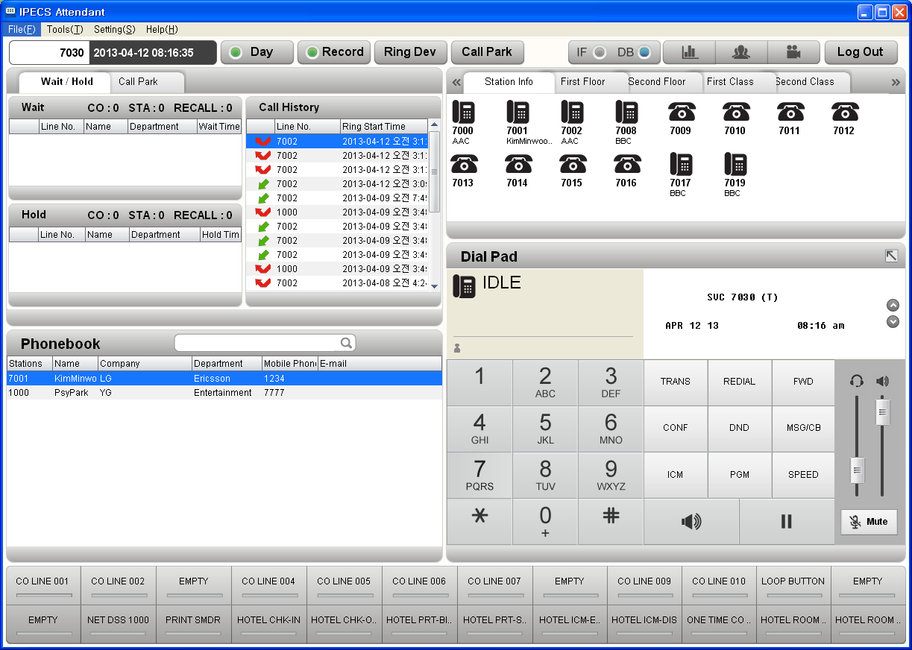

- Window switching Phonebook window and Station Info window.
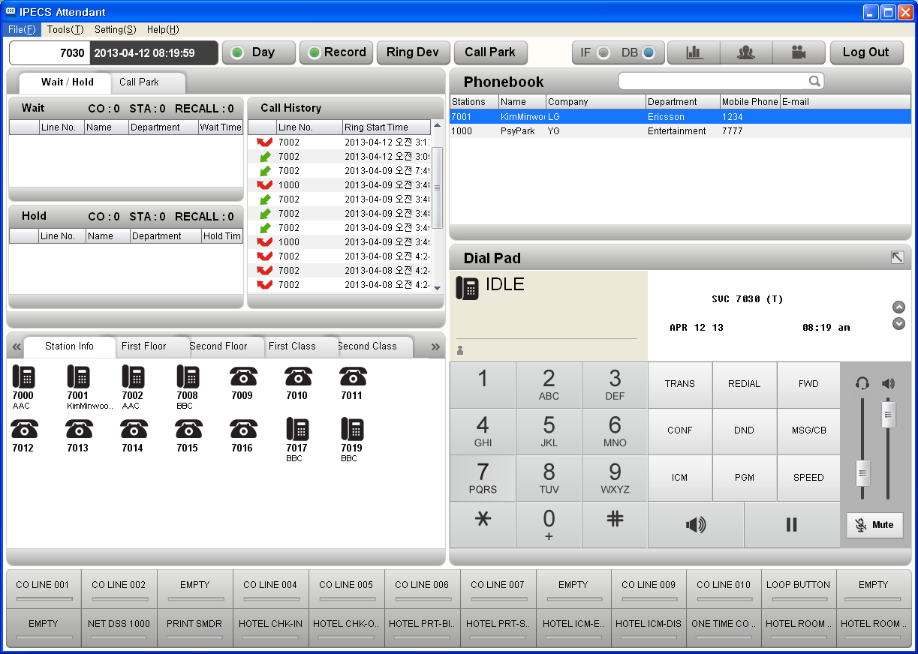

- Window switching Hold/Wait window and Station Info window.
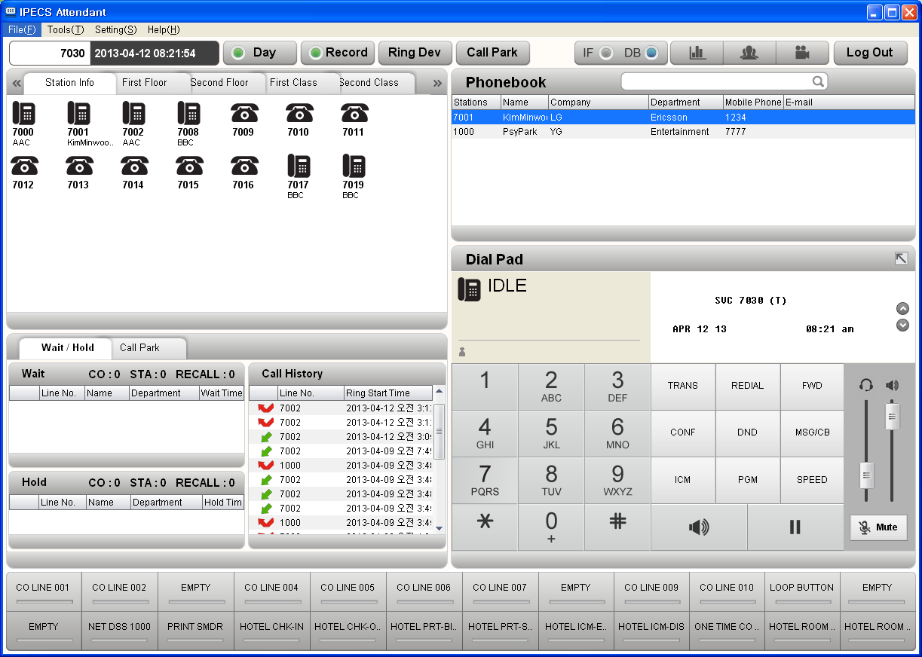

- User can use Station Info window more widely as below.
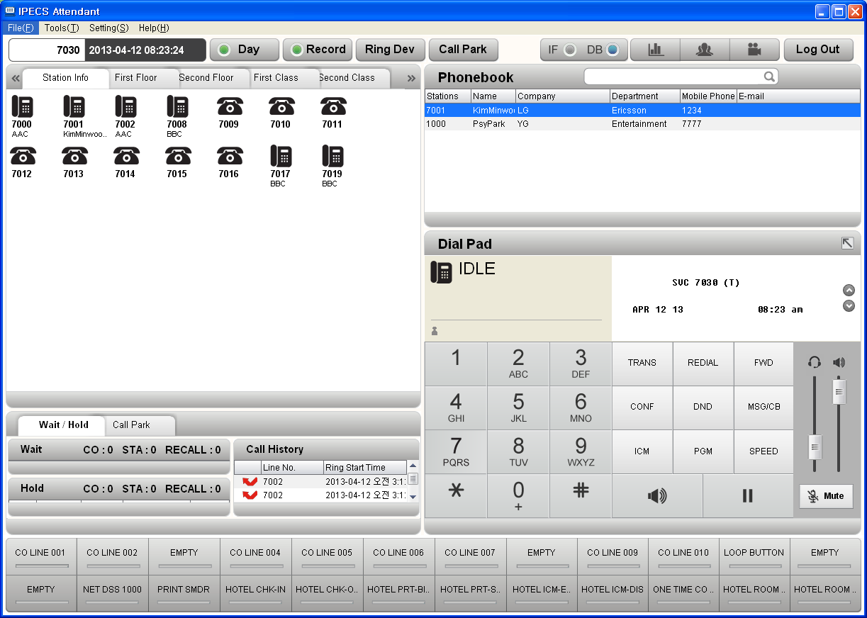

Note
- Dialpad Window size and position is fixed.
- Dragging & Dropping each windows is possable as below ways.


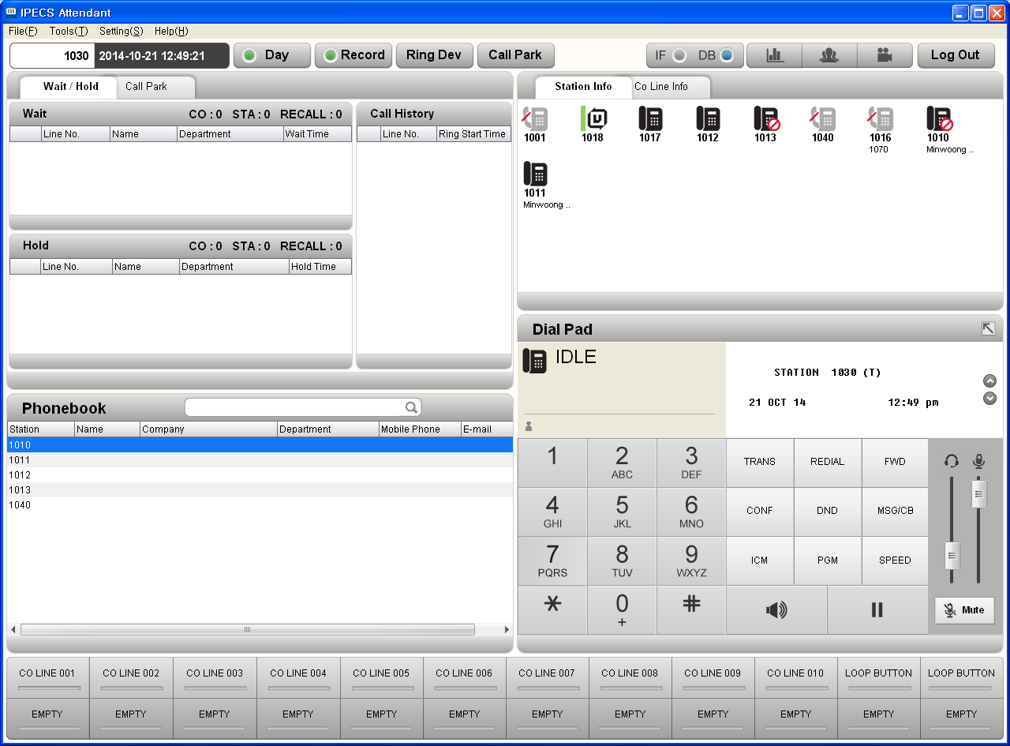

Installer’s Section

IP ATTENDANT. Program Installation
Description
The initial program installation shall take the following steps

Procedure
- Select the iPECS_Setup.exe file and then execute it.
- Windows 7 or more PC, execute it [Run as administrator by pressing mouse right button].
- Install the program by following the install wizard (no options are required)
- User can choose Office version or Hotel Version.
- Hotel Version have PMS application together.
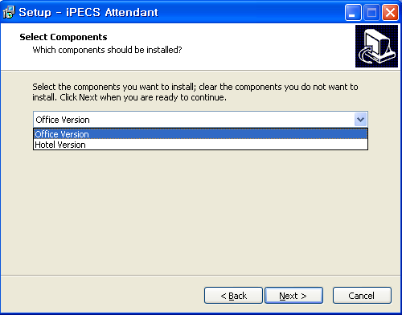
- Once IP ATTENDANT installs, the installer will automatically proceed with the installation of WinPCap 4.1.1 and FireBird 2.1 (if WinPCap is already installed chose the appropriate action when requested)
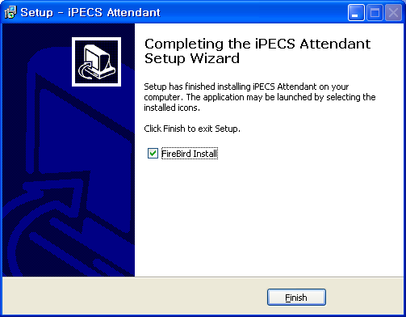
- Once installation procedure is completed, operate the program by selecting the icon (iPECS-Attendant) from the start menu.

Notice
- If WinPCap program is not installed, IP ATTENDANT cannot communicate with iPECS.
- If “FireBird 2.1” is not installed, the program cannot operate normally because program data cannot be managed properly.
- You may need to locate the iPECS_Launcher.exe in Programs folder, if it is not added to the start menu (you can ‘pin it to Start menu’ from here (via right click context menu) if you wish.
- WinPCap version 4.1.1 is highly recommnaded for IP Attendant. Sometimes, different WinPCap version cause log in problem.
- In C:\Program Files\iPECS Attendant\Drivers, related installation file is saved.
- If Windows theme is set as Windows Classic, then the IP Attendant display may not be correct.

IP Attendant Login

iPECS-SMB Setting

IP Attendant is a full Softphone application with special Attendant functions available

At PGM 443, apply User ID and Password for IP Attendant. (You should delete any prior softphone assignments for the ATD, if connecting IP-ATD as linked pair)
Check the Desired Number is the Station number of an Attendant at PGM 164.
If the IP-ATD is not yet set up and is to be a Stand Alone IP-ATD (not linked pair), ensure the desired number is the next available STN number – set that number as an Attendant.

An IP Attendant license (or the 90 day demo code) must be enabled at iPECS in order to connect IP Attendant

Note: ‘EZ PWD Login’ (Station Attributes) must be disabled for the connecting ATD station (prior to E.5Gz and E.6Cc iPECS SW)

Program Basic Setting

Description
Set the basic information to operate the program.
IP ATTENDANT program supports multiple users by the use of multiple ID settings within

Procedure
1st start up connection

- Check the iPECS for an IP ATTENDANT license. If iPECS has not got a license for IP Attendant, enter it now, or use the 90 day demo code.
- Open IP Attendant & follow the button from the Login Screen, to access the Custom Settings screen

- At the Custom Settings screen input IP Address and mode.

- At iPECS Admin, ensure the Attendant station has a User ID and password, by setting the ‘desired number’ to the Attendant station number. Save the data.

- PBX ID and PBX Pwd are iPECS PGM 443 ID & Password (above) for the Attendant Phone.

- If the disried number in PGM 443 is assigned to Linked Pair, IP Brigde feature can be set.

- Apply the correct Adapter for the IP Attendant PC, then use Apply to save the settings.

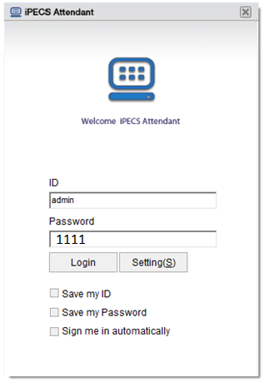
- Back at the IP Attendant Login screen, apply the temporary ID and Password of admin / 1111

Select Login

- The application begins to initialize:

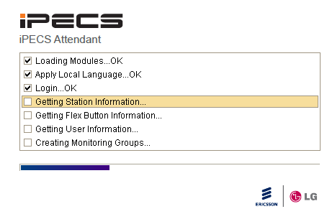

- Once ‘Login..UCTI Fail’ shows, you can click the close button or wait – in a few seconds the initialize screen will close and the IP Attendant Main Screen will open – with a limited desktop available.
Note 1: this ‘admin’ access has a forced logout at about 1 minute after opening!
Note 2: accessing IP ATTENDANT using the ‘admin/1111’ account will not allow full operation of the IP ATTENDANT.
Note 3: ‘Login..DB Fail’ will not allow access to the IP ATTENDANT main screen (like ‘Login..UCTI Fail’ does.)

The Account Info screen is accessed here (via the ‘Login..UCTI Fail’ mechanism).

- Once the Main Screen opens access TOOLS > ACCOUNT:
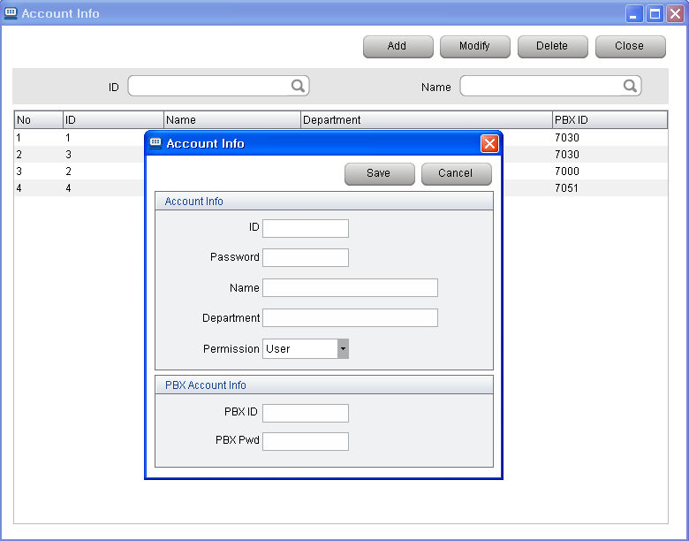

At Account Info, press the Add button to create a new IP Attendant user (the default admin user cannot be modified).

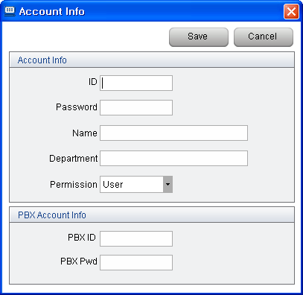

Set before the session expires! (~ 1 min.):
- Account ID (free form field)
- Account Password (free form field)
- Name and Department (not verified/not compulsory )
- Permission level (normally Supervisor)
- PBX ID: iPECS PGM 443 ID (for ATD)
- PBW Pwd: iPECS PGM 443 Password (for ATD)
- Save then Close.

(The Account ID & Password will be required to log in to IP Attendant next time)

- The ‘admin’ Main Screen will close automatically at about 1 minute forcing the application to exit.

iPECS PGM 443

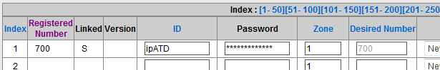

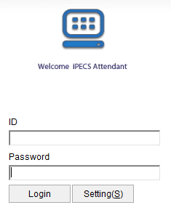

- Execute the IP Attendant program once more. Input the ID and Password for the newly created IP Attendant Account, and proceed with the login.

- Now IP Attendant should login fully and open the main Screen without restrictions.

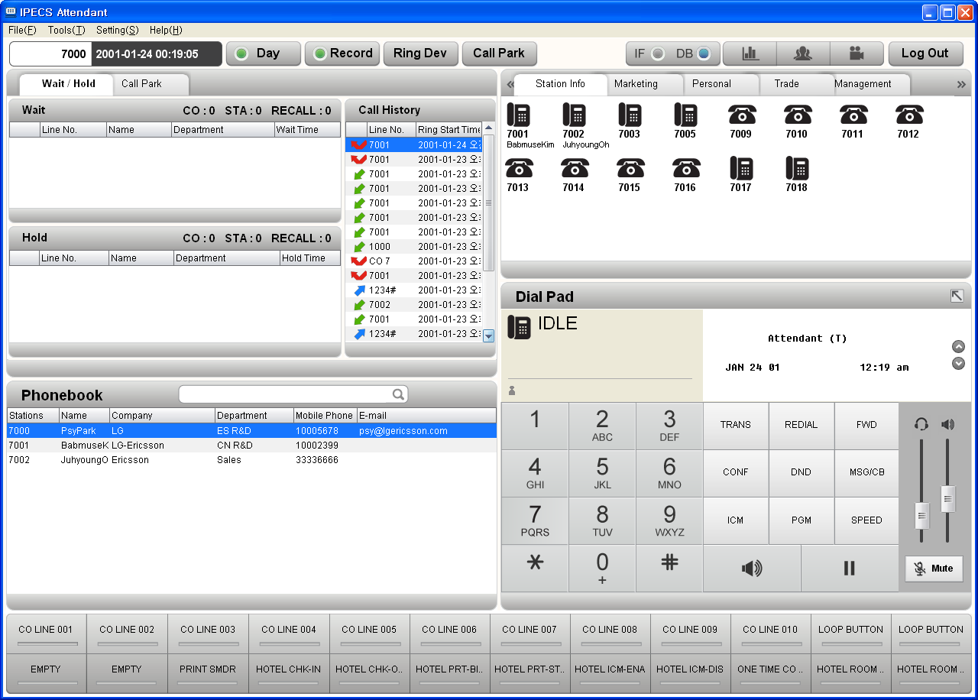

The ‘admin’ account still remains.

- The default account - ‘admin / 1111’ still remain after making new account, but this account still has restriction for almost feature.
- About default account – “admin / 1111’, refer to the 4.2.4 Account – Note(24 page).

Possible Log In Issues

If The IP Attendant Initialise window produces:
- Login..UCTI Fail → you are using the special admin access
→ The account ID and Password are OK, but the Account’s PBX ID & PBX Pswd are not correct
→ The iPECS system does not have the IP Attendant License/s required (the 90 day demo license includes IP ATTENDANT)
→ In a PC, user should not run IP Attendant, Phontage, UCS, Click Call program at the same time. Because, these application uses same UCTI driver.

- Login... DB Fail → The account credentials (User ID & Password) are not correct
- Getting Station Information .. Login Fail → Credentials are OK, but PBX ID etc are for a station that is not ATD
- Login… UCTI Video Fail → It might be caused from WinPcap version.
If you see this error message, install WinPcap.exe again.
In C:\Program Files\iPECS Attendant\Drivers, WinPcap_4_1_1.exe is
driver file.

If you get Login…DB Fail then you can try the default admin / 1111.
- If that does not work, and you can’t login, uninstall IP ATTENDANT (check – ‘delete data files?’), and reinstall, using the default ‘admin / 1111’ settings to access the program (as above).

Program Start
Description
After login, apply the system information into iPECS-LIK to operate.

Window

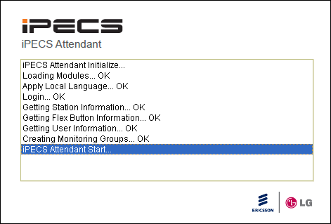

Procedure
The above window [“IP Attendant Initialize...”] will come up when the program starts. From this window, the operator is able to check the preparation for the program initialization.
Refer to the following messages:

- “Loading Modules...” means the process of uploading messages that are necessary for program operation.
- “Apply Local Language...” means the application of the relevant language (local language or English) into the program.
- “Login...” means login request with the preparation of login by the operator's information that has been saved. During this process, if “Login...db fail” is displayed, this will mean that the installation of program DB is not done normally or ID & password for log are incorrect, so make sure correct ID & password are inputted. If “Login...ucti fail” is displayed, this will mean that “WinPCap” program is not installed normally or the information of connection with PBX is not recorded normally. In this case, move to the main window by clicking the "Close" button on the top right and check if account & connection information are correct from"Tools" → "Menu", and check if the information of system connection is correct from "Setting" → "Custom Setting". If all information is correct, delete the program and install it again.
- “Getting Station information...” means that after getting station information, the process of importing the information necessary for program operation & its result will be displayed. OK means success and the others mean failure in terms of importing the information. In case the information is not imported normally, import the information again after restarting the program. In case the same problem still goes on, check the system settings because it might be confident that this problem is due to wrong settings on the system.
- “Getting Flex Button Information...” means the process of importing Flex information of the operator's station which has been set at the system.
- “Getting User Information...” means the process of importing the information that has been saved at the Phone Book.
- “Creating Monitoring Groups...” means the process of importing the information of the station that needs to be monitored.

PMS for Hotel Version

About PMS
Description
If LIK system have a valid Hotel License Copy, valid PMS IP Attendant version is installed in the PC, Hotel Menu can be activated.

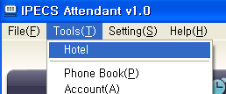

From 3.xx(C.xx) version, PMS DB should be shared with each other.
If user want to use multiple PMS per a system, IP Attendant DB setting should be set Remote except Master PMS.

In Hotel PMS, there are two Windows – Monitoring Window, Reservation Window.
When User choose Hotel, PMS Monitoring Window is shown as below.

- Monitoring Window
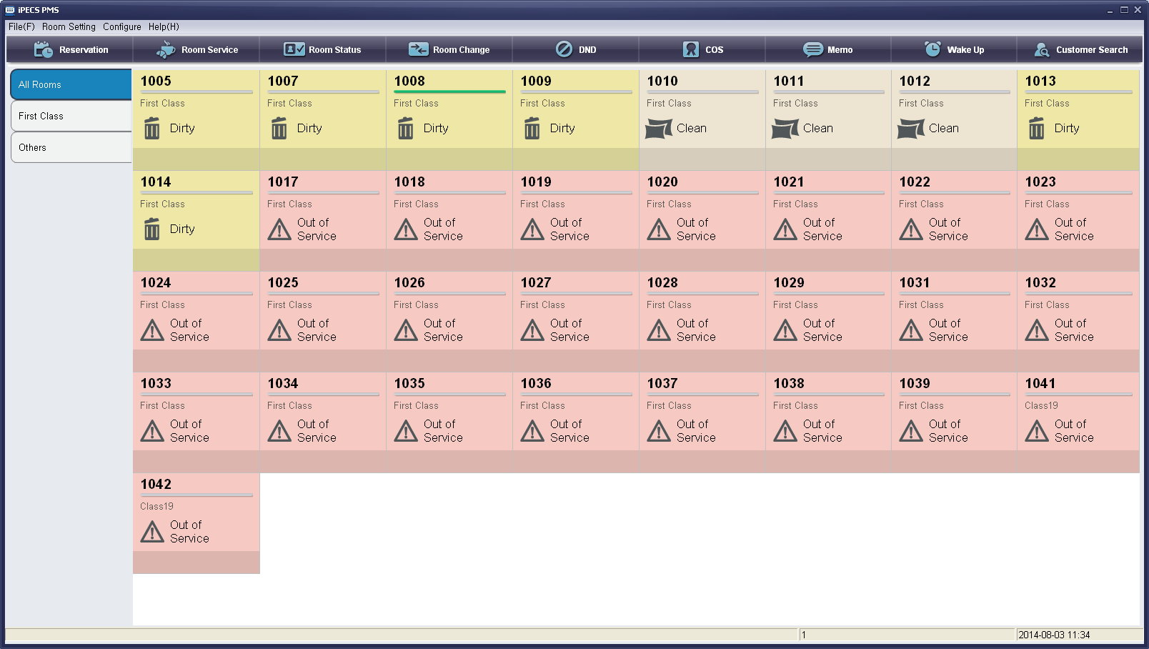
In this window, each room management for guest is allowed.
When User press Reservation button, or choose Reservation menu, below reservation window is opened.

- Reservation Window
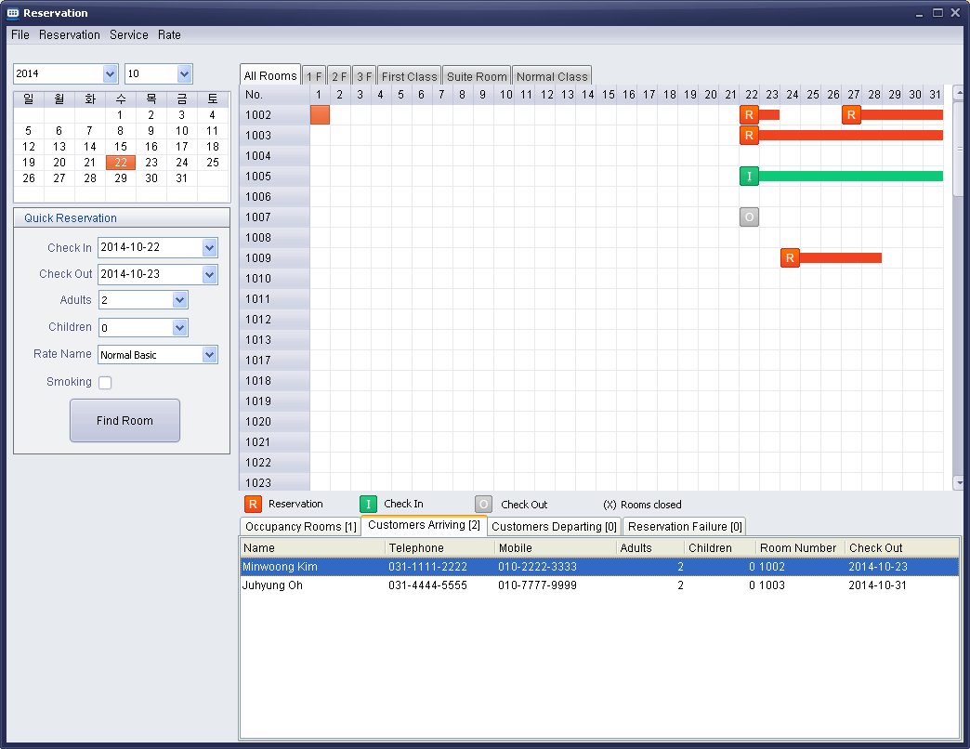
In this window, Reservation / check-in / check-out history is displayed per a month.
Room reservation / check-in / check-out and related room management for guest is allowed.

This IP Attendant PMS is suitable for small Hotel management without perchasing commercial PMS S/W.

PMS Monitoring Window
Description
Each Room information is displayed and it is changed with real time.
- Green Bar / Gray Bar indicates the room’s Check-In / Check-Out State.
Red Bar indicates the room has reservation record.
- Each room’s color and room’s icon, room status are indicated.

- By pressing right Click of Mouse with pop up menu, various room setting(Wake Up, DND, Room Status Change, ….) are allowed.
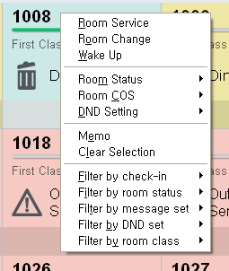
- By dividing group(ex : divide by floor, divide by guest, divide by room class), room number can be managed more efficiently.
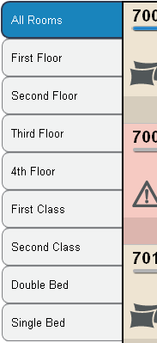

Database Syncronization with System and PMS
Description
Guest Data Information is synchronized with PBX information and PMS information.
PMS data is always synchronized on the basis of PBX data.

Procedure
- Choose “File – DB Sync”.
- DB Sync process is indicated with process bar.
- When DB Sync is end, PMS Monitoring Window is re-freshed.

Note
- DB Sync process is executed automatically when PMS program is started.
- DB Sync process is executed manually when choosing DB Sync menu.

Database Backup
Description
IP Attendant Database directory is located in C:\Program Files\iPECS Attendant\DB.
The database file is IPECS_SMB.FDB.
In multiple PMS site, for reservation feature, each PMS PC should share one PC’s DB.
To protect DB broken with unusual case, DB back up feature can be activated by automatically or manually.

Procedure
- Choose “File – DB Backup” by manually.
- The DB file is saved in pre-assigned path.
- The backup path and backup period is set in “Menu – Configure – PMS Setting – Database Backup”.
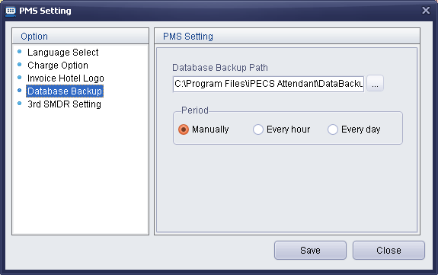

Note
- Default DB Backup path is C:\Program Files\iPECS Attendant\.

Reservation
Description
In Reservation Window, Reservation / Check-In / Check-Out is executed.
Refer to the 7.3 Reservation part to see more detail.

Window

Room Serivce
Description
Minibar services or other registered services are charged to a room.
It is only allowed in a check-in room.

Window
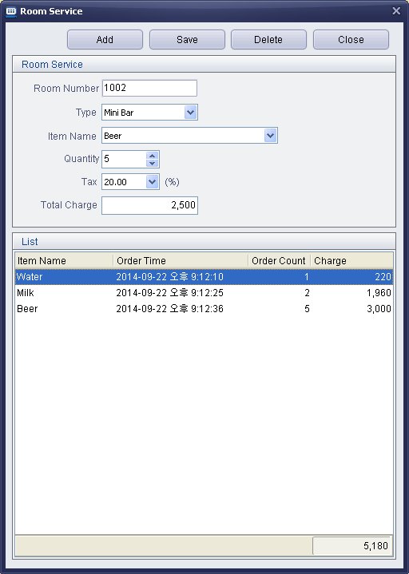
Procedure
Charge a service item to a room
- Choose a check-in room to charge a service.
- Press Room Service button.
- Choose service type.
- Choose item name in the item list.
- Choose a quantity, and tax.
- Press [Save] button, then consumption list and total cost is updated.

Delete a service item to a room.
- Choose a check-in room to charge a service.
- Press Room Service button.
- Choose a item from the consumption list.
- Press [Delete] button, then consumption list and total cost is updated.

Note

- Minibar is default type of Room Service.
- Minibar items are synchronized with PBX PGM 306 table, when DB Sync is done.
- Minibar item or other service type is configured in Reservation Window – Menu - Service.

PMS Setting
Description
Additional information is set in Configure menu.

Window & Procedure

- Language Select – Choose PMS(IP Attendant) Lanugage.
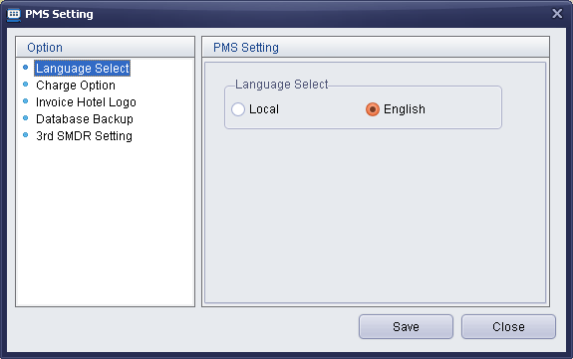

- Charge Option
  - Call Charge - Call Billing calculation is done by PABX or PMS.
  - Period of Charge – Usually, Call Charge and Bar Chare information is generated from PBX, and it transferred to PMS periodically.
This charge information requisition period is set.

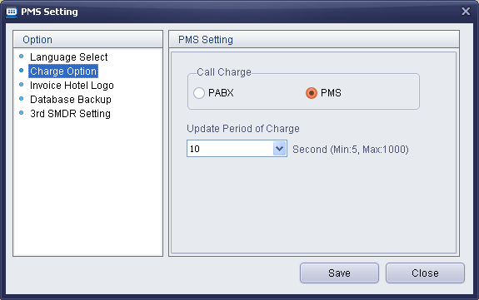

- Invoice Hotel Logo – Hotel Image is used in Invoice.
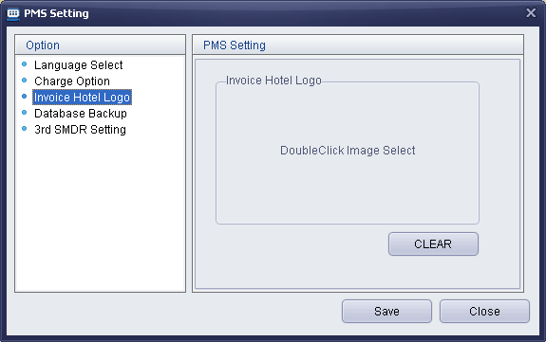

- Database Backup – Set Backup Path & Period.

- 3’rd SMDR – Default Value is Not Use.
If it is set to Not Use, SMDR information is transferred from PABX.
If this option is set to USE, SMDR information is transferred from 3’rd party SMDR equipment.
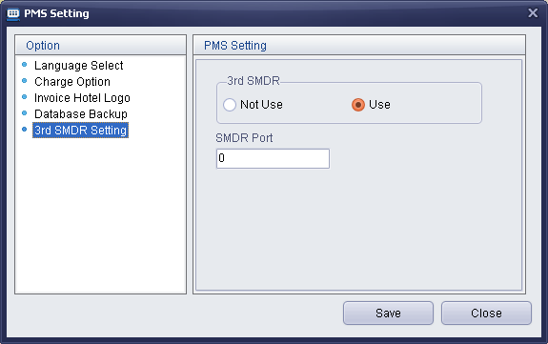

Note
- If language setting is changed, it works after re-starting the application.
- To receive charge information from PBX, the period should be set a certain value, not set [Not Use].
- 3’rd SMDR option is OFF by default.
- Hotel Log recommended size is 192*90 pixels.

Group
Description
Guest rooms can be grouped by similar characteristics.
When a group is made, a new group tab is shown in monitoring window.

Window
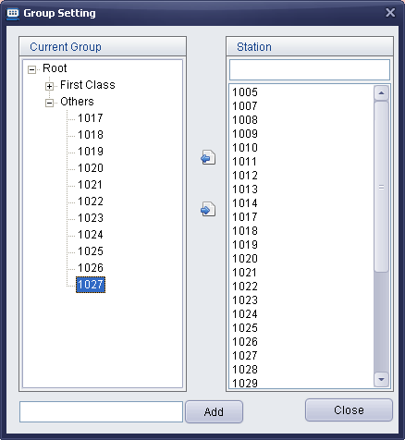

Procedure
Create Group
- Choose “Configure - Group”.
- Enter new group name.
- Press [Add] button, new group is made.
- In right station window, choose station number that want to be included, and press [<<] button.
- Press [Close] button, then main window is re-freshed.

Delete Group
- Choose “Configure - Group”.
- Choose group that want to remove.
- Click mouse right button.
- Choose [Delete].

Change Group Name
- Choose “Configure – Group”.
- Choose group that want to change name.
- Click Mouse right button.
- Choose [Rename].

Note

- If Group setting is changed from IP Attendant, it affect to PMS.
- If Group Information is changed from PMS, it also affect to IP Attendant.

Document
Description
When Reservation is confirmed or check-out is done, if registered mail address is valid, the information is sent by e-mail.
The E-mail format can be made as below.

Window

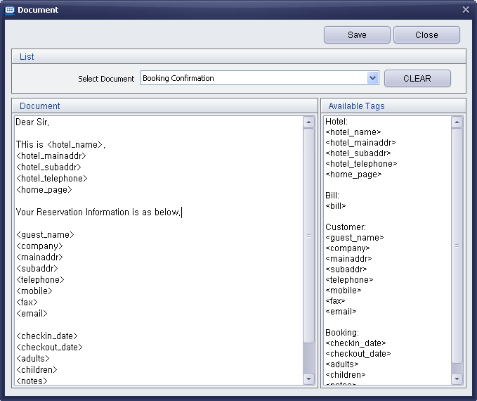

Procedure
- Choose “Configure – Edit Document”.
- Choose Document type – Reservation Confirmation / Customer Bill.
- Enter text by following e-mail style, and drag or double click each Tag of right side [Available Tags]
- Press [Save] button.

Note

Hotel Information
Description
Hotel Information is used in Invoice and Confirmation e-mail.
This information is synchronized with PBX Hotel Info in Hotel Data.

Window

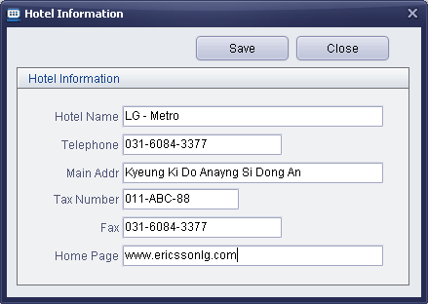

Procedure
- Choose “Configure – Hotel Information”.
- After enter each values, press [Save] button.

Note
- Hotel Name is synchronized with Site Name in PGM 100.

Currency
Description
When guest check-out – Invoice print, this currency table is referred.
Currency table is only updated by manually.

Window
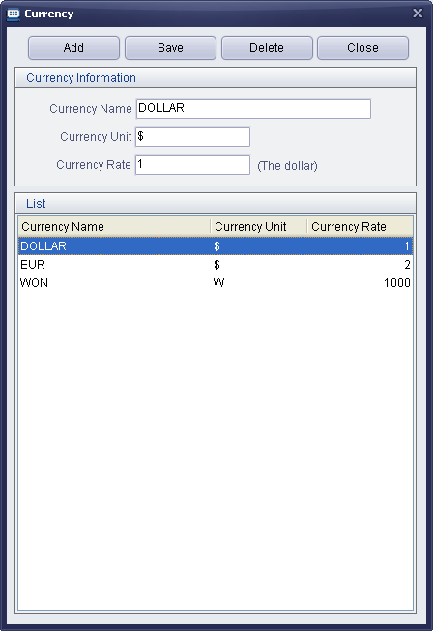

Procedure
- Choose “Basic Code – Currency”.
- Press [Add] button.
- Enter Currency information.
- Press [Save] button.

Note
- The basis currency is Dollor.
- If a guest information is set as WON, when the guest does check-out, the invoice total charge is calculated from Dollar to Won.

Customer Search
Description
Searching Customer is allowed.

Window
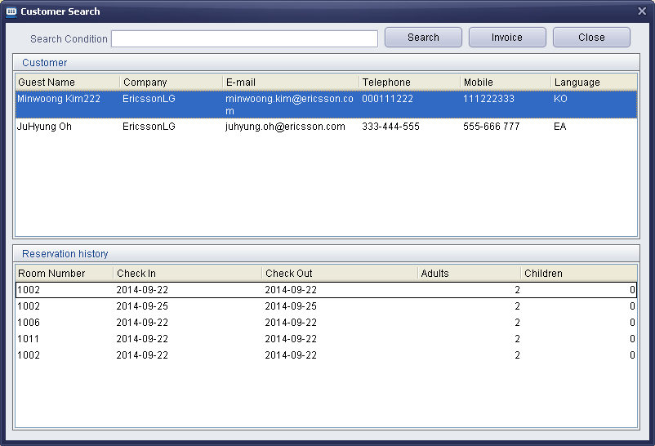

Procedure
- Press [Customer Search] button.
- Enter some condition and press Search button.
- To check Invoice, choose customer, choose Reservation history, and click Invoice button.

Note
- If press [Search] button with no condition, all customer is listed.

Room Status
Description
Room Status is shown and changed by maid.
4 kinds room status is allowed – Dirty, Clean, Out-Of-Service, Inspected.
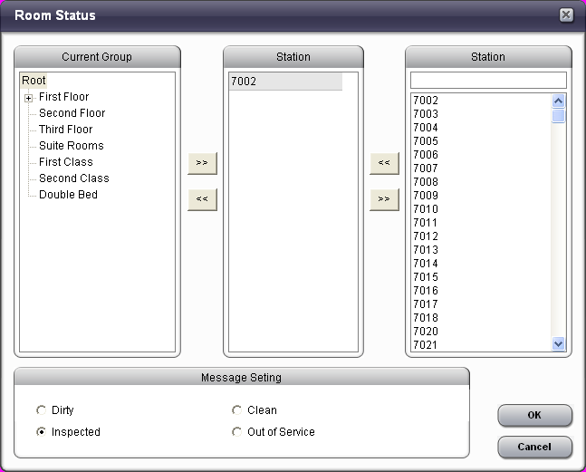

Procedure
- Click Room Status button.
- By double click of group name or by selecting stations and pressing [<<] button, multi room can be chosen.
- In middle window, the selected room list is displayed.
- Choose Room Status and Click OK.

Note

Room Change
Description
Room to Room change is allowed.

Procedure
- Choose room that is checked in.
- Press Room Change button.
- Choose room that is empty.
- When Room change is done, confirm message is shown.

Note
- Room Change must be done from occupied room to empty room.

COS
Description
Each Room’s COS can be assigned.

Procedure
- Choose “Room Setting – COS”
- In case of COS, multi room setting is possible.
- If user uses mouse right button, individual room setting is possible.

Note

Memo
Description
When front desk get a message from a person to a guest room, front desk manager can leave a short memo to the room.
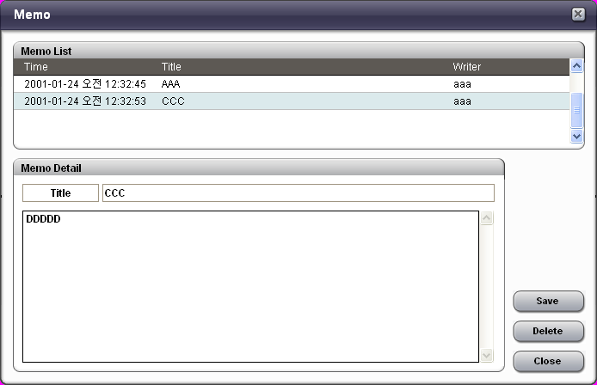

Procedure
- Choose “Room setting – memo”.
- If user uses mouse right button, message is left to a individual room.

Note

DND
Description
Each room’s DND can be set or re-set by PMS.

Procedure
- Choose “Room setting – DND”
- Multi station Selecting is allowed.

Note
- This DND is only affect to room station’s DND. This is not Room DND.

Wake Up
Description
Wake Up Alarm can be registered.
If wake up is set at a room, wake up icon is displayed in monitoring window.
If a wake up alarm is not answered, the icon is flashing with red color.

Window
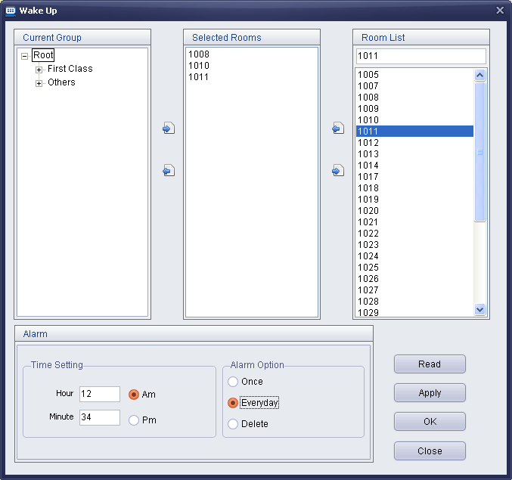

Procedure
- Choose “Room setting – wake up”.
- Multi station selecting is allowed.

Note
- If user choose “read”, only first room’s wake up value is displayed.
- If PBX setting value(System setting – New 5 Wake Up Usage) is ON, 5 wake up setting per a room is allowed.
- When monitoring window is closed at once, the red color flashing Icon goes to not flashing gray icon.

PMS Reservation Window
Description
In PMS Monitoring Window, press Reservation button or choose Reservation menu, Reservation is opened.
Room Reservation, guest check-in, check-out is executed in Reservation Window.

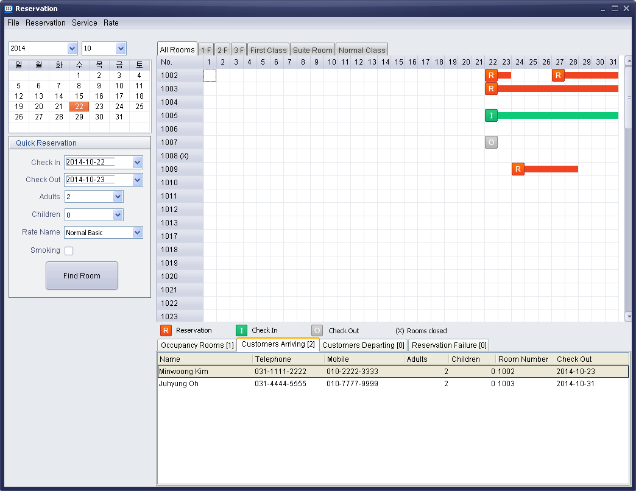

Whole room list per a month is displayed in the window.
It is easy to check reservation / check in / check out status.
[R] : Reservation.
[I] : Check-In.
[O] : Check-Out.
(x) : Room is Closed.
[?] : Room Check-In status is different with PBX and PMS. It should be checked PBX Check-In status.
After checking the difference with PMS and PBX Check-In status, it can be deleted manually by clicking mouse right buuton.

In case of more than 2 PMS site, to support reservation feature, Database should be shared with each other PMSes.
The below is how to set Database.
- There are 2 PMS PC – A PMS, B PMS.
- A PMS PC use own Database, then B PC should set A PC’s Database.
- A PMS PC setting is as below.
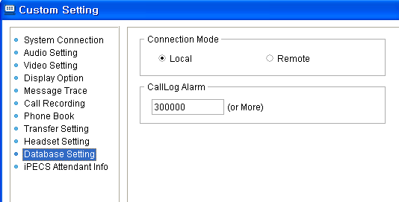

- B PMS PC setting is as below – connection mode : Remote / server name : Master PC’s IP Address.
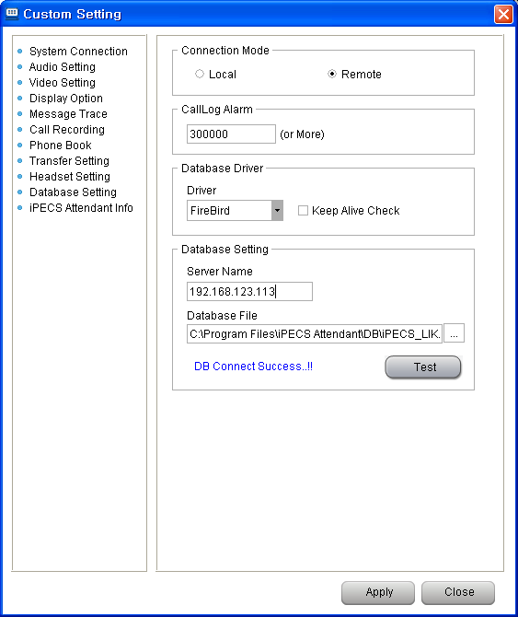

Holiday
Description
Holiday Setting is available.
When room charge is calculated, this table is referred.

Window

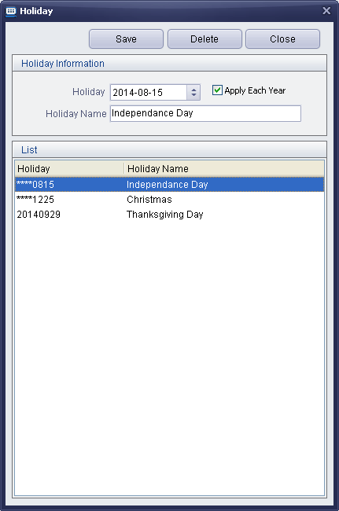

Procedure
- Choose “Rate – Holiday”.
- Choose Date.
- If the date is fixed date in every year, check Apply Each Year.
- Enter holiday name.
- Press [Save] button.

Note

Peak Information
Description
Peak season setting is available.
When room charge is calculated, this table is referred.

Window

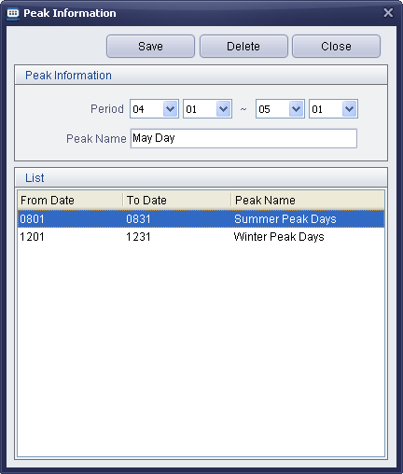

Procedure
- Choose “Rate – Peak Information”.
- Choose Period.
- Enter Peak name.
- Press [Save] button.

Note
- The peak season start date should be earlier than end date.

Sale Information
Description
Sale Information Setting.
Sale Information is used in making Room Information Table & Call Information Table.

Window

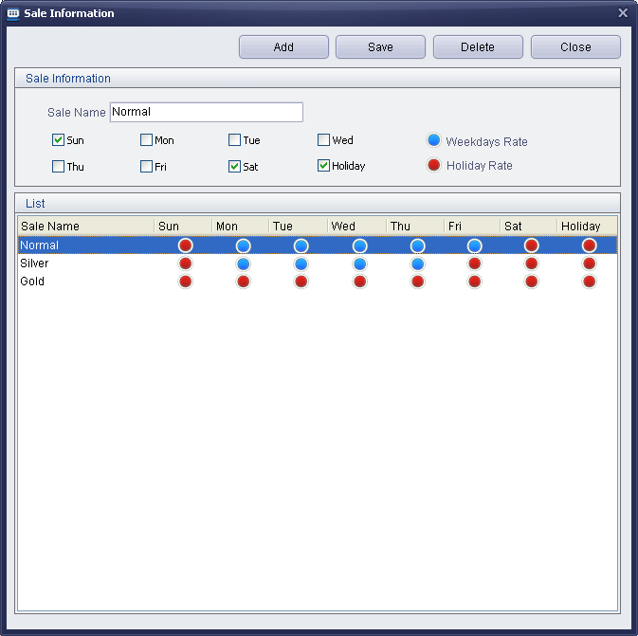

Procedure
- Choose “Rate – Sale Information”.
- Enter Sale Name.
- If user check at a day, then the day is applied to holiday rate.
- If user do not check at a day, then the day is applied to weekday rate.
- Press [Save] button.

Note

Room Information
Description
Room Rate Information Setting.
Room Information is used in Room List for setting each Room Rate.

Window

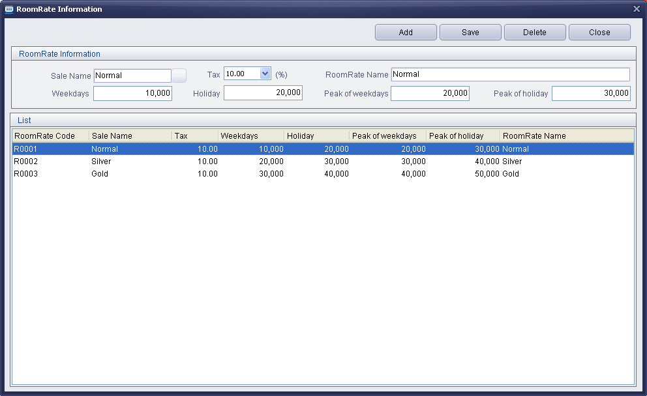

Procedure
- Choose “Rate – Room Information”.
- Enter [Add] button to create a new Room Rate record.
- Choose Sale Name.
- Enter Room Rate Name.
- Choose Tax.
- Enter the price at each day type.
- Press [Save] button.

Note
- Sale Name should be assigned ahead in “Rate – Sale Information”.
- Tax should be assigned ahead in “Rate – Tax Table”.

Call Information
Description
SMDR raw record is transferred from PBX or 3’rd party SMDR server to PMS.
In PMS Setting, Call Charge is set to PABX, then billing data from SMDR raw record is used for call charge.
If Call Charge is set to PMS, then although billing data is included in SMDR raw record, call billing calculation is executed by Call Information Table.

Call Information Table is composed of Prefix, Sale Name, Prefix Name, Rate per seconds, Tax.
Call rate can be decided by prefix of SMDR dialing data.
200/10 means, call is charged 200 per 10 seconds.

Window

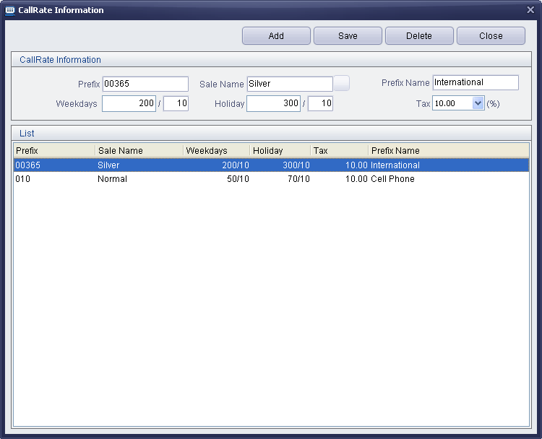

Procedure
- Choose “Rate – Call Information”.
- Press [Add] button.
- Enter Prefix code and Prefix name.
- Choose Sale Name.
- Enter Call Rate and choose Tax.
- Press [Save] button.

Note
- Sale Name should be registered in “Rate – Sale Information” ahead.
- Tax should be registered in “Rate – Tax Table” ahead.
- In SMB system – PGM 177 – SMDR Interface service option should be set as ON, to get the SMDR raw date from the system.

Tax Table
Description
Tax is used for Room Charge, Item Charge(Room Service) and SMDR Charge.
Tax table is synchronized with PBX.

Window
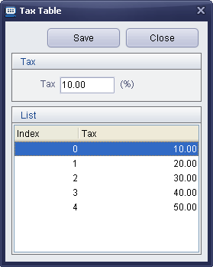

Procedure
- Choose “Basic Code – Tax Table”.
- Choose Tax index.
- Enter Tax.
- Press [Save] button.

Note
- PBX Tax table is PGM 307

Call Rate Table
Description
Call Rate is used when guest check-in.
When guest check-in, Call Rate is entered.
If Call Rate is set to 200%, a call is charged double compare with original call cost.
Call Rate table is synchronized with PBX.

Window
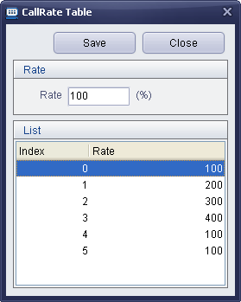

Procedure
- Choose “Rate – CallRate Table”.
- Choose index.
- Enter Rate.
- Press [Save] button.

Note
- PBX Call Rate table is PGM 305

Service Type
Description
MInibar is default service type.
Additional service type is registered as below.
This is service type registration, and each sub items can be registered in “Service – Service Table”.

Window

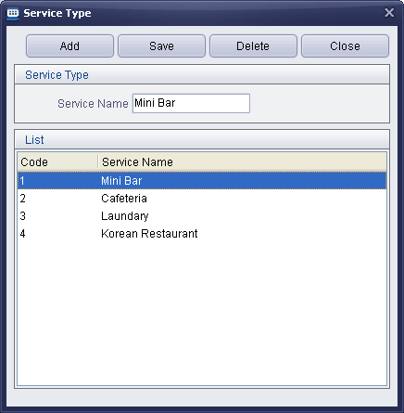

Procedure
- Choose “Service – Service Type”.
- Press [Add] button.
- Enter Service Type.
- Press [Save] button.

Note
- Service type is used for Room Service.

Service Table (Item Information)
Description
Minibar is default Service type.
This Minibar table is synchronized with PBX – PGM 306 table.

Except Minibar, additional service type can be registered in “Service - Service Type”(ex : Cafeteria, Laundary..).
After new service type is registered, each sub items can be registered here.
Each service type have up to 100 sub items.

Window

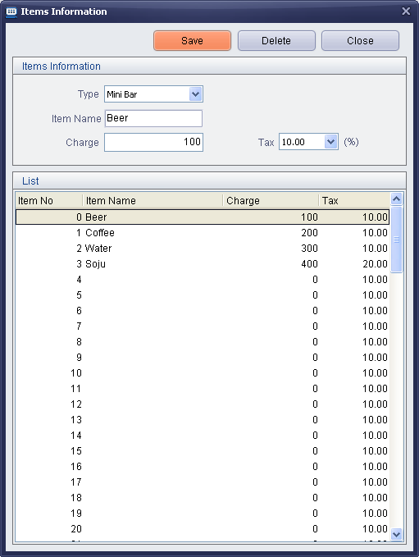

Procedure
- Choose “Service – Service Table”.
- Choose Type.
- In the list, choose item that want to be add or that want to be updated.
- Enter item information.
- Press [Save] button.

Note
- Execpt Minibar type, (-) value can be entered.

Room List
Description
Room Information(Number of guest, Room Closed, Smoking, Room Rate) is set by each room.
Only rooms that has valid room information is shown In the Reservation list.

Window

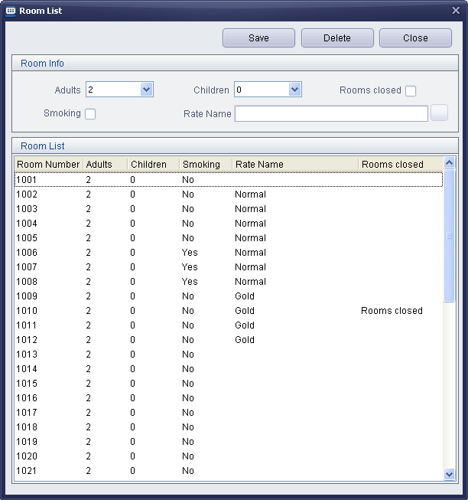

Procedure
- Choose “Reservation – Room List”.
- Choose room from Room List.
- Enter proper number of guests, smoking, Room Closed, and Rate.
- Press [Save] button.

Note
- All Room default setting is Adults is 2, Children is 0.
- If Room Closed is checked, then (X) is indicated in Reservation list, and the room is not allowed reservation or check-in.

Customer Information
Description
When a guest does check in or reservation, guest information(name, address, phone number..) can be registered.
This registered information is saved to Customer Information List.

Window

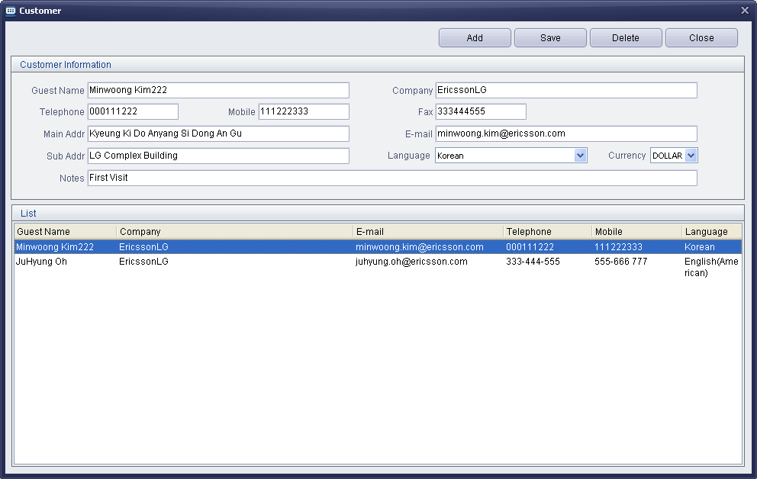

Procedure
- Choose “Reservation – Customer List” or “Find Room – New Customer”.
- Enter Customer information.
- Press [Save] button.

Note

Reservation / Check-In
Description
Room Reservation / Guest Check-In is allowd in Reservation menu or Quick Reservation.

Window & Procedure
- Choose “Reservation – Room Reservation” or Press [Find Room] button in Reservation window.
- Enter Check-In date, Check-Out date.
- Enter number of guest, Room Rate, Smoking.
- Press [Find Room] button.
- Matched room list is shown in right side, choose a room.
- Choose a customer from Customer List.
- If a new costomer want to reserve a room, press new customer and save his information.
- Select Customer button, or Double Click a Customer from Customer list.

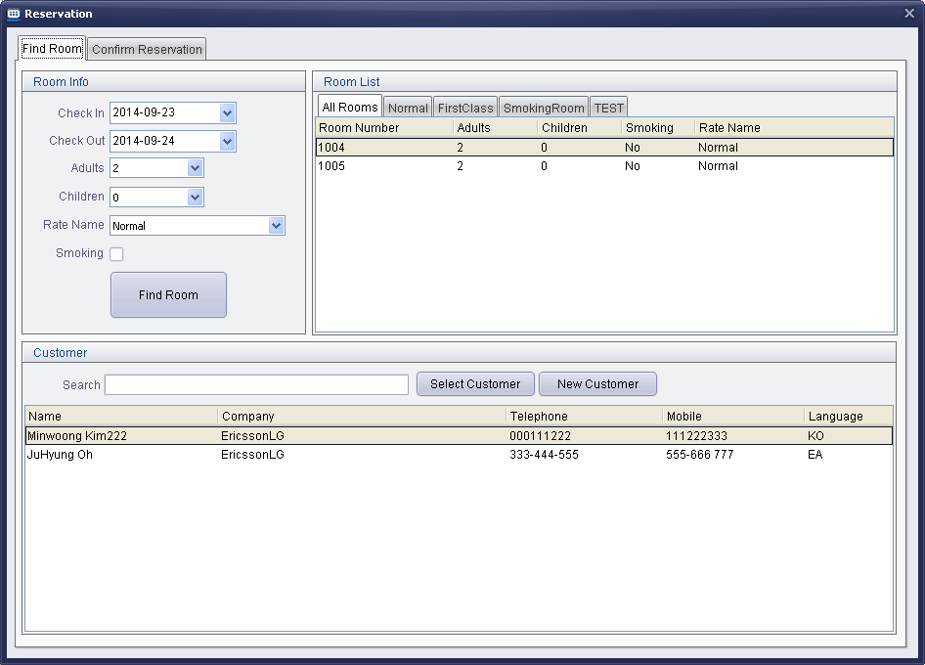

- After select customer, enter reservation(check-in) information.
- press [Reservation] or [Check In] button.

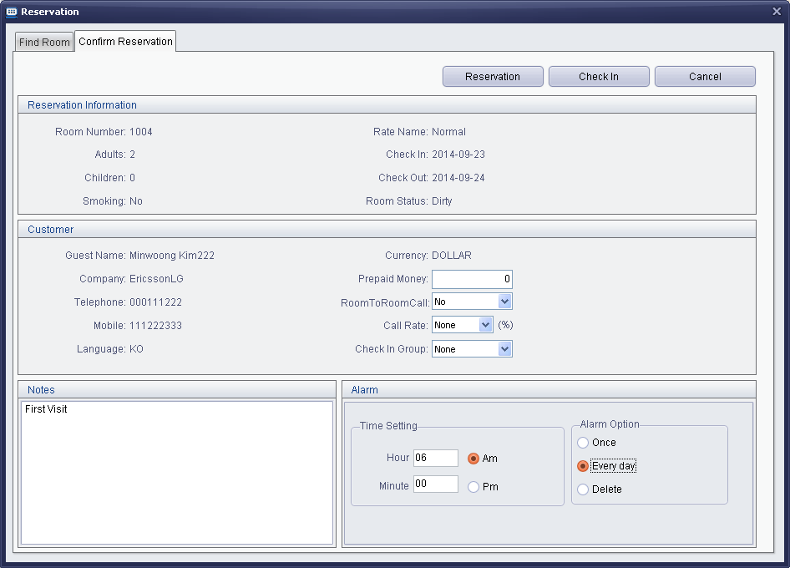

- Reservation or Check-In information is displayed in Reservation Window.
- Mouse is located on [I] or [R], then reservation(check-in) information is pop-up.
- Occupied Room, Today arriving, Today Departing, Reservation Failure list is shown in the window.
- Mouse Right button on [R], then check-in, sending e-mail, Update Reservation(Update reservation duration), Reservation Calcel are allowed.
- Mouse Right button on [I], then Update Check In(Update check in duration), Room Service, Check Out, Checking Invoice are allowed.
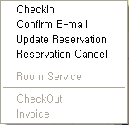
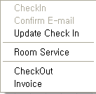
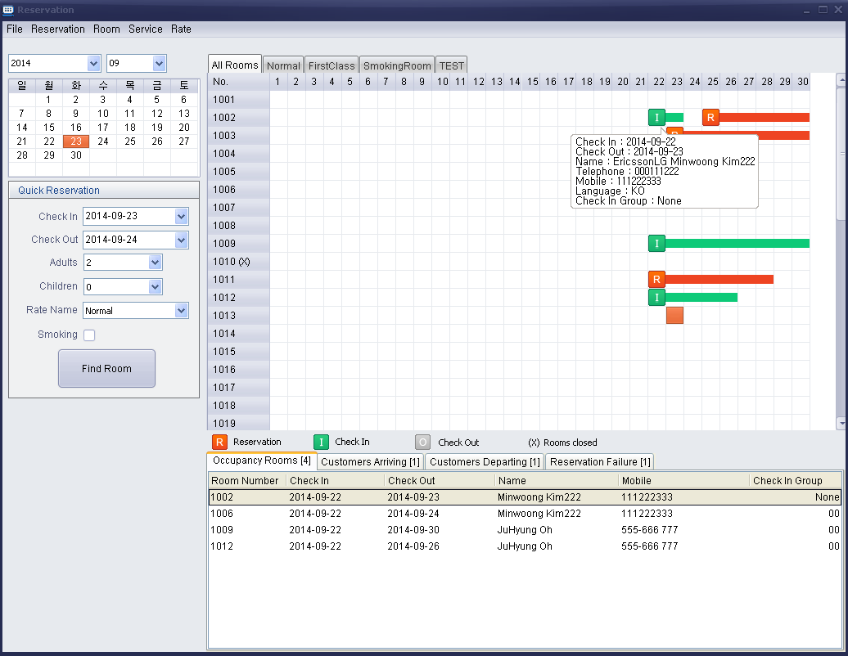
- In case of Chek-In room, double click [I], then check-in information is displayed as below.
- Check-In information can be modified.
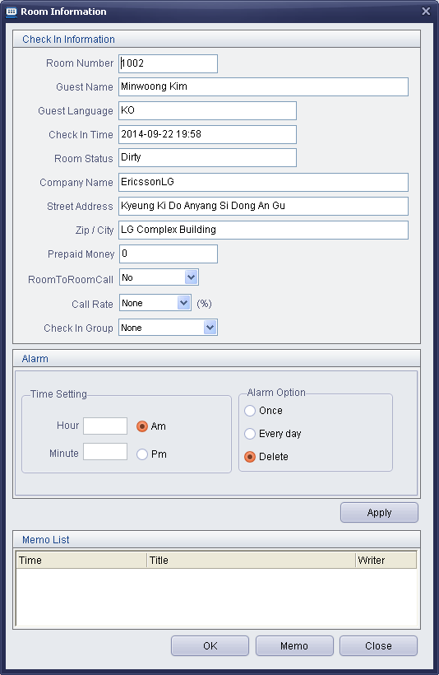

Note

Check-Out / Invoice
Description
Check-Out is enable in Reservation Window.

Window & Procedure
- Mouse right button on [I] icon.
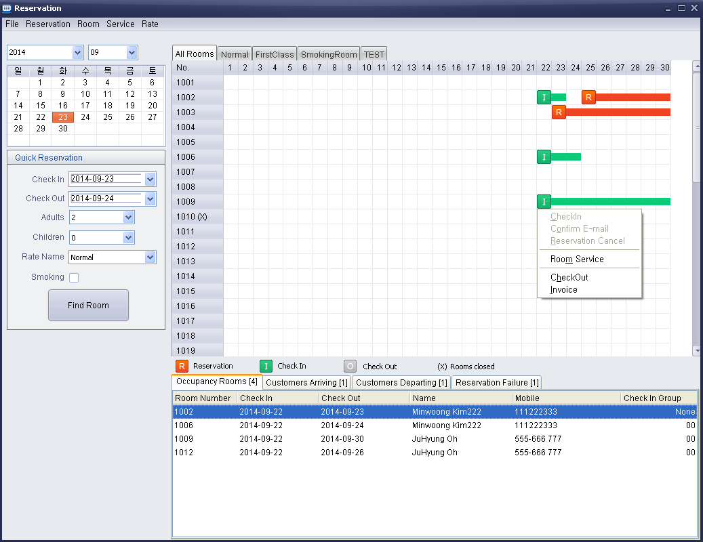
- Choose Invoice.
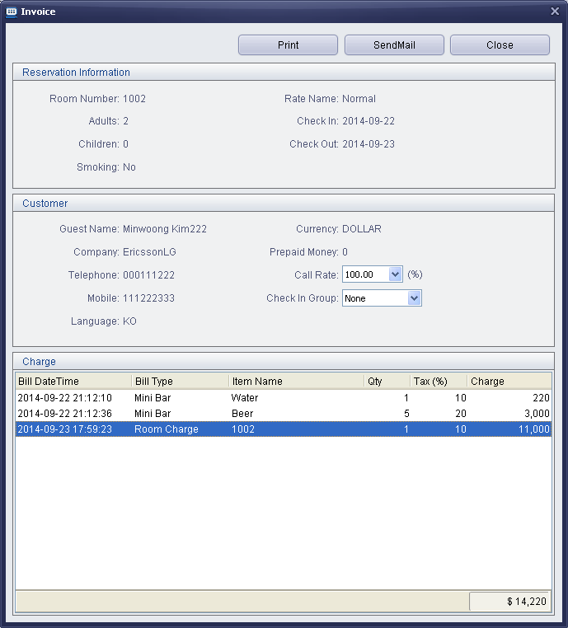
- Adjust Invoice – Mouse Right button and choose Insert Invoice Charge.
The inserted charge is allowed with Plus charge or Minus charge.
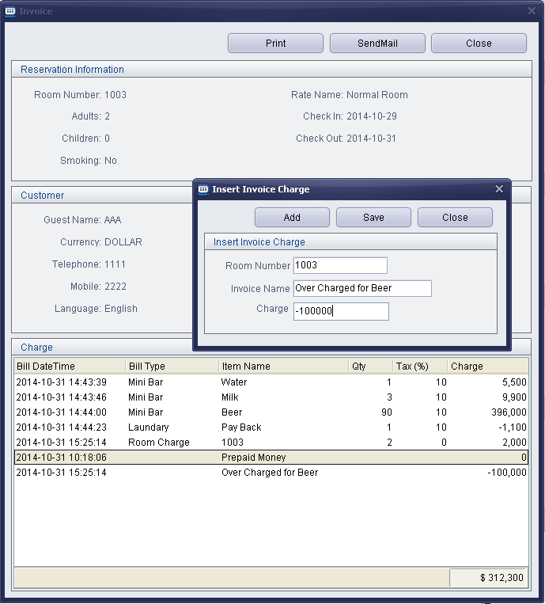
- Choose Check-Out and press Confirm.
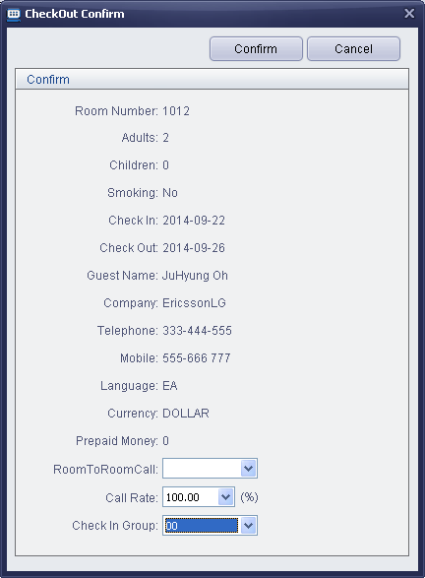
- Check-Out is indicated in Reservation Window.
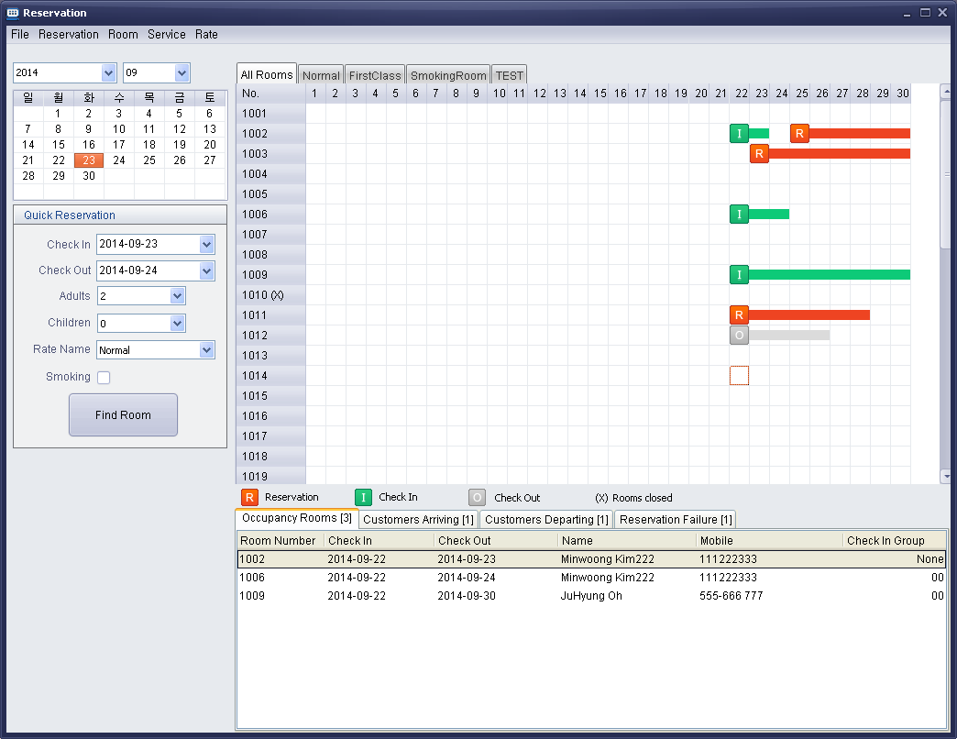

Note

