**UCP MULTI VOIM CONFIGURATION WITHOUT WANU**

If the router can be configured to route from the public IP address to multiple internal private IP addresses for different port ranges, then this set up can be used. By replacing the WANU function it is less complicated to implement. The software level of the UCP should be 1.3.18 or above and the VOIM should be 6.0Fa or above.

The WANU function on the VOIM can be used where all ports on the router are to be forwarded to a single internal IP address. This requires additional configuration on the UCP and WANU section of the VOIM and is described in a separate WANU document on the solutions section of the Pragma web site.

This guide is based on an example using a UCP100 with 2 external VOIM24s for SIP, Remote Phone and UCS connections. More VOIMs can be added according to the system capacity; when this done the port ranges configured must not overlap with any other VOIU or VOIM ports. SIP, Remote Phone and UCS programing is covered in other guides on the Pragma Web Site.

**VOIM – Wiring**

LAN1 (WAN) on the VOIM connects to the system network routing local LAN traffic.

All VOIMs will have a patch lead from LAN1(WAN) to the switch, LAN2 (LAN) is NOT connected to the switch, this is only used when using the WANU configuration method.

Note: Older VOIM8/24 Gateways had the LAN1 port marked as WAN, and the LAN2 port marked as LAN

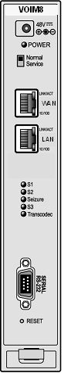

LAN2 (LAN) – Internet WANU. DO NOT CONNECT

LAN1 (WAN) - System Network

**Step 1 UCP Configuration**

System IP Plan PGM 102

Set IP Address plan including Router, Firewall (Public IP Address) and DNS IP Address

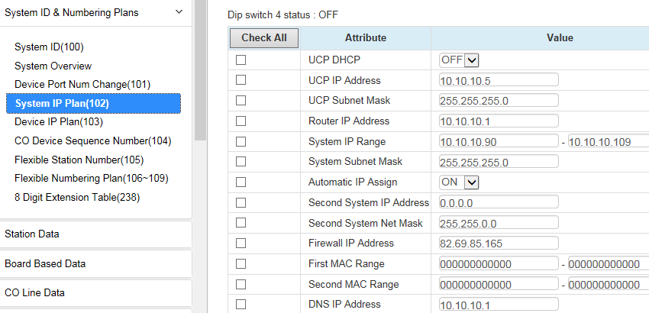

Device IP Plan PGM103

Note VOIM Seq number 2402-2404

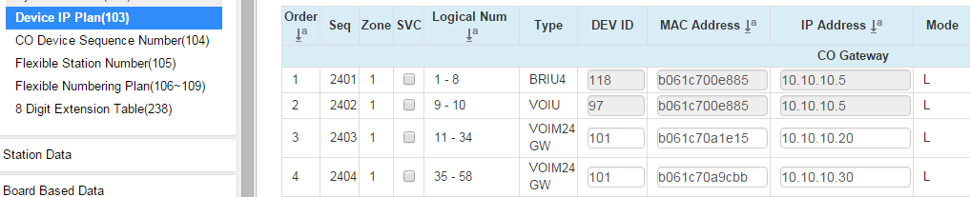

Board Based Data PGM132

For VOIU sequence numbers, enter Firewall IP Address

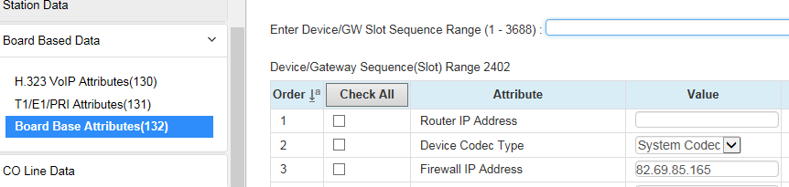

For VOIM sequence numbers, enter Router IP Address and Firewall IP Address

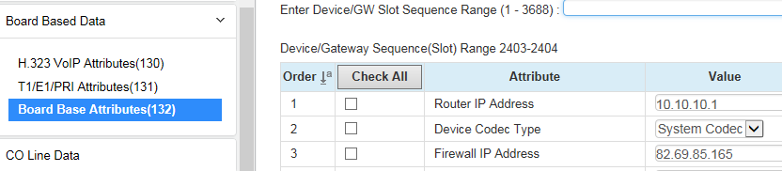

Step 2 VOIM RTP Ports Configuration

The UCP VOIU and the first VOIM gateway VOIM1 (10.10.10.20) can be left with the default port settings.

VOIM1 Default port settings are shown below

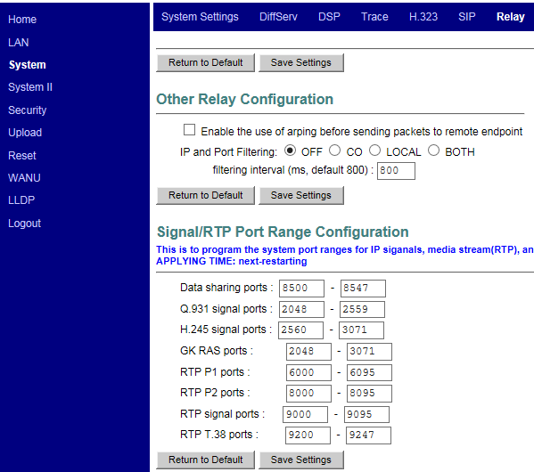

VOIM2 (10.10.10.30) Port configuration must be changed to avoid any conflicts and correct port forwarding. In this example RTP ports 22000-22335 are used.

Go to System, Relay and make the following RTP port changes and press Save Settings.

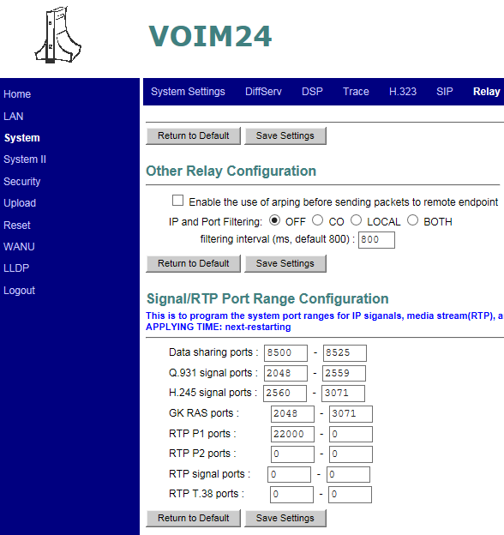

After saving you can see the RTP port ranges are automatically filled.

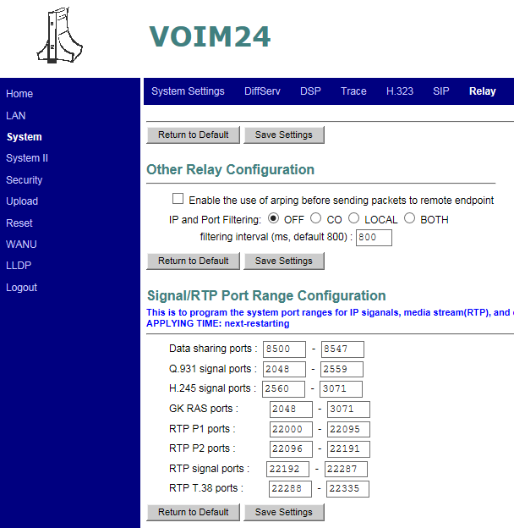

Reset VOIM

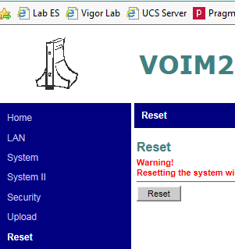

Static Routing

**Router Port Forwarding Configuration**

On the router set the port forwarding according to the devices used as below

UDP 5060 for SIP

UDP 7000-7031, 7100-7147 for VOIU

UDP 10000-10239 for VOIUSW

UDP 5588 for Remote LIP, UCS Standard TCP/UDP 5588, TCP7878, TCP8899

UDP 6000-6095, 8000-8095, 9000-9095, 9200-9246 for VOIM1

UDP 22000-22335 for VOIM2

|  |  |  |
| --- | --- | --- |
| Public Address | Private Address | Ports UDP unless otherwise stated |
| 82.69.85.165 | UCP 10.10.10.2 | 5060, 7000-7031, 7100-7147, 10000-10239  For Remote LIP add 5588  For UCS Standard add TCP/UDP 5588, TCP 7878, TCP8899 |
| VOIM1 10.10.10.20 | 6000-6095, 8000-8095, 9000-9095, 9200-9246 |
| VOIM2 10.10.10.30 | 22000-22335 |
|  |  |

**Draytek Vigor 2820 Port Forwarding screens for this example**

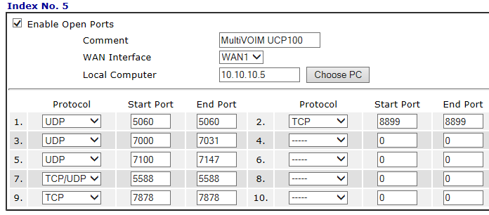

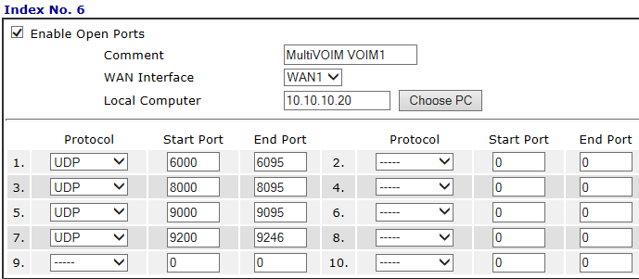

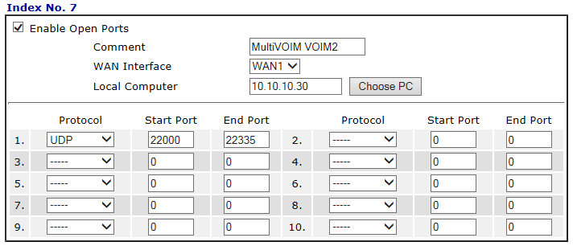

END