**WANU UCP Unified Software Configuration Guide**

The configuration of the WANU is required when the iPECS system has multiple Media Gateways (UCP VOIP Gateway and/or multipleVOIM8/24) installed and only one Fixed Public IP Address on the DSL, (internet).

The multiple IP Channels available could be used for SIP lines and/or Remote IP Phones behind NAT,

The WANU feature, LAN 2 on the VOIM8/24 connects the iPECS to the Internet just like a network router.

**Internet**

Web Admin

Remote Phones

IP System

10.10.10.12

10.10.10.150

Master VoIM

LAN2

30.30.30.1

40.40.40.1

50.50.50.1

UCP

VOIM

LIP

10.10.10.2

10.10.10.10

10.10.10.11

Master VOIM LAN1

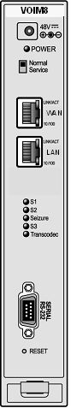

Router/Gateway

LAN IP

10.10.10.252

IP Signal

Media

Maintenance

The WANU is an additional feature within the VOIM, which will need to be activated. The software of the VOIM should be version 6.0Fa or higher.

If more than one VOIM is installed, then the WANU feature must only be enabled on one VOIM.

The WANU is programmed with a static IP Address, this enables features such as web programming, Remote IP Phones, SIP lines and other features to connect via a single IP Address.

The ALG functions of SIP and H323 within the WANU allows multiple IP Gateways (UCP VOIU Gateway and VOIM8/24) to connect to the Internet by using a single Fixed Public IP Address.

**Master VOIM – Wiring**

LAN1 on the VOIM connects to the system network routing local LAN traffic.

LAN2 (WANU) connects to and routes Internet traffic.

All VOIMs will have a patch lead from LAN1 to the switch, only the Master VOIM will have LAN1 and LAN2 connected to the switch.



LAN2 - Internet

LAN1 - System Network

Note: Older VOIM8/24 Gateways had the LAN1 port marked as WAN, and the LAN2 port marked as LAN.

WANU

MFIM

VSF

PC

WAN

SIP Port Ranges

H323 Port Ranges

ALG

UCP Port Ranges

Local Port Ranges

VSF Port Ranges

PC Port Ranges

Other Port Ranges

Media Port Ranges

LAN

VoIMs

The ALG – Application Level Gateway allows customised NAT transversal filters to be entered into the gateway to support address and port translation for protocols such as SIP and H323.

Port information regarding each Media Gateway is programmed into the WANU to allow routing of traffic from the WANU to each VoIP Gateway.

The Default port ranges of the Media Gateways will need to be changed to avoid conflict. These can be randomly selected, but care must be taken to ensure they do not overlap. It has been found from Lab setup, that it is best to use high port numbers e.g. 1st VOIM to use 11 000 range, 2nd VOIM to use 20 000 range, 3rd VOIM to use 30 000 range etc.

**System Programming**

Gamma SIP lines, IP Address Authentication, on Public IP 217.34.220.153

Telephone number 01403 221 700

**Step 1** – Register all VOIM Gateways on the UCP, refer to PGM 101

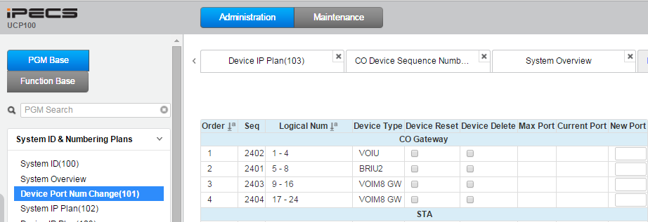

**Step 2** – Configure UCP Router IP Address (Gateway) and Firewall IP Address.

PGM 102-103

The Routers IP Address is the Master VOIMs, (the one with the WANU enabled) LAN 1, IP Address.

The master VOIM needs to be selected, in this example it is the VOIM8, with IP Address of 10.10.10.12

The Firewall IP Address is the Fixed Public IP Address of the DSL e.g. 217.34.220.153

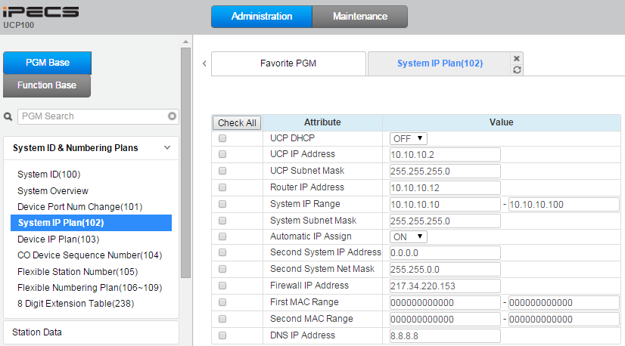

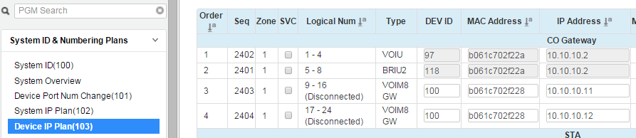

WANU Enabled on Master VoIM

**Step 3** – Program the SIP Lines and associated Station programming

1. PGM 113 Option 10 – Station CLI 1

This is the last 3 digits of the SIP Telephone number – e.g. 700

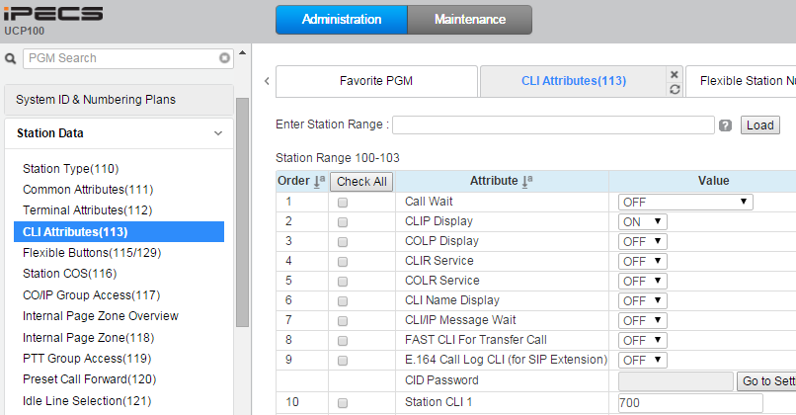

1. PGM 132 – Board Base Attributes

Program the Gateway and Firewall IP Address for the UCP VoIP Gateway and the VoIMs

Make a note of the Sequence numbers of the UCP VoIP Gateway and VoIMs, this can be checked in

PGM 103.

In this example UCP VOIU Gateway is Seq 2402, VOIM8 is Seq 2403, VOIM8 (WANU) is Seq 2404

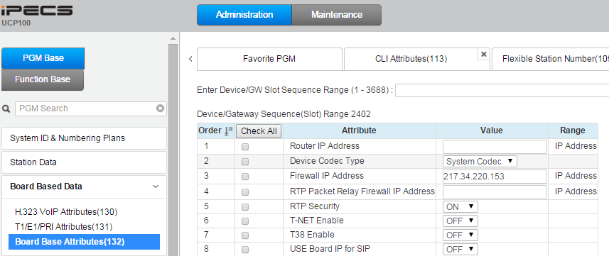

Seq 2402, UCP VoIP Gateway.

Note: Router IP is blank as it refers to PGM 103 Router IP

Seq 2403, VoIM8.

Note: Router IP is set as Master VoIMs LAN 1 IP Address

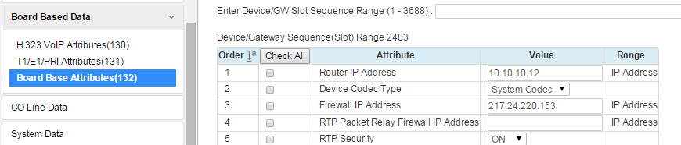

Seq 2404, VoIM8 (Master with WANU Enabled)

Note: Router IP is set as Master VoIMs LAN 1 IP Address

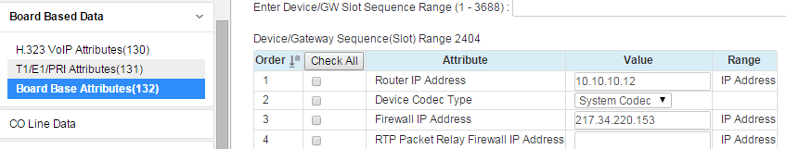

1. PGM 133 – SIP CO Attributes

Program the IP lines with the SIP providers credentials

In this example the IP lines are lines 1-4 on the UCP VOIU Gateway, lines 9-16 on the VOIM8 and then lines 17-24 on the second VOIM8

Proxy Server Address - as per SIP provider e.g. 83.245.6.81

Domain - as per SIP provider e.g. 83.245.6.81

P-Assert Identity – Not Use

Codec Priority – as per SIP provider e.g. 1st = G.711_a, 2nd = G.729, 3rd = G.711_u

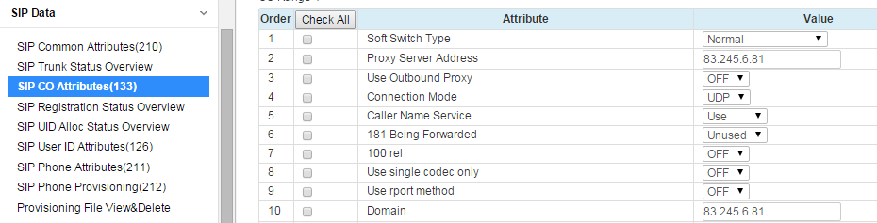

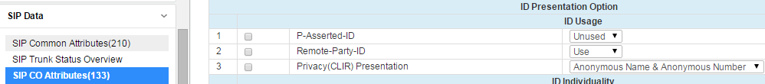

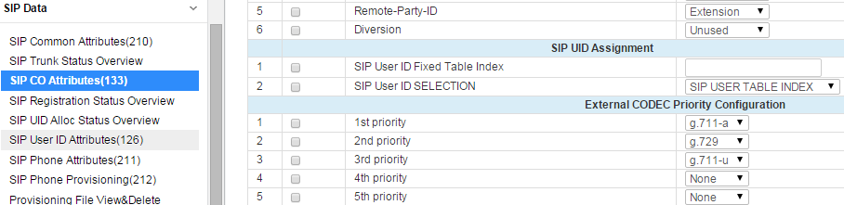

1. PGM 210 – SIP Common Attributes

Option 1 – Primary DNS Address

This is usually the DSL routers local LAN Address e.g. 10.10.10.252

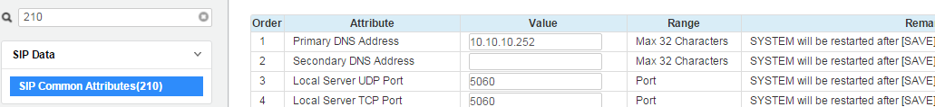

1. PGM 140-142 – CO/IP Attributes

In this example the IP lines are lines 1-4 on the UCP VOIU Gateway, lines 9-16 on the VOIM8 and then lines 17-24 on the second VOIM8

Set the IP Line, CO Type as DID (DDI)

Allocate IP Lines in to a working CO/IP Line Group

Also ensure that the IP Lines, CO VOIP Mode is set Common. This allows the channel to be used as SIP or H323 i.e Remote IP Phones.

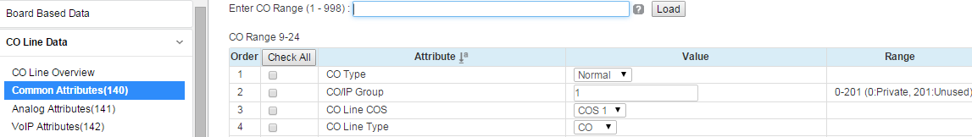

DID

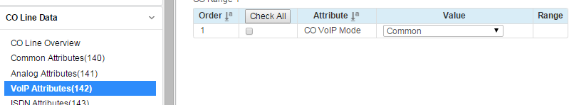

1. PGM 143 – ISDN CO Line Attributes

In this example the IP lines are lines 1-4 on the UCP VOIU Gateway, lines 9-16 on the VOIM8 and then lines 17-24 on the second VOIM8

Program the SIP Lines to send the digits dialled by the user as Enblock, basically all digits will be sent in a block to the SIP provider.

And program the lines to send and receive CLI.

COLP Table Index – 1

CLIP Table Index – 1

Type of Number for Calling Party Info – National

Incomming Prefix Code Insertion - On

Outgoing Prefix Code Insertion - Off

My Area Prefix Code – 0

Enblock Sending – On

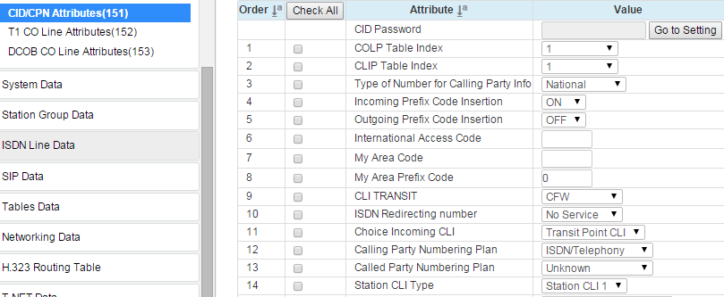

1. PGM 145 – DID Service Attributes

In this example the IP lines are lines 1-4 on the UCP VOIM Gateway, lines 9-16 on the VOIM8 and then lines 17-24 on the second VOIM8

Program the IP Lines to route the DID (DDI) using the Flexible DID Table PGM 231

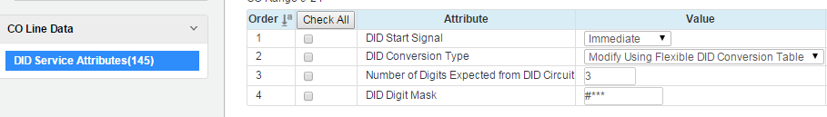

1. PGM 201 – CLIP/COLP Table

This is part of Outgoing CLI programming.

Use Table 1 as this was referred to in PGM 143

When entering the Telephone number drop the zero and the last three digits of the number, as these are added in PGM 143 (Outgoing Prefix Code Insertion) and PGM 114 (Station CLI 1)

SIP Telephone Number is 01403 221 700

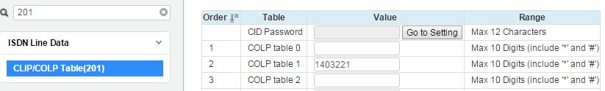

1. PGM 231 – Flexible DID Conversion Table

Program the DID (DDI) numbers as required e.g. DDI ending 700 routes to Station 100

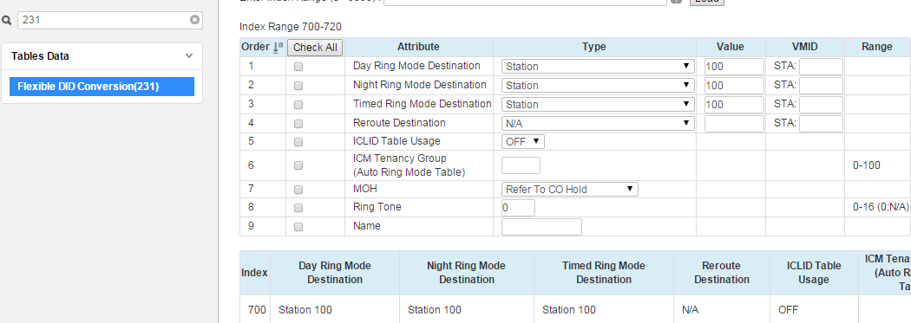

**Step 4** – Re-Assign the RTP and Data Sharing Port Ranges on Media Gateways (UCP VOIU Gateway

and on each VOIM)

This is done as the default ports on the VOIM8/24 are the same and will conflict when setting up the routing in the WANU i.e. The RTP Ports are UDP 6000-6047, 8000-8047 and 9000-9047

As mentioned earlier these ports can be randomly selected, but care must be taken to ensure they do not overlap.

In this example, the below have been assigned:

11 000 port ranges to the UCP VOIU

20 000, 21 000 and 22 000 port ranges to the1st VOIM8

30 000, 31 000 and 32 000 port ranges to the 2nd VOIM8

1. To change the ports on the VOIM8/24 - Browse to the IP Address of the VOIM itself.

Note this needs to be done for each VOIM used.

Browse to the IP Address of the 1st VOIM8 - <http://10.10.10.11>

Click on **System**, then **Relay** then adjust the **Signal/RTP Port Range Configuration**

As per below values, then **Save the Settings**

Browse to the IP Address of the 2nd VOIM8 - <http://10.10.10.12>

Click on **System**, then **Relay** then adjust the **Signal/RTP Port Range Configuration**

As per below values, then **Save the Settings**

Note the values entered are then adjusted by the system to suit a VOIM8 or a VOIM24.

See below table...

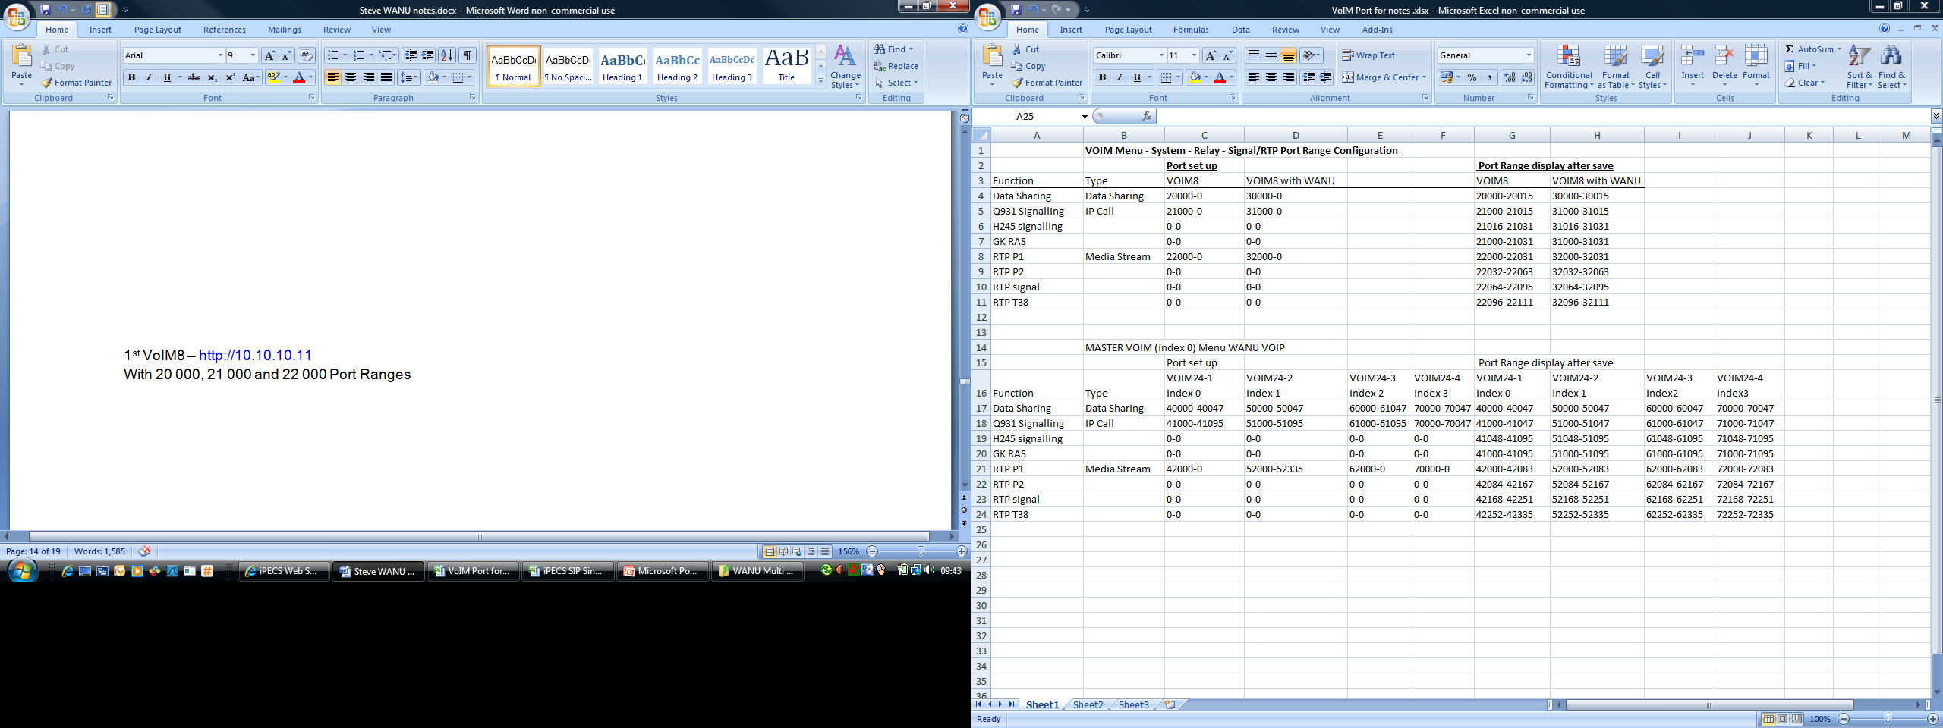

The values are entered as per Port set up, when the settings are saved – the values are adjusted to suit VoIM

1st VOIM8 – <http://10.10.10.11>

With 20 000, 21 000 and 22 000 Port Ranges

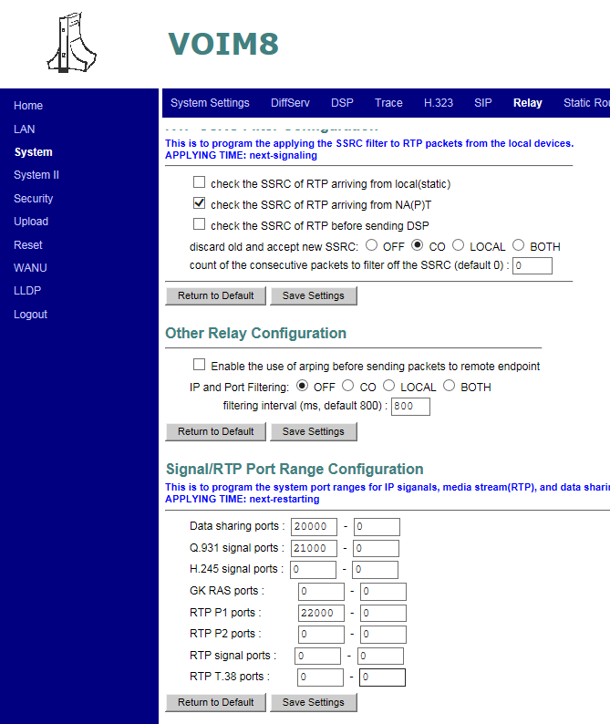

Enter Save

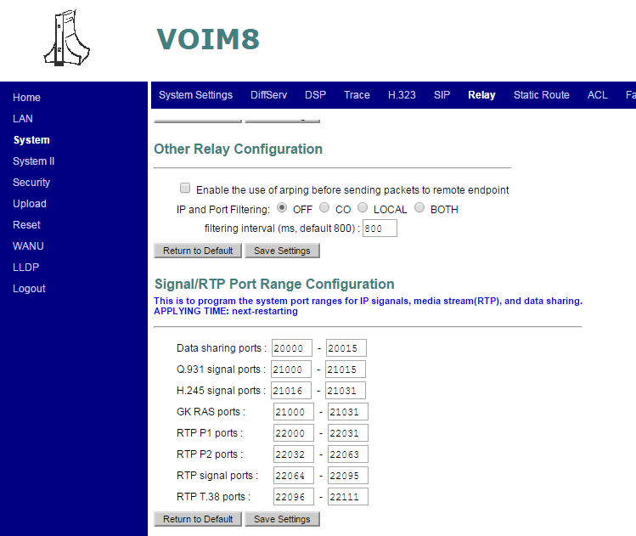

*Make a Note of the New Port Values as they will be required in later programming - Step 8

2nd VOIM8 – <http://10.10.10.12>

With 30 000, 31 000 and 32 000 Port Ranges

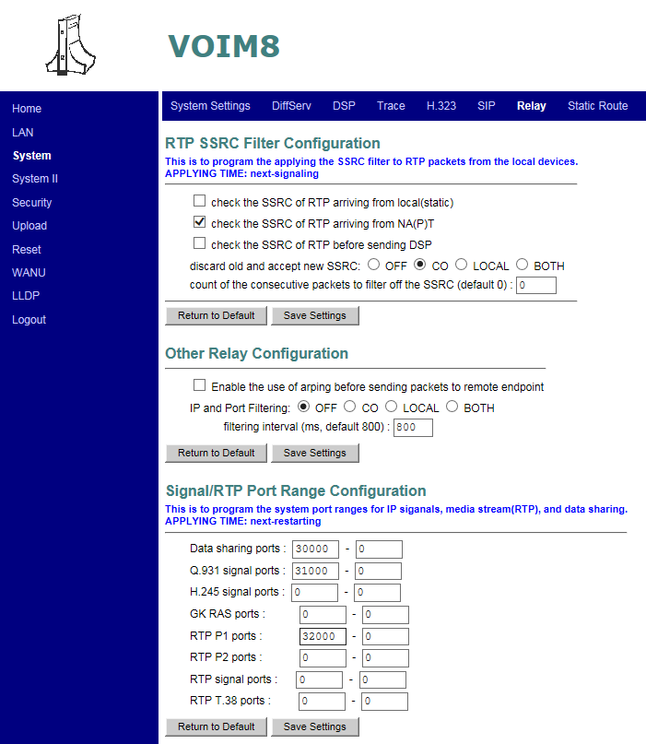

Enter Save

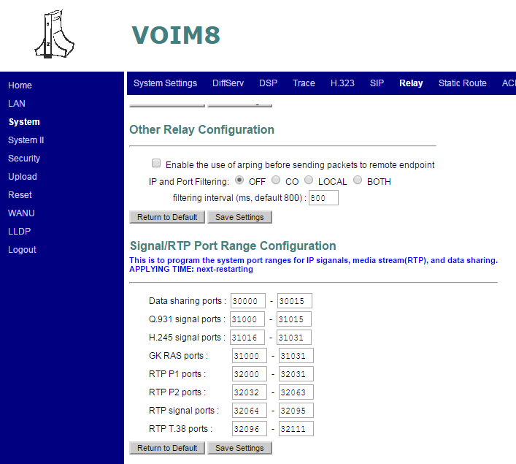10.10.10.10

*Make a Note of the New

Port Values as they will be

required in later

programming – Step 8

1. The UCP ports are changed and viewed either via Serial or Telnet connection – Direct connection to the UCP.

Serial connection default settings are 115200 Baud, 8, N, 1

If using Telnet – set IP Port to be used in PGM 175 e.g. 23

To view the current UCP port setting.

Connected to UCP - This example is via Telnet on port 23

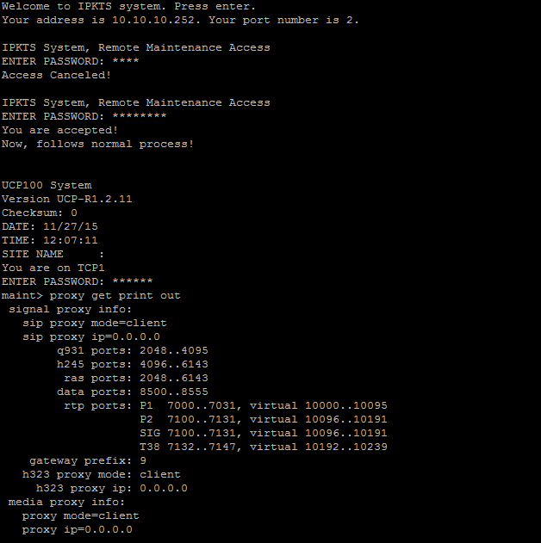

Password is brandy

From the maint> prompt, type

proxy get print out

This is your UCPs Remote Maintenance

Password in PGM162

To change the current UCP port setting.

Connected to UCP - This example is via Telnet on port 23

In this example the UCPs RTP ports have been changed to a higher range to fit in with the scheme used. The RTP ports start at 11000

Just like the VOIMs, the start values are entered and the system adjusts the end values to suit the UCP

Note: The Data sharing ports cannot be changed on the MFIM. This is correct operation as per Ericsson-LG WANU configuration documentation.

From the maint> prompt, type

proxy rtpports 11000



Reset the UCP so ports can take their new value

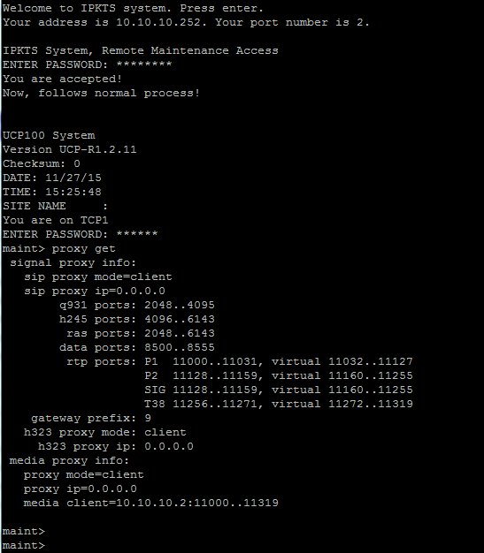

*Make a Note of the New

Port start and end Values as they will be required in later

Programming – Step 8

Make a note of the port range

Make a note of the port range

Password is brandy

From the maint> prompt, type

proxy get

This is your UCPs Remote Maintenance

Password in PGM162

**Step 5** – WANU Configuration

The WANU configuration is located within the selected Master VoIM

This is effectively the LAN2 port on the VOIM

Browse to the selected Master VOIMs IP Address e.g. <http://10.10.10.12>

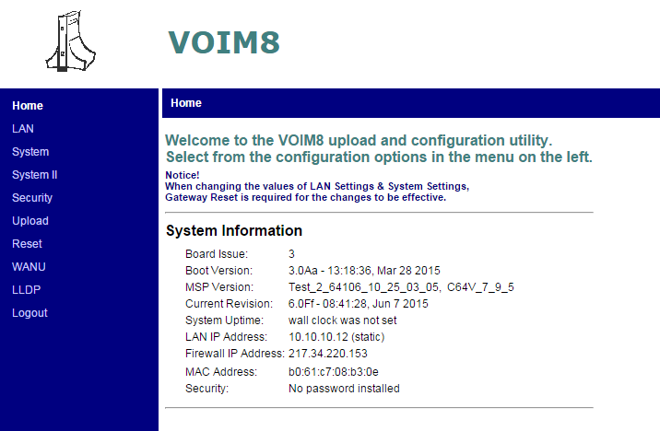

Note: The VoIMs Software Revision

To use the WANU, VoIMs software needs to be v6.0Fa or higher

1. Turn on WANU and ALG Function

Click on WANU, Config, then

1. Enable WANU Control
2. ALG Function – SIP = On

SIP Seize = Round

SIP poll = 10 seconds

Save WANU Settings

Enable WANU Function

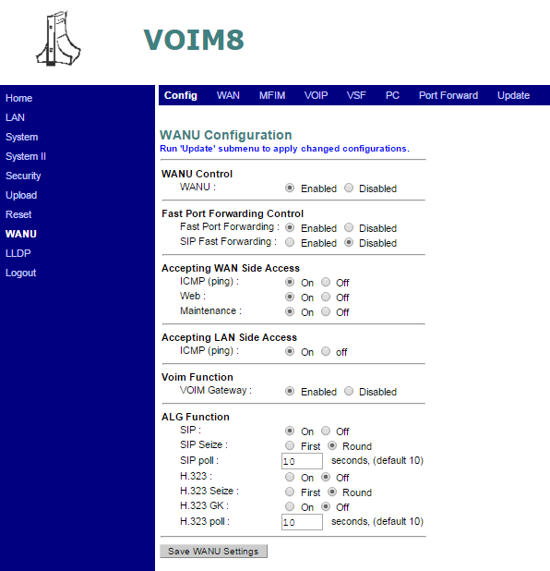

Reply to a ping from the system side

Turn ON if required

Reply to ping from WAN side

Accept web access to WANU from WAN side

Accept maintenance access of WANU from WAN side

Enable SIP ALG

How IP channel is selected - Round is load balancing, First seizes highest channel

SIP poll is a keep alive timer

**Step 6** - WAN Network Resources Configuration

This is the configuration of the LAN2 port on the Master VoIM

Click on WANU, WAN, then under WAN Configuration

1. IP Address = 10.10.10.150
2. Netmask = 255.255.255.0
3. Gateway = 10.10.10.252
4. Firewall = 217.34.220.153

Save WAN Settings

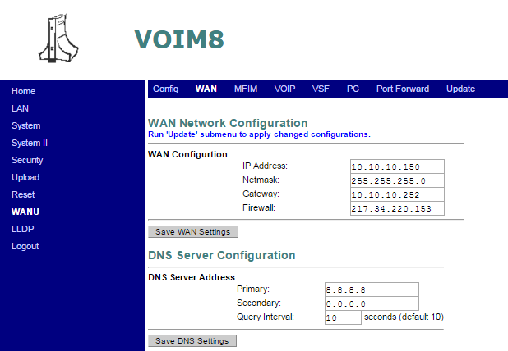

IP Address of DNS Server if needed

LAN2 IP Address – must be a free un-used IP Address

Network SubNet Mask as per local network

LAN2 Gateway – Local LAN IP Address of external DSL router.

The Firewall IP Address is the Fixed Public IP Address of the DSL

**Step 7** – Setting up UCP Information

This is where the WANU is told about the UCP

Click on WANU, UCP, then under UCP Configuration

1. IP Address = 10.10.10.2

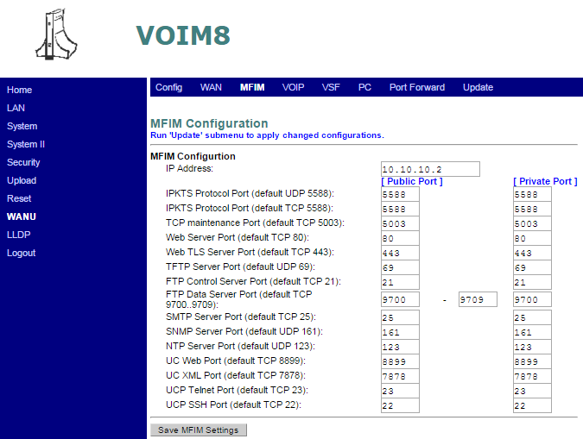

UCPs IP Address

IPKTS Protocol Port UDP 5588 – for connection of modules and IP Phones

TCP Maintenance Port TCP 5003 – For access of UCP Maintenance commands via “brandy”

Web Server Port – System Programming via web browser. Change TCP port to suit your system

Default Web server port on UCP is TCP 443

**Step 8** – Setting up Port Ranges of each Media Gateway (VOIM VOIU Gateway and VOIM) within the WANU

This is where each Media Gateway is defined within the WANU, in relation to its IP Address, Ports used, Number of SIP Channels used and SIP Proxy Address.

Note: Will now need to refer back to Step 4, where the Port Values were noted down.

1. With the UCPs changed ports to hand....

Click on WANU, VOIP, then under VoIP Gateway Configuration

1. VOIP IP Address = 10.10.10.2
2. SIP Proxy Address (IP or Name) enter 255.255.255.255 not SIP Proxy
3. ALG Total Channels = 199 (This relates to the maximum number of ports on the UCP, 199 for UCP100, 600 for UCP600 and 2400 for UCP2400)
4. ALG Max SIP Channels = 199 (This relates to the maximum number of ports on the UCP, 199 for UCP100, 600 for UCP600 and 2400 for UCP2400
5. Enter the Data Sharing, IP Call (Start with first Q931 port and end with last GK RAS port) and RTP Media Ports (Start with first RTP P1 port and end with last RTP T38 port) as per below format, for the UCP

|  |  |  |
| --- | --- | --- |
| Data Sharing | Data Sharing | 8500-8507 |
| Q931 Signalling | IP Call | 2048-6143 |
| H245 signalling |  | 0-0 |
| GK RAS |  | 0-0 |
| RTP P1 | Media Stream | 11000-11111 |
| RTP P2 |  | 0-0 |
| RTP signal |  | 0-0 |
| RTP T38 |  | 0-0 |

See below for the Web browser screen shot before Save is pressed.

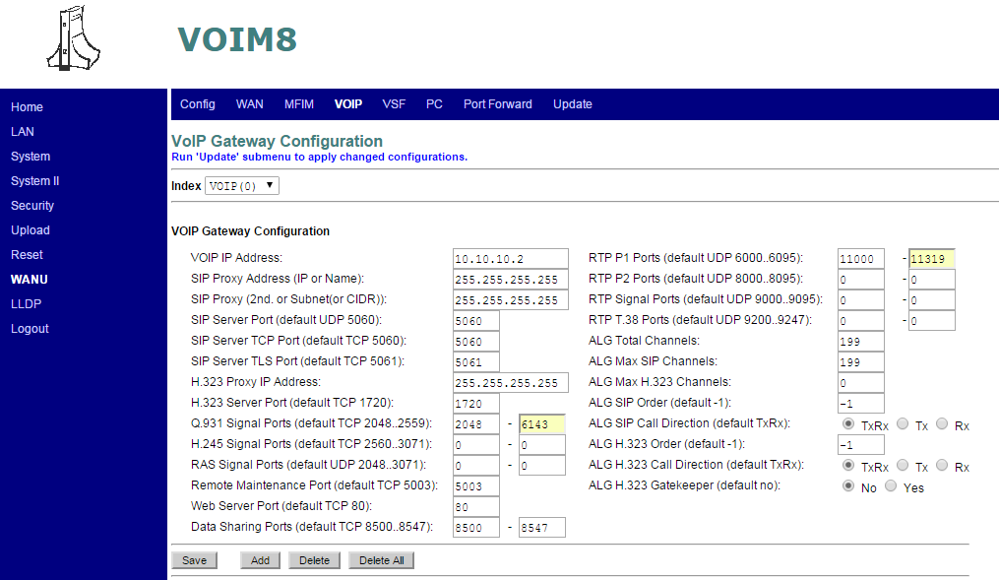

ALG Total channels and ALG max SIP channels should be set to maximum capacity of system UCP100 199, UCP600 600 UCP2400 2400

1. Then Press Save

Now notice how the system updates the ports and details

VoIP Index 0 has been created and the Port values are displayed.

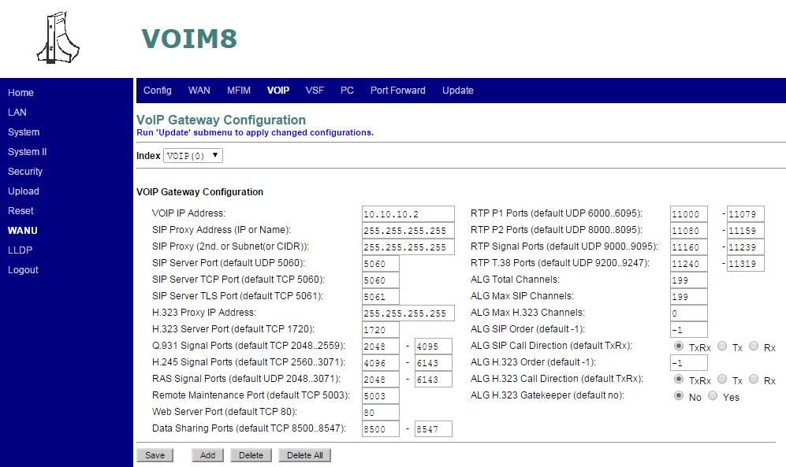

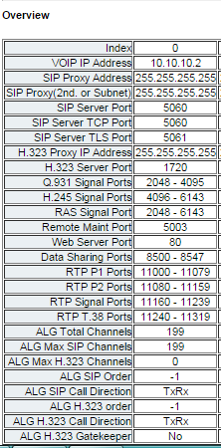

1. With the 1st VOIM8 changed ports to hand....

It’s time to create a new entry for the 1st VOIM8

Index – VOIP (0) is still displayed with all its values...

TYPE OVER THESE VALUES

1. VOIP IP Address = 10.10.10.11
2. SIP Proxy Address (IP or Name) = enter 255.255.255.255 not SIP Proxy
3. ALG Total Channels = 8 (This relates to the number of IP channels on the VOIM Gateway)
4. ALG Max SIP Channels = 0 (This should be set to 0)
5. Enter the Data Sharing, IP Call (Start with first Q931 port and end with last GK RAS port) and RTP Media Ports (Start with first RTP P1 port and end with last RTP T38 port) as per below format, for the VoIM

|  |  |  |
| --- | --- | --- |
| Data Sharing | Data Sharing | 20000-20015 |
| Q931 Signalling | IP Call | 21000-21031 |
| H245 signalling |  | 0-0 |
| GK RAS |  | 0-0 |
| RTP P1 | Media Stream | 22000-22111 |
| RTP P2 |  | 0-0 |
| RTP signal |  | 0-0 |
| RTP T38 |  | 0-0 |

See below for the Web browser screen shot before ADD is pressed.

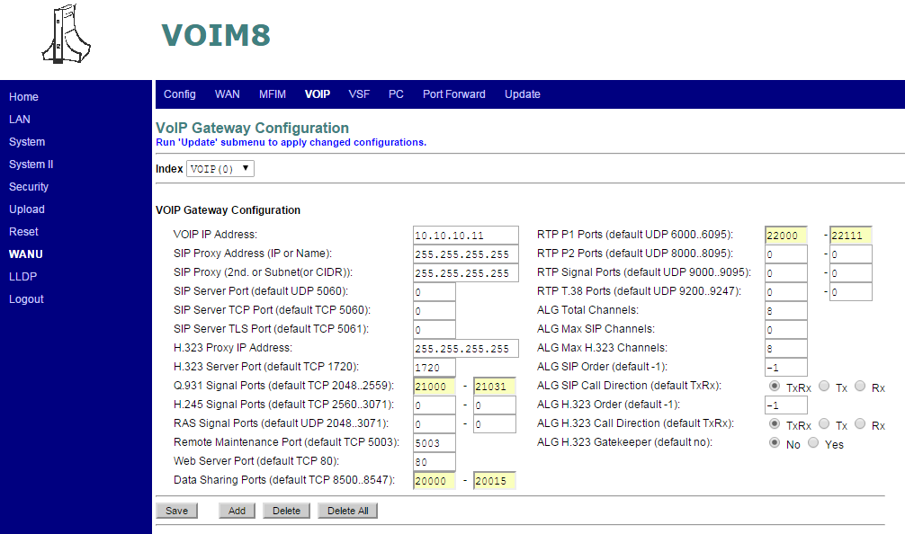

Click on ADD to update entry

1. Now click ADD........... DO NOT Press SAVE or the VoIP 0 entry will be over written!!

Now notice how the system updates the ports and details

VoIP Index 1 has been created and the Port values are displayed.

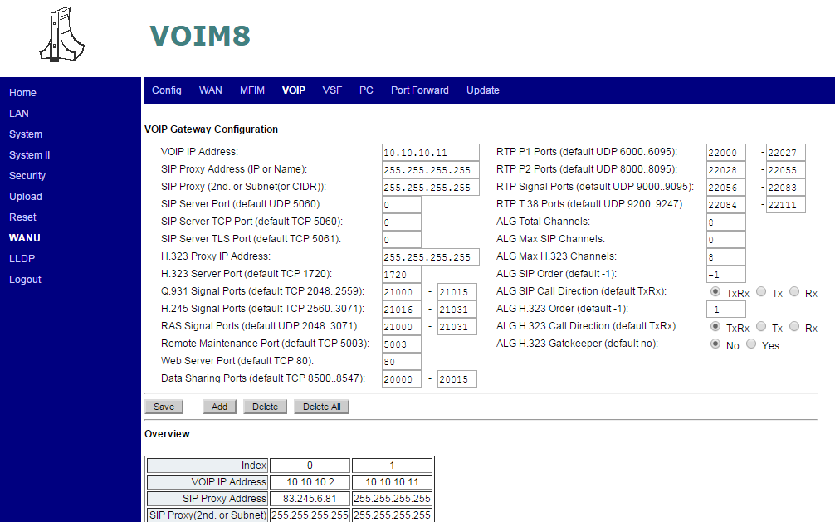

1. With the 2nd VOIM8 changed ports to hand....

It’s time to create a new entry for the 2nd VOIM8

Index – VOIP (1) is still displayed with all its values...

TYPE OVER THESE VALUES

1. VOIP IP Address = 10.10.10.12
2. SIP Proxy Address (IP or Name) = enter 255.255.255.255 not SIP Proxy
3. ALG Total Channels = 8 (This relates to the number of IP channels on the VoIP Gateway)
4. ALG Max SIP Channels = 0 (This should be set to 0)
5. Enter the Data Sharing, IP Call (Start with first Q931 port and end with last GK RAS port) and RTP Media Ports (Start with first RTP P1 port and end with last RTP T38 port) as per below format, for the VoIM

|  |  |  |
| --- | --- | --- |
| Data Sharing | Data Sharing | 30000-30015 |
| Q931 Signalling | IP Call | 31000-31031 |
| H245 signalling |  | 0-0 |
| GK RAS |  | 0-0 |
| RTP P1 | Media Stream | 32000-32111 |
| RTP P2 |  | 0-0 |
| RTP signal |  | 0-0 |
| RTP T38 |  | 0-0 |

See below for the Web browser screen shot before ADD is pressed.

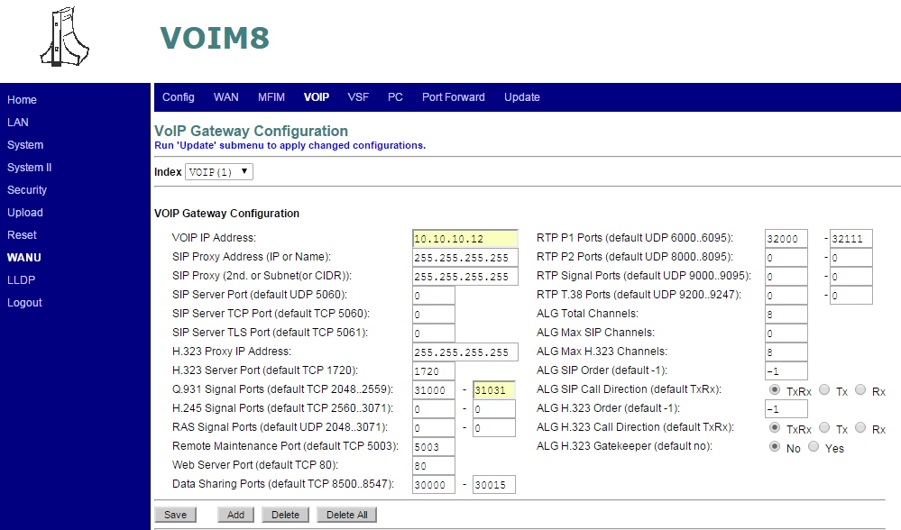

Click on ADD to update entry

1. Now click ADD........... DO NOT Press SAVE or the VoIP 1 entry will be over written!!

Now notice how the system updates the ports and details

VoIP Index 2 has been created and the Port values are displayed

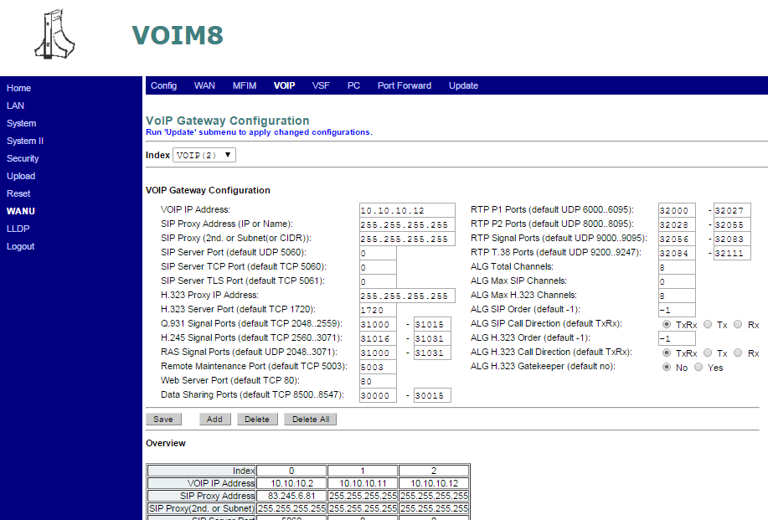

Step 9 – Verify Port Ranges of each Media Gateway (UCP VOIU Gateway and VoIM) within the WANU

Click on WANU, VOIP, then under VoIP Gateway Configuration, scroll down to Overview. For UCP100 using and VOIM8 it should be as below except with the actual IP address used. UCP600, 2400, VOIM24 will have their corresponding channel values as defined in the set up part of this document.

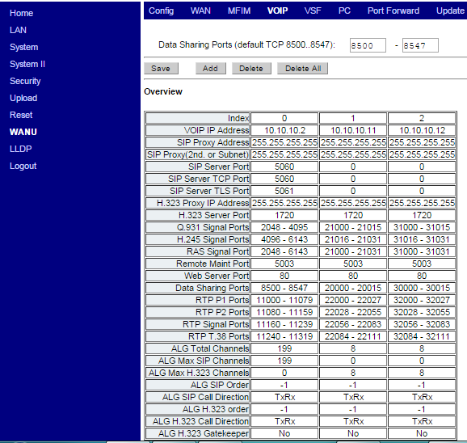

**Step 10** – Update changes to the WANU settings

When configuration changes are made within the WANU, the WANU memory needs to be updated.

Click on WANU, Update, then under Update/Stop, Flush and update current settings

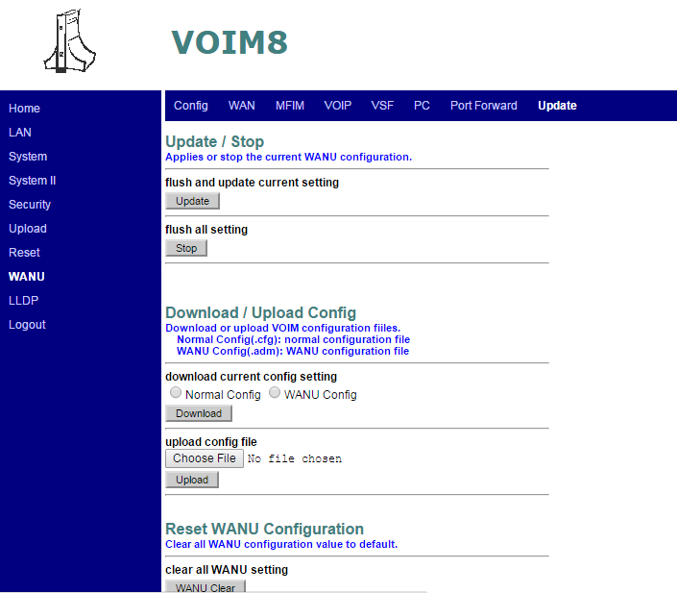

Update to apply settings within the WANU

**Step 11** – Program Port Forwarding on the DSL Router.

The DSL router will need to have Port forwarding programmed to route the required TCP and UDP ports from the Public WAN side to the Private LAN side.

The port Ranges to be Port Forwarded need to be taken ranges set on each Media Gateway – Refer to Step 4, or see below for the port ranges used within this example.

|  |  |  |  |
| --- | --- | --- | --- |
| **Router Port Forwarding for SIP Trunks** | | | |
| **Public IP Address** | **Local Address** | **Open Ports UDP** | |
| Firewall IP Address 217.34.220.153 | Master VOIM LAN2 IP Address 10.10.10.150 | 2048 | 8555 |
| 11000 | 11319 |
| 20000 | 22111 |
| 30000 | 32111 |
| 5060 | 5060 |

Below is a table of Reference for the Ports configured within this example.

